M Y M A N I F E S T O

What is a manifesto?

A public declaration of policy and aims, especially one issued before an election by a political party or candidate.
- why you do what you do in a clear and concise way
- a clearly defined sense of purpose
- keeps you on course towards the goals you wish to achieve
A manifesto should include;
- What you believe
- What you value most
- How people feel when they interact with you
A manifesto should;
- Grow as you grow
- Grow as you learn more about your audience and what they desire
- Anchor you to reality as you pursue your dreams

In Todd Henrys book ‘louder than words’ he shares a manifesto is “a constant grounding document you can turn to for inspiration and help in focusing” and “an easy way to introduce others to what you care about”
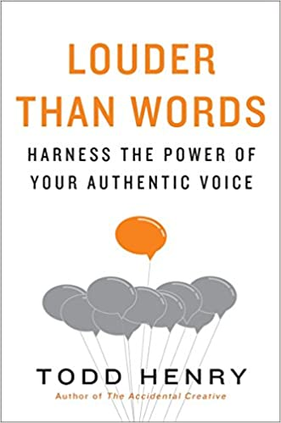

3 important elements when writing your manifesto

Focus on the “who”
- Define this before creating your content
- The more you know about your audience and the struggles they face the better you can create something that will result in a lasting change in their lives
Crafting your “what”
- What do you do that makes a difference
Identifying your “why”
- Selflessly add to the lives of others
- Your purpose should transform lives
- Defeat status quos
- Add value to the world

What does a manifesto mean to me?

For me, my manifesto should be something I can turn to in times of uncertainty and self-doubt. It should be a guiding light to put me right back on track. I want it to be something I can look to in all elements of my life and not just as a designer. It is important that my manifesto pushes me out of my comfort zone and allows me to preform to the best of my ability.

My views and core beliefs
To me its important to be honest, kind and genuine. I try to see beauty in everything

Manifesto examples

Surrealists

Surrealism was an artistic, intellectual, and literary movement led by poet André Breton from 1924 through World War II. The Surrealists sought to overthrow the oppressive rules of modern society by demolishing its backbone of rational thought. To do so, they attempted to tap into the “superior reality” of the subconscious mind. “Completely against the tide,” said Breton, “in a violent reaction against the impoverishment and sterility of thought processes that resulted from centuries of rationalism, we turned toward the marvellous and advocated it unconditionally.”
https://www.moma.org/learn/moma_learning/themes/surrealism/

Surrealisms main aim was to revolutionise human experience. Poets and artists involved in the movement found beauty in the unexpected, the more disregarded and unconventional, the better.
I like this because, I think its important to break social norms and not be another clone in society. To be unapologetically yourself. There is lots of creative freedom allowed within this. No rules to abide by and no specific approach needed. Able to push boundaries.

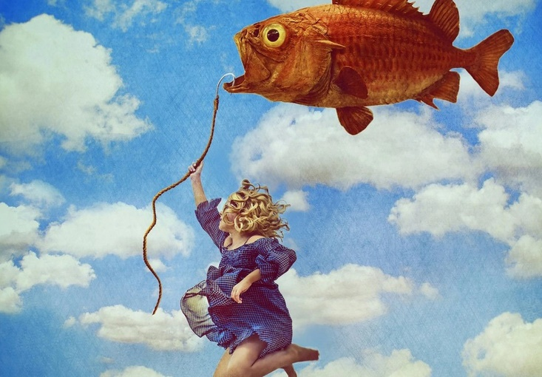
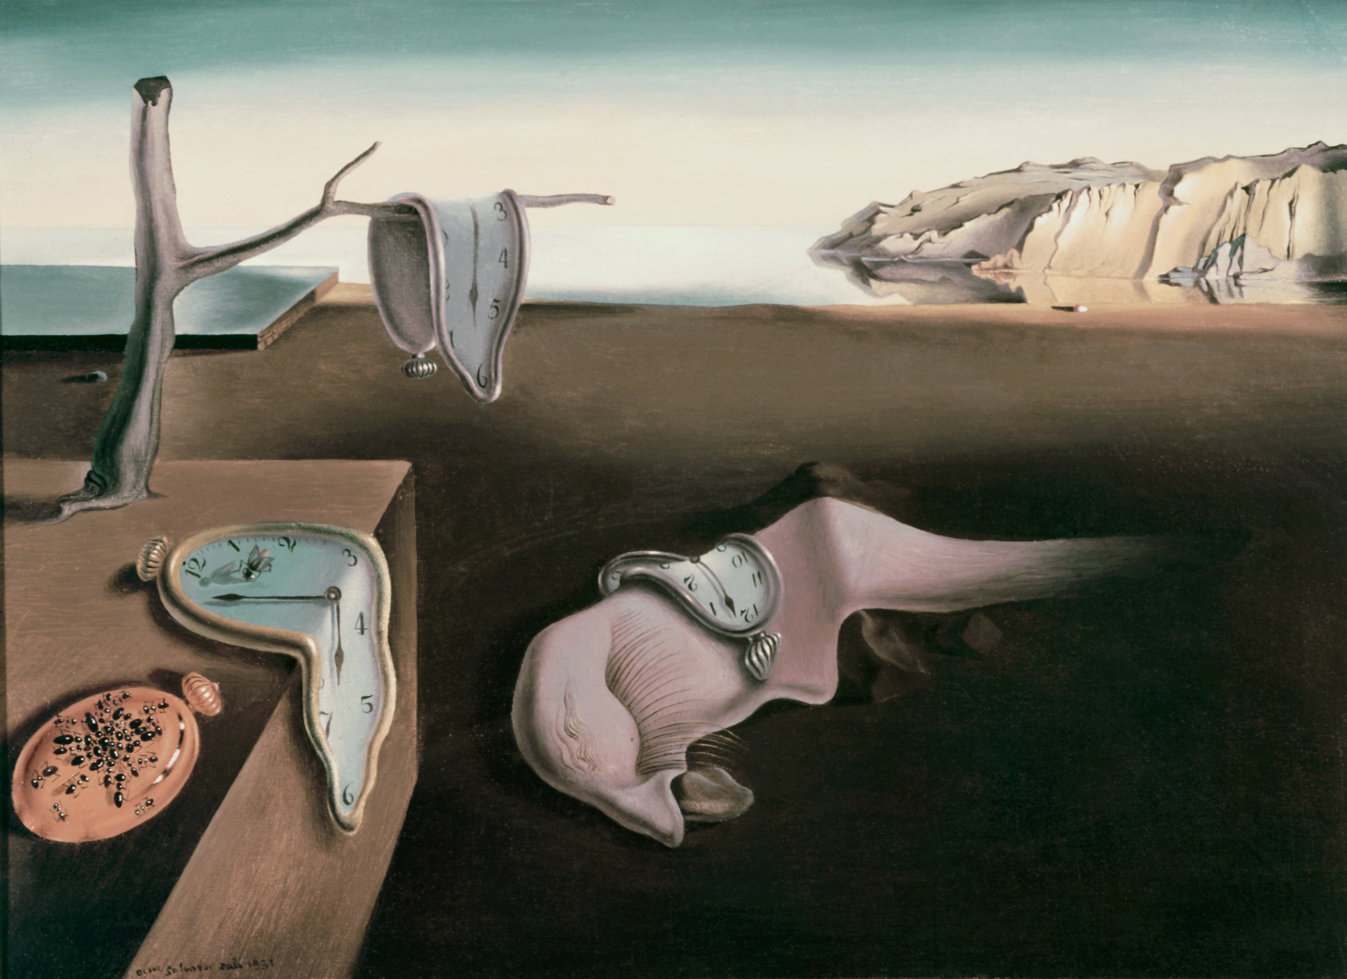

Dadaism
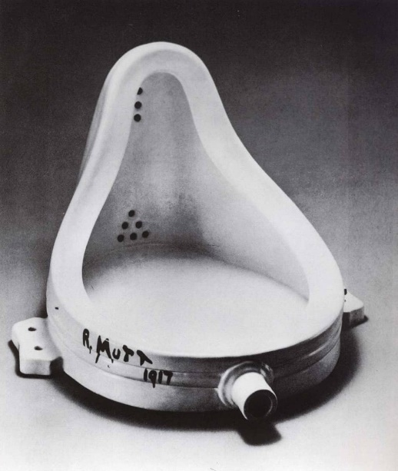
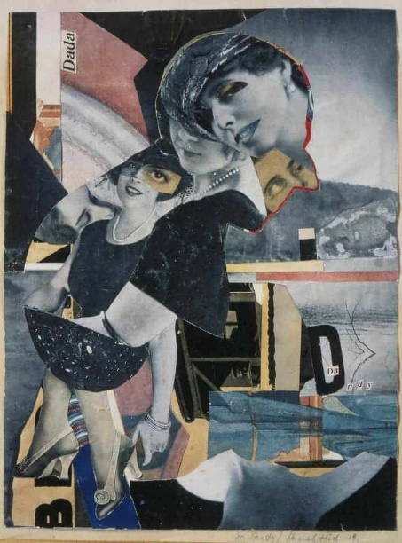
As a word, it is nonsense. As a movement, however, Dada art proved to be one of the revolutionary movements in the early twentieth century. Initially conceived by a loose band of avant-garde modernists in the prelude to World War I but adopted more fully in its wake, the Dadaist celebrated luck in place of logic and irrationality instead of calculated intent.

De Stijl
https://www.tate.org.uk/art/art-terms/d/de-stijl

definition taken from tate.org.uk
“De Stijl was a circle of Dutch abstract artists who promoted a style of art based on a strict geometry of horizontals and verticals”
De Stijl, aka neoplasticism.
De Stijl translated from Dutch, meaning ‘the style’
Began in 1917 and lasted roughly until 1931.
Piet Mondrian describes it as “a utopian perception of spiritual harmony”
Paintings are purely abstraction, the big point of emphasis that separated this from other abstract movements like Cubism or abstract expressionism is that there is a reduction to just the essentials of form and colour, these paintings are simple visual compositions consisting strictly of just vertical and horizontal lines, basic shapes like squares or rectangles and primary colours in addition to black and white. The artists were a lot more concerned with the nature of form and colour themselves than they were with the appearance of the world around them. Mondrian believed that the three dimensional world was deceptive in away and that De Stijl aimed to get down to the essence of meaning within the world, on its most simplest basic level. Hence the emphasis on just the primary colours and simple shapes.
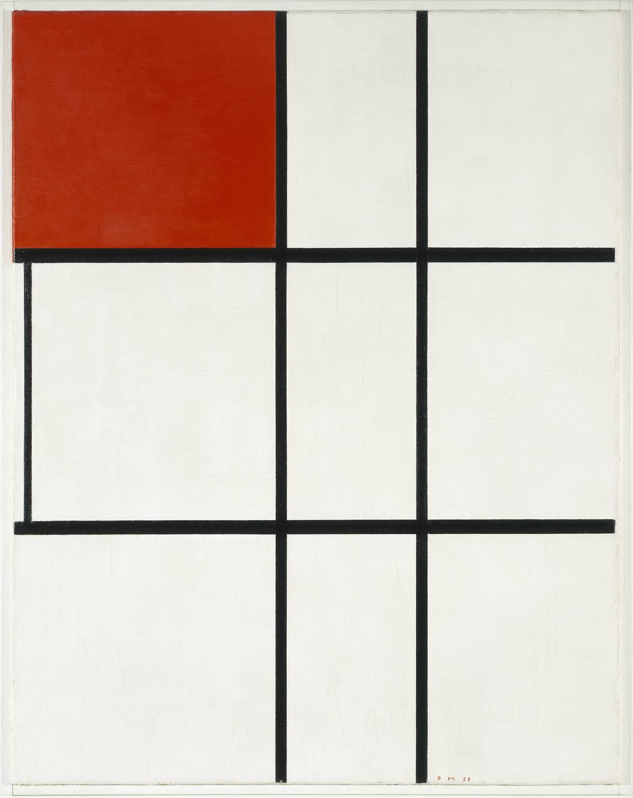

More honourable mentions;
- The Guerilla Girls, 1985-90
- Women's Art: A Manifesto

Swiss Modernism & Punk Rock

For me music is a huge part of my life, so I have looked to music posters for inspiration. A few of my favourites are listed below. Beginning with the smiths promotional poster.
Mike Joyce, owner of Stereotype Design, combines two things he loves – punk rock and Swiss modernism – result in an ongoing project called swissted. The series consists of vintage punk, hardcore, new wave, and indie rock show flyers that Joyce has redesigned into international typographic posters
The entire posters typography is in lowercase, this is appealing to me as the style stays consistent throughout, allowing the focal point ‘S’ to stand out even more so.
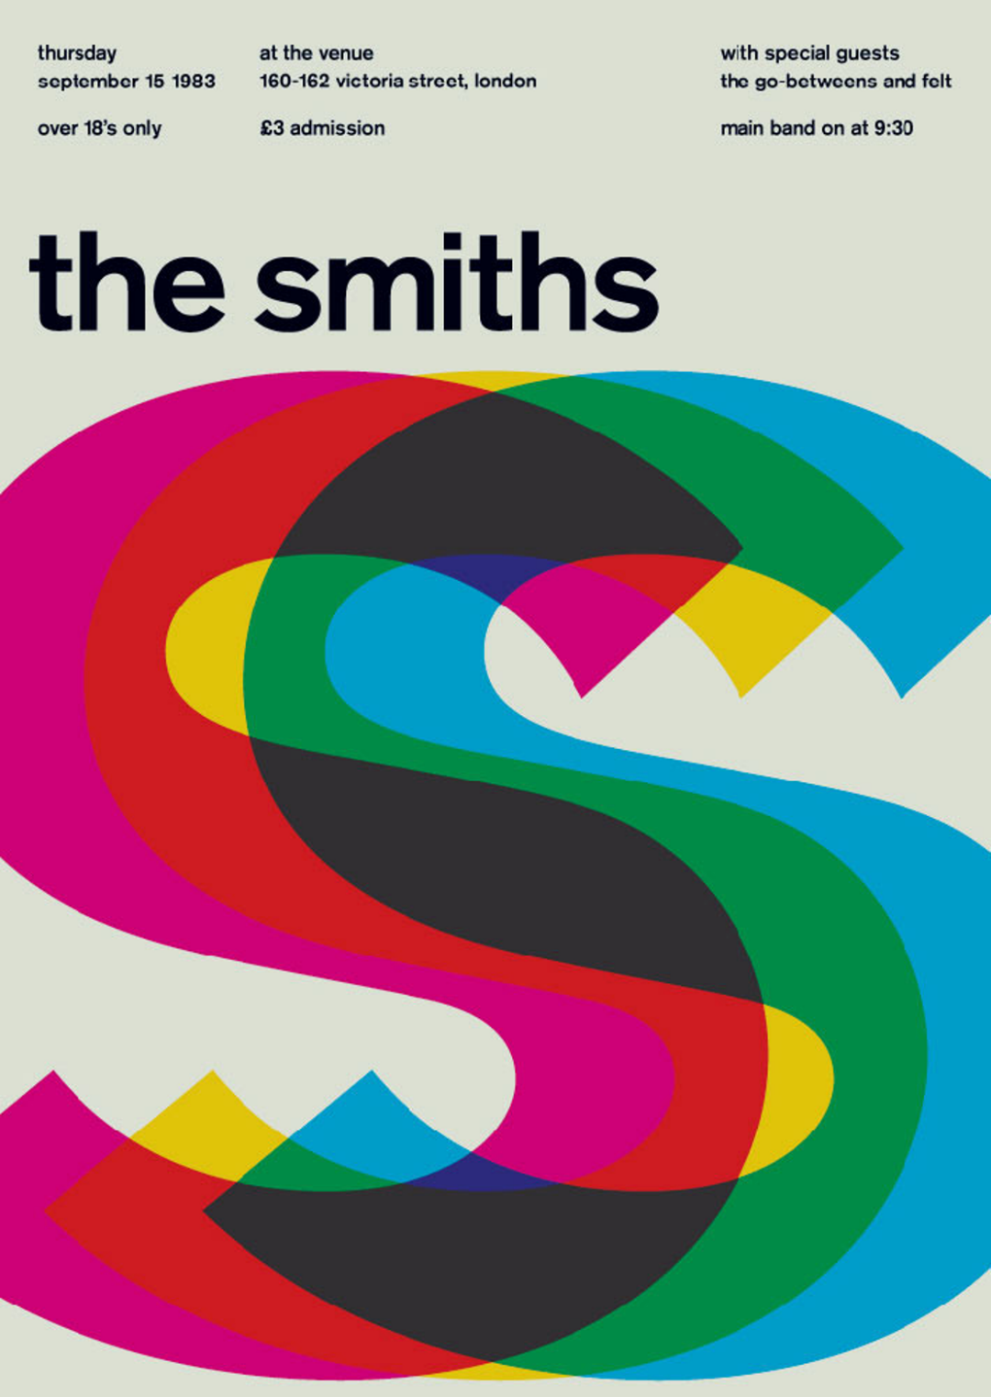
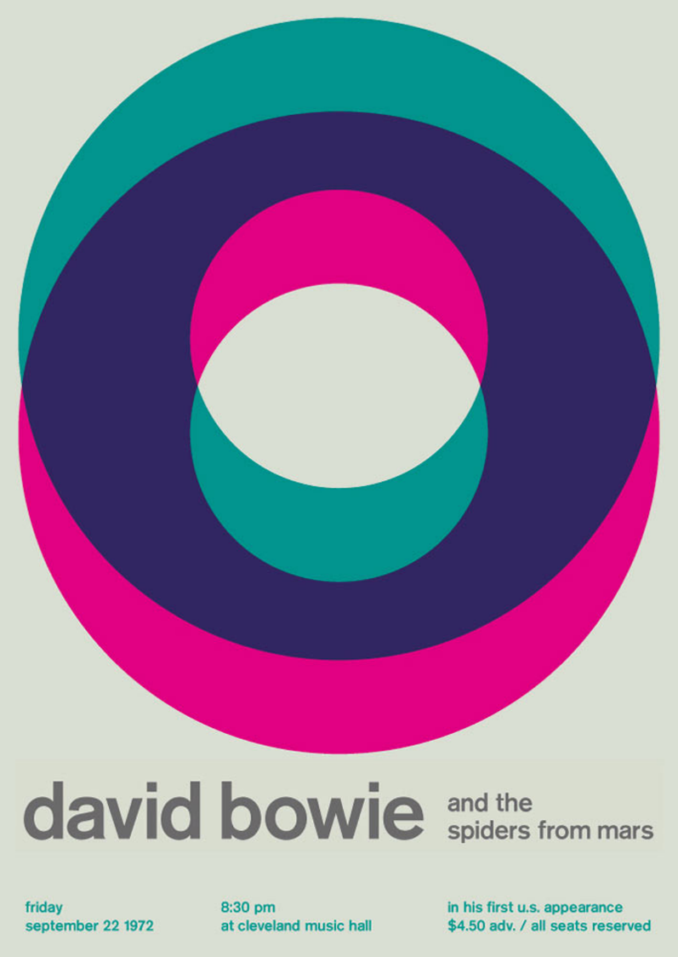
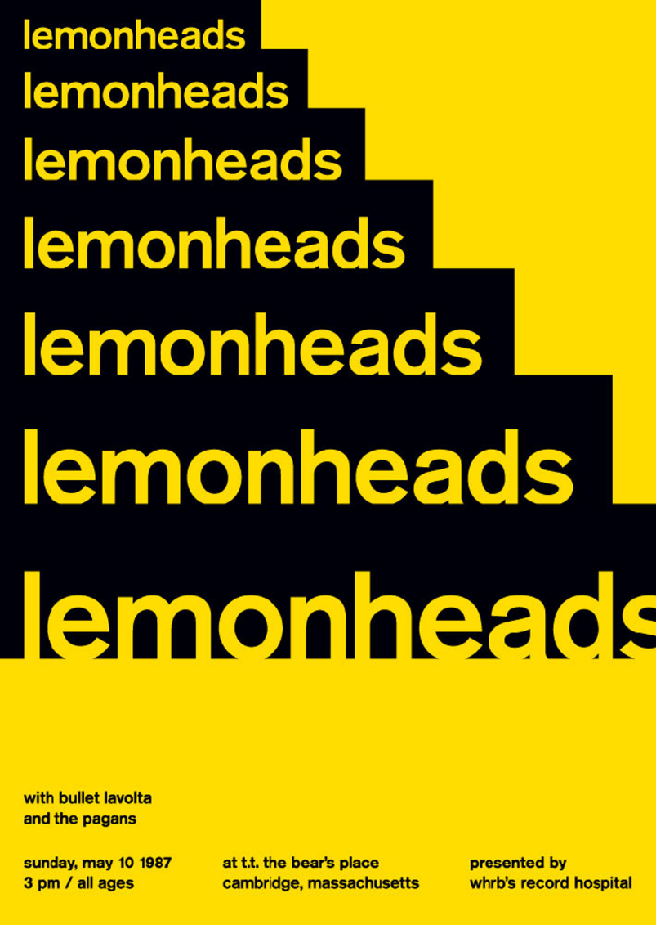

Initial ideas

- Be the solution to a problem people don’t even know they have yet
- You’re stronger than this.
- The only constant in life is change, so be open to it.
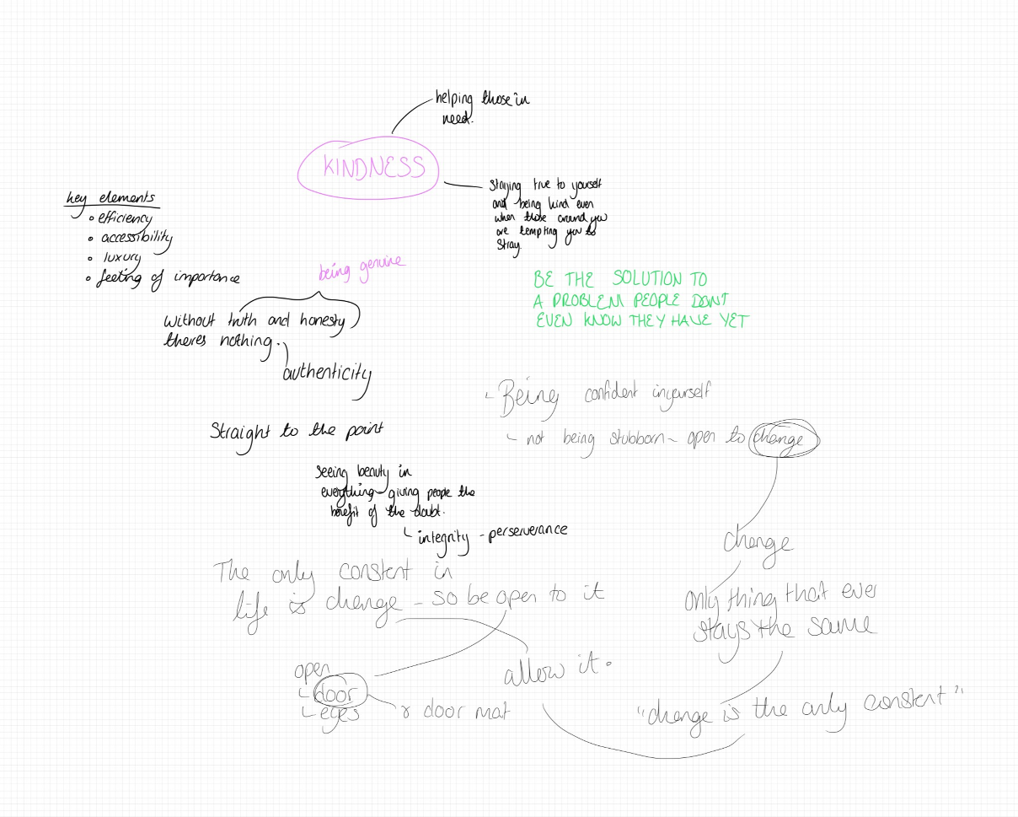

My chosen manifesto
“The only constant in life is change, so be open to it”

I chose this as it is important to me that my manifesto allows me to grow as things around me change. I don’t want to be held down by a ‘rule’ that does apply to me and my circumstances anymore.
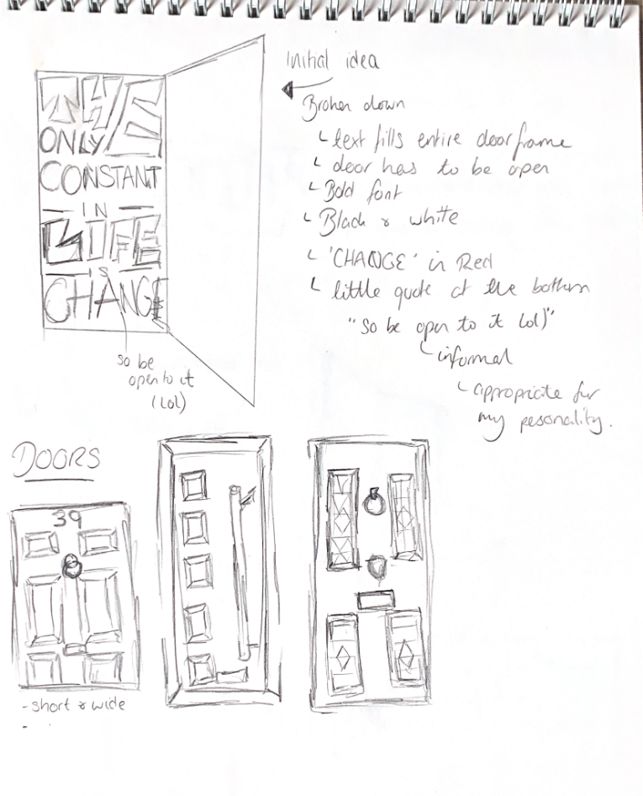
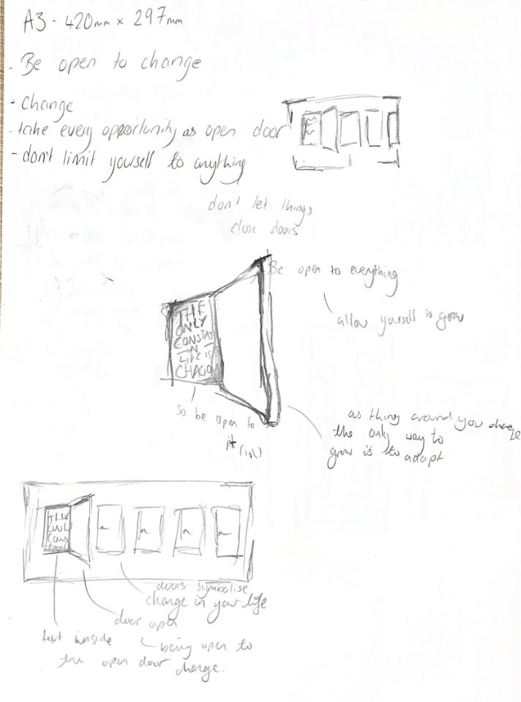
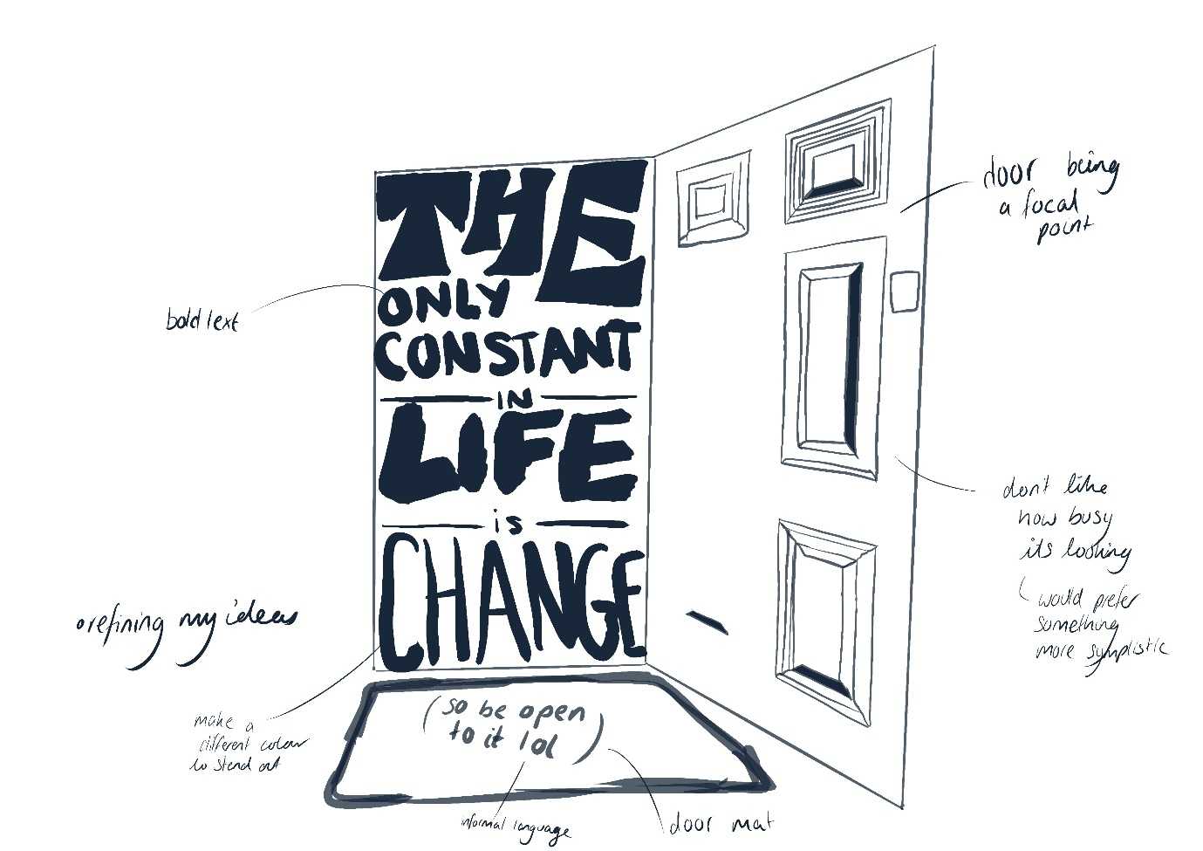
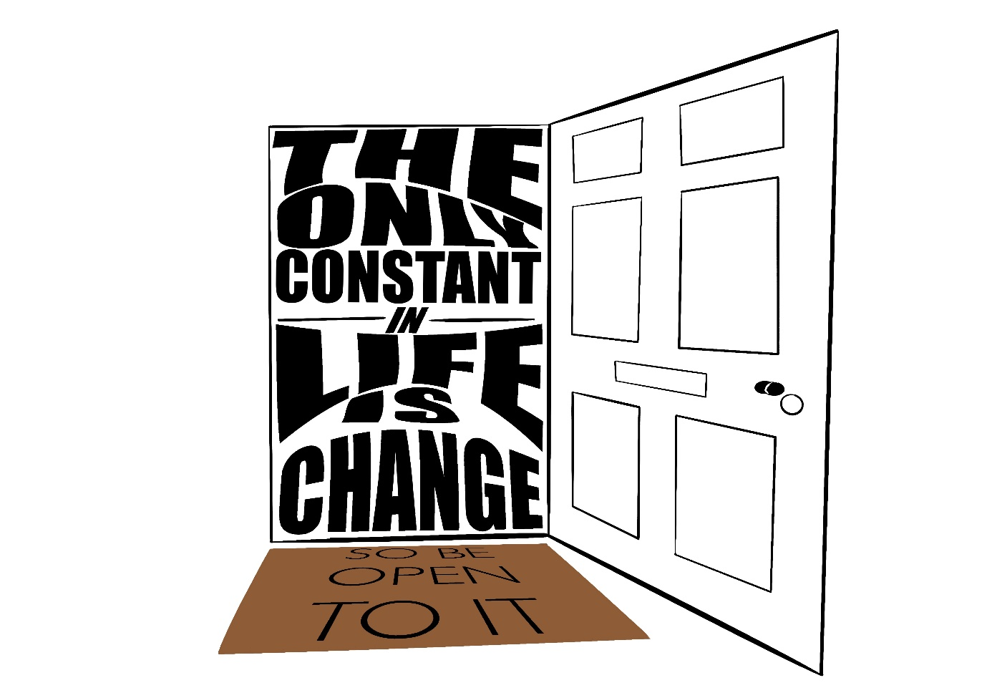
I am happy with my ‘final’ outcome. However much more development is needed in both research and design elements of this project. With time and more practice on different design software I will be able to complete this task to a standard I am truly proud of.

Developments after feedback

Following the feedback given I revisited my manifesto and altered it accordingly.

Images below show the process;

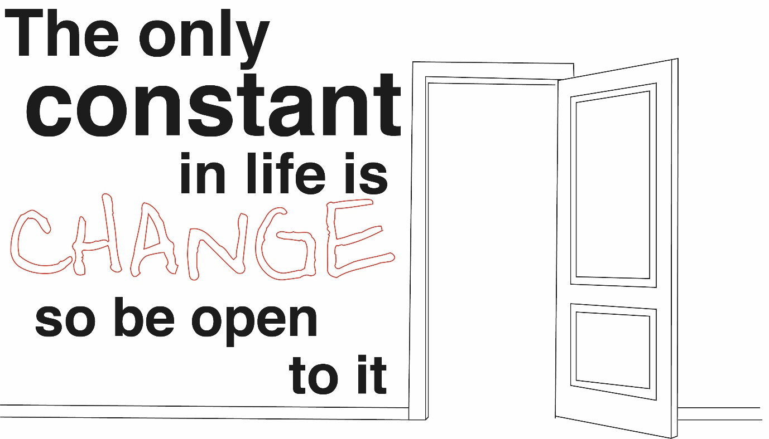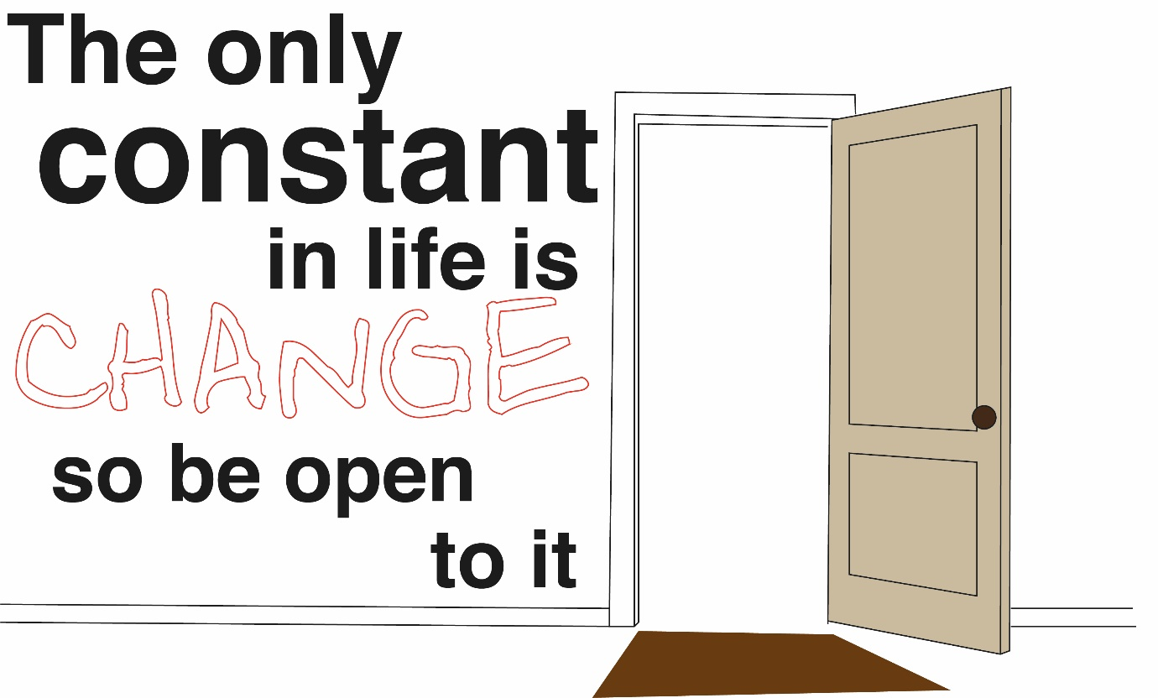
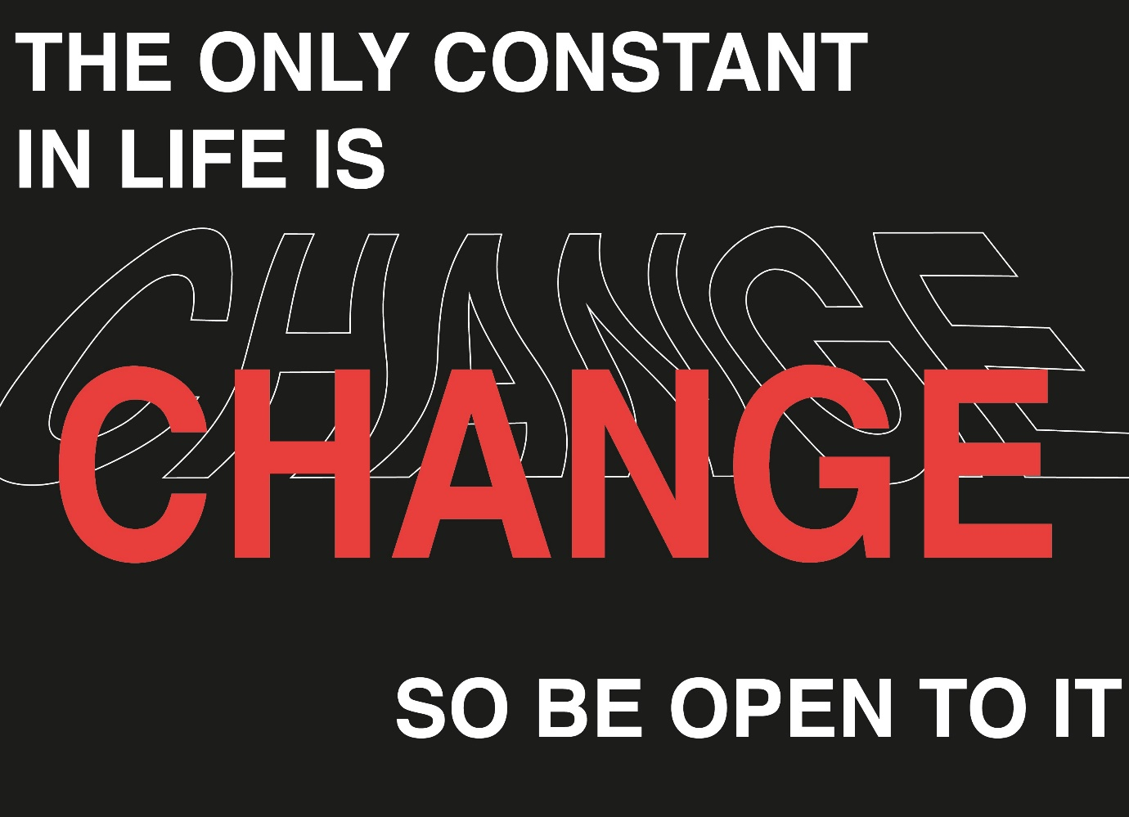
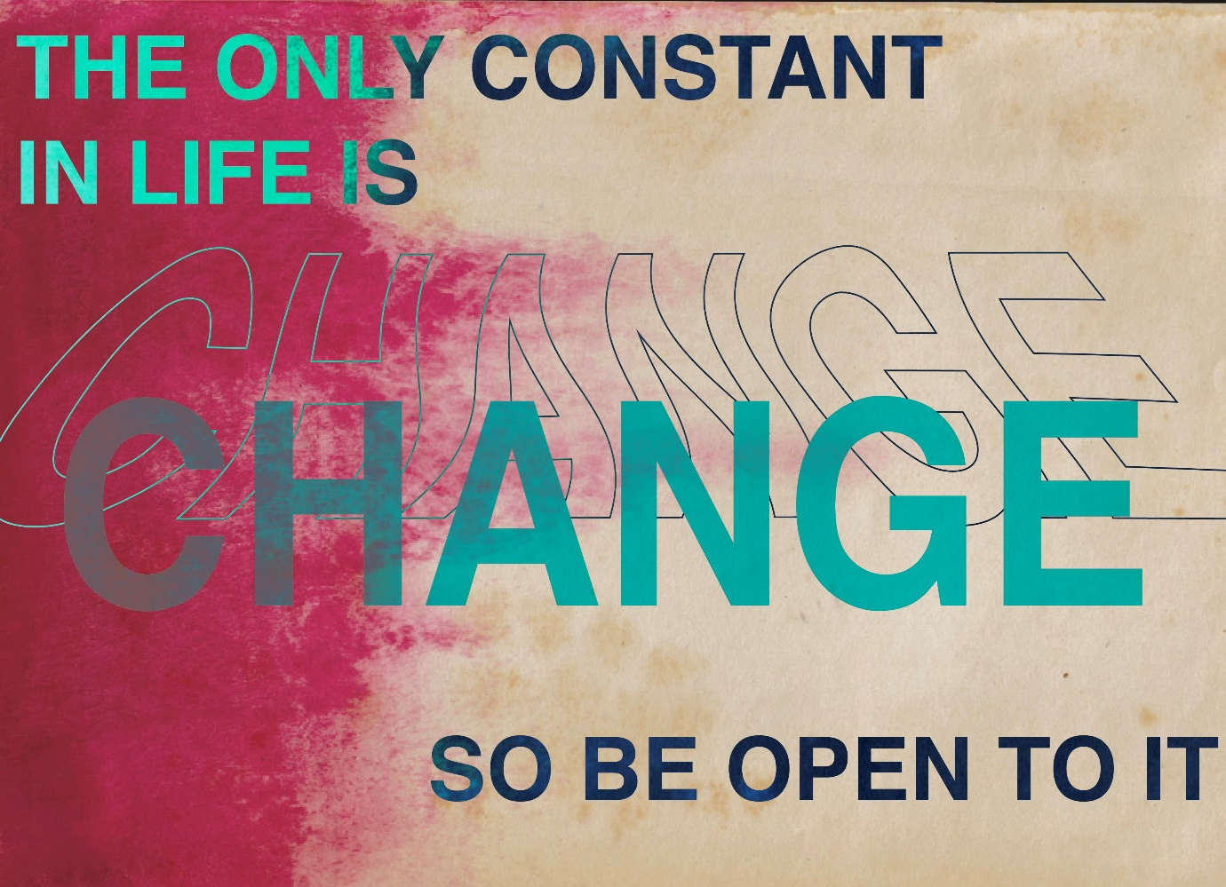

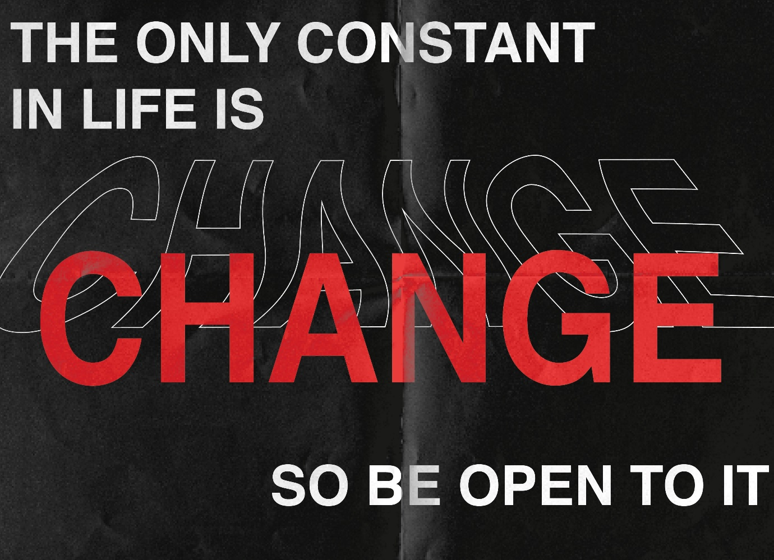
Final design

