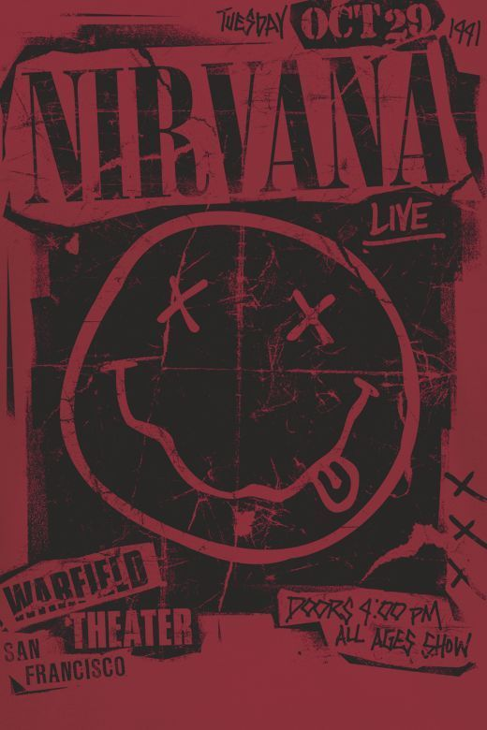
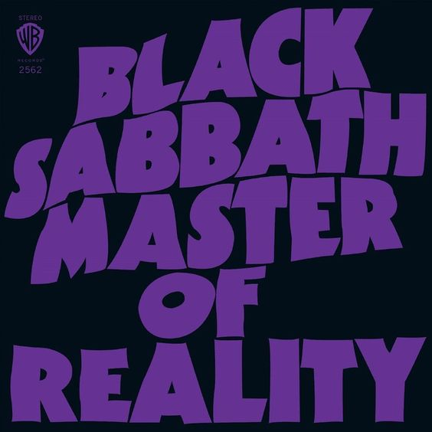
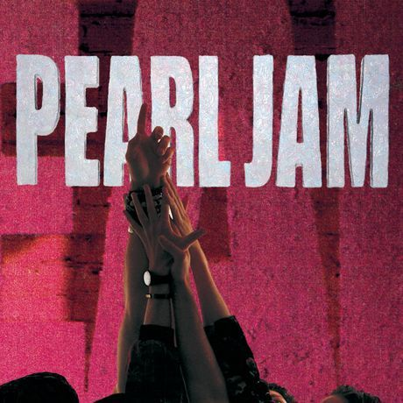
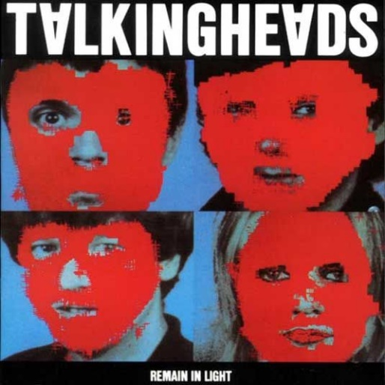
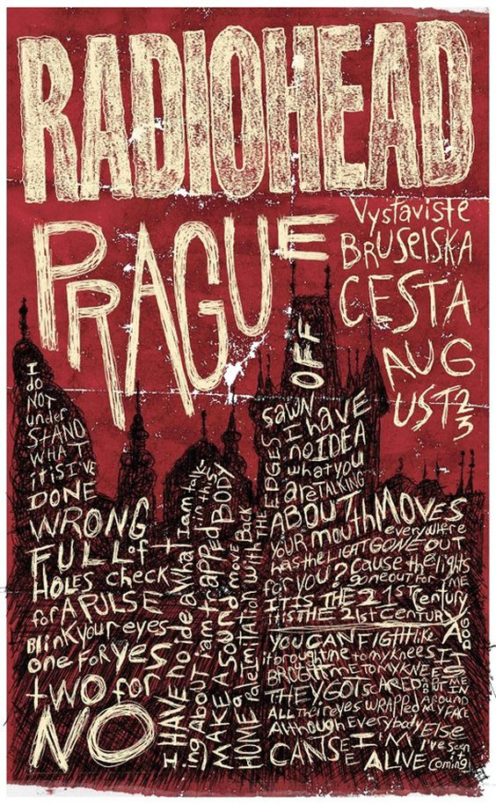
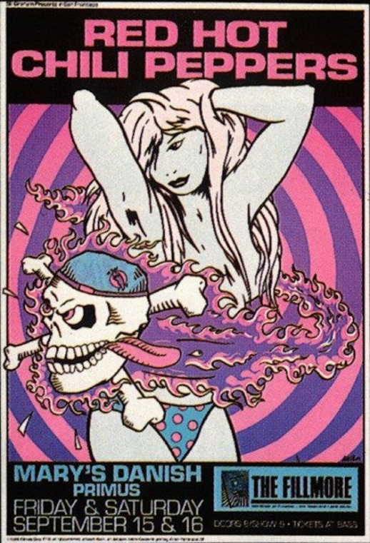
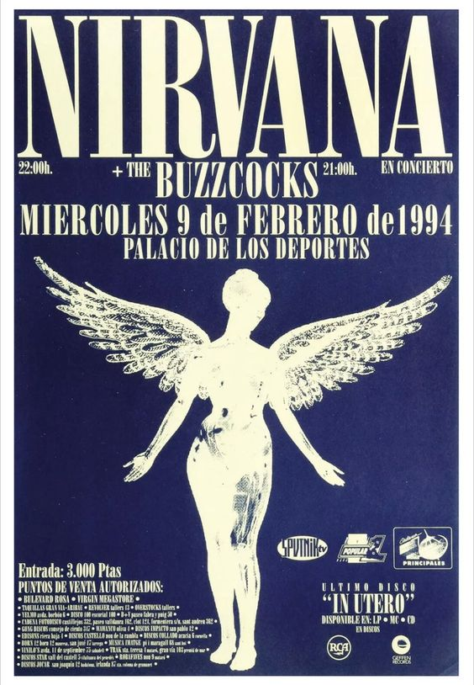
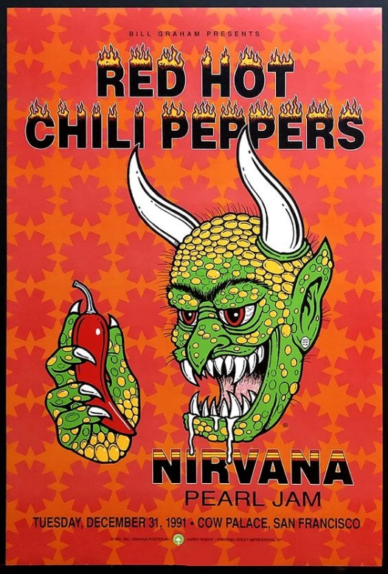
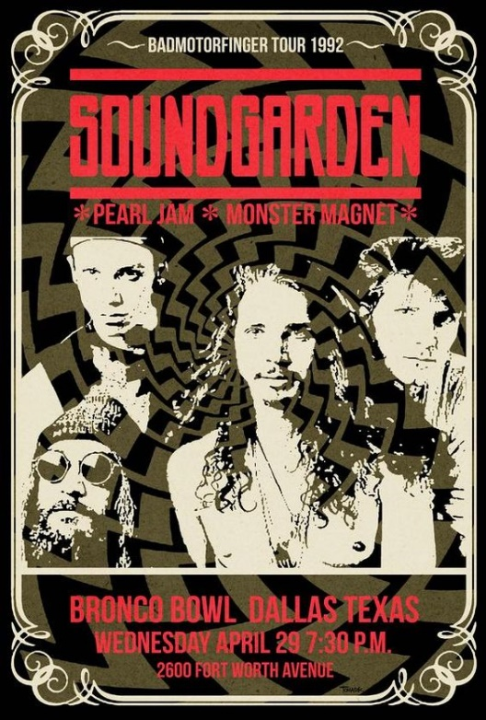
Follow the Rhythm

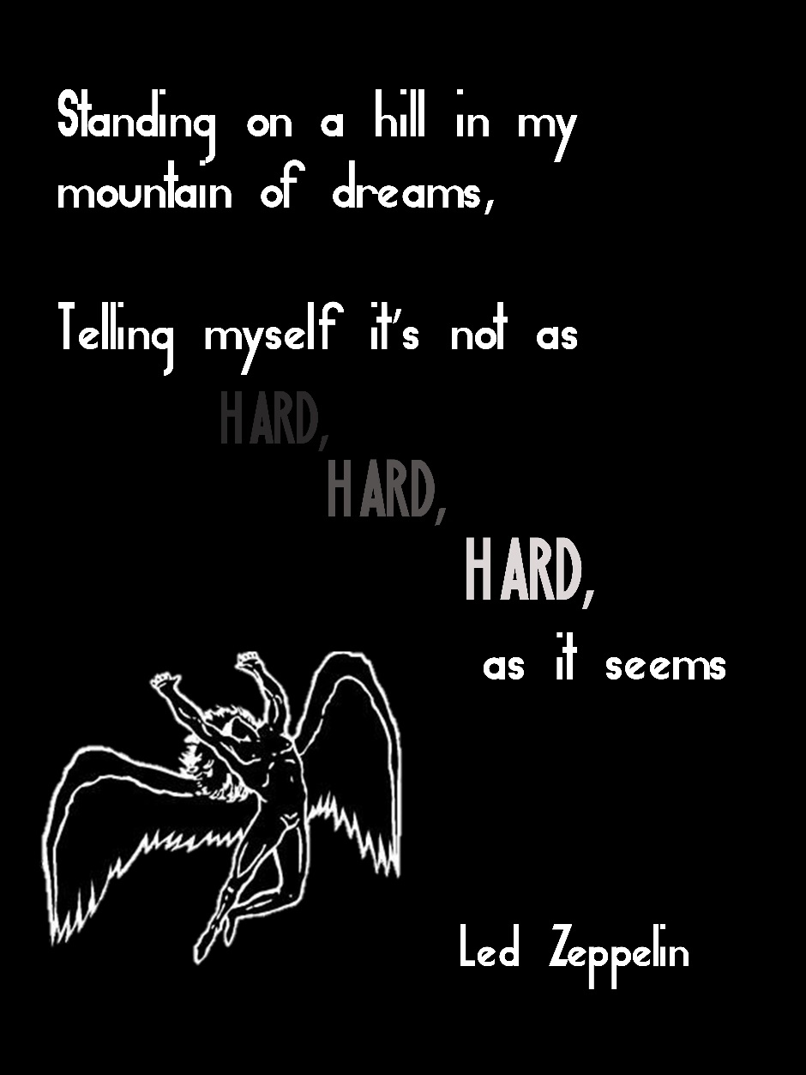
First attempt
Without any real planning I jumped right into designing my poster on illustrator , I took inspiration from 70s rock posters and decided to kept it monochromatic.
I downloaded A ‘led zeppelin’ font from the internet and also included a png.
I really dislike how this came out, so decided to start over entirely.
Nothing is eye catching and overall its very basic and boring.
The only reason you may associate this poster with Led Zeppelin is because of the use of image, but apart from that, its unspectacular.
Although I don’t like the poster it was a good learning experience and allowed me to improve my skills and figure out what I do and don’t want.

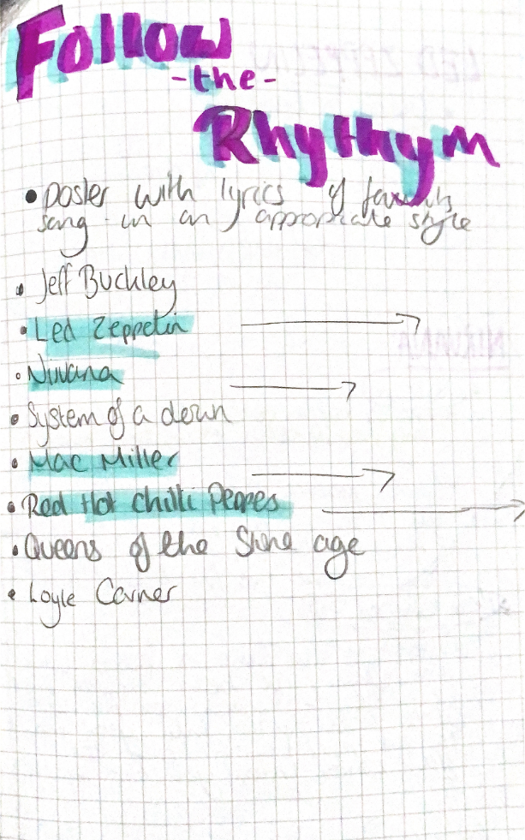
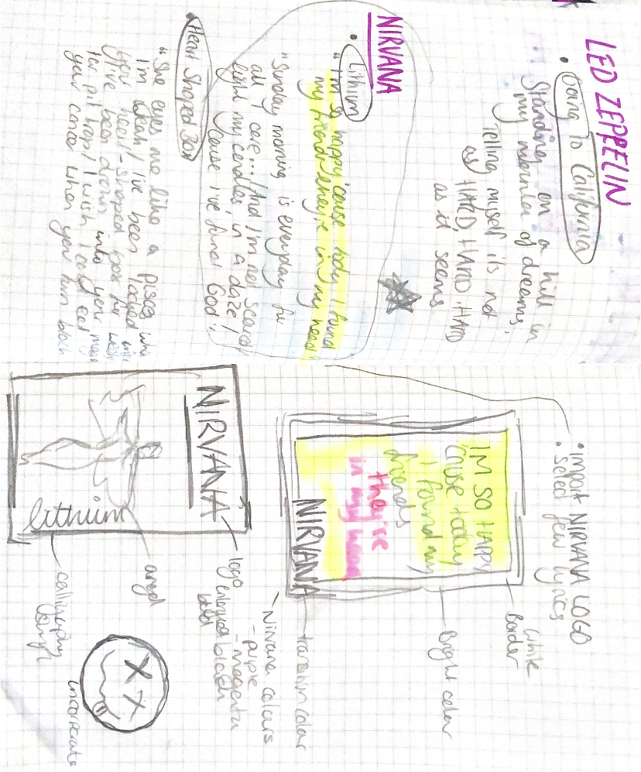
Planning
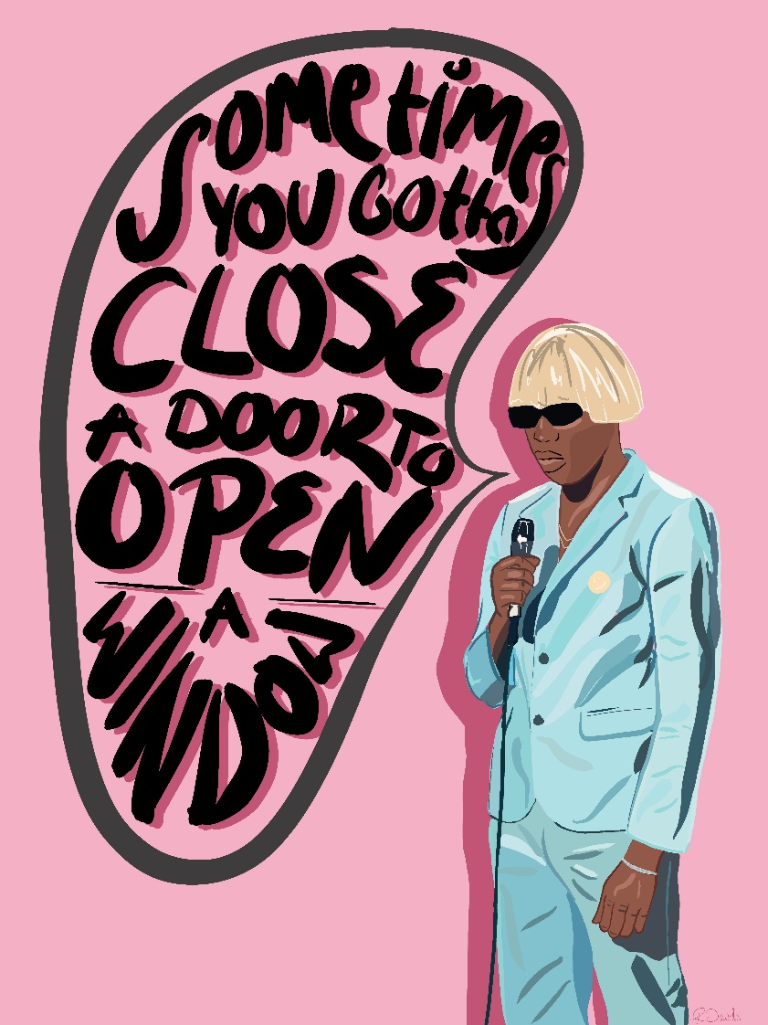
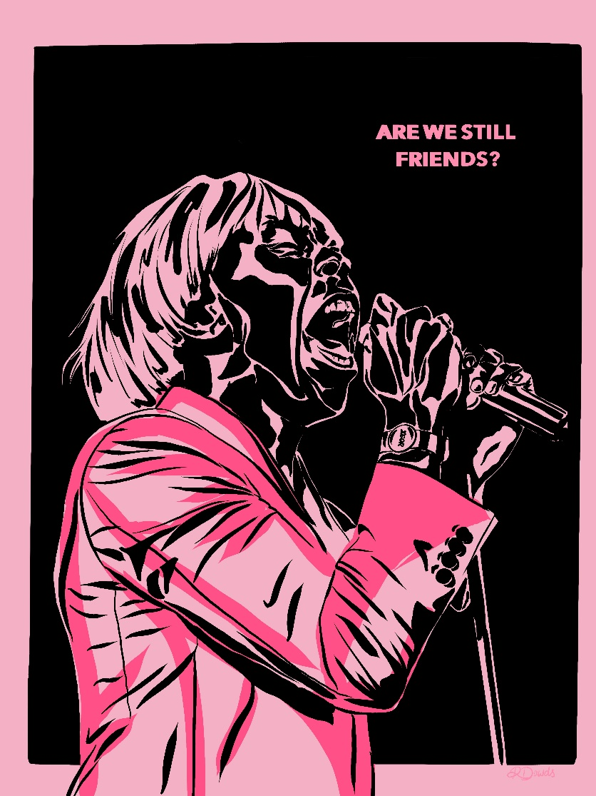
Lyric posters I have made in the past

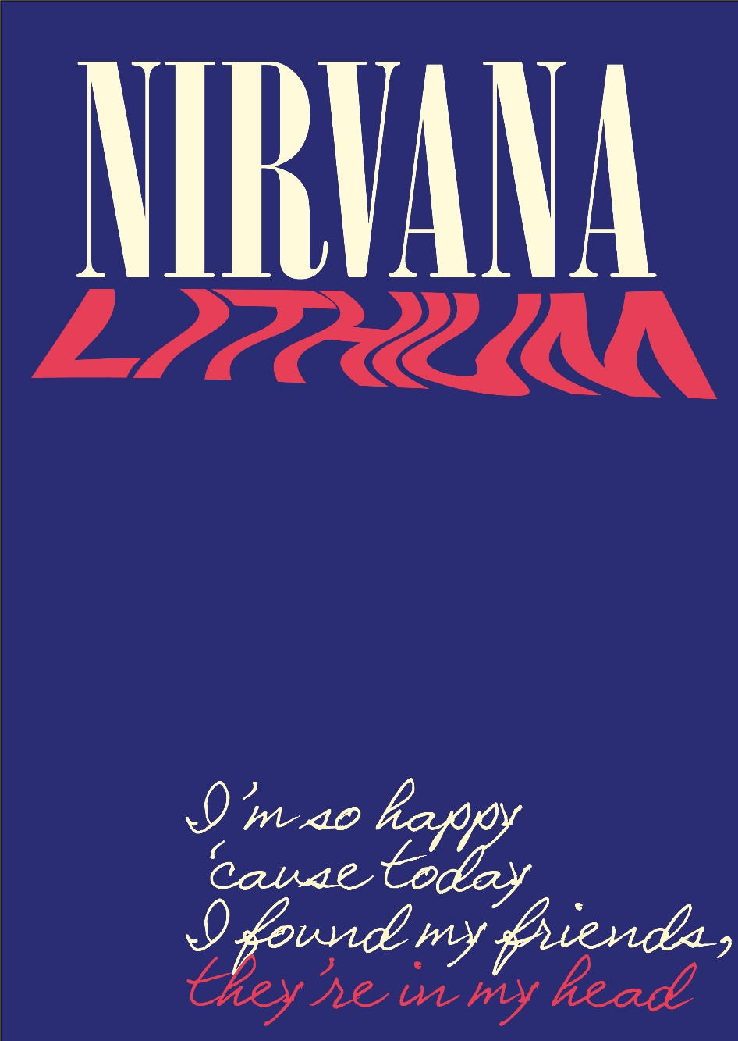
Development
I initially imported a nirvana font to create the logo. Which allowed me to make it any colour I want.
I then added all my text and experimented with different fonts sizes and colours.
For ‘lithium’ I chose a simple sans serif font to contrast against the nirvana logo. Which I then warped and stretched to mimic the font on the nevermind album cover.
I chose complimentary colours which are pleasing to the eye. It was important for “they’re in my head” to stand out so I highlighted it using the same colour I used for ‘lithium’, tying the poster together.
For the most part I wanted to keep it pretty minimal. To me less is most always more.
Everything you see on the image below was done on illustrator. At this stage I felt it was still missing something.
So exported it to procreate on my iPad, where I drew on the logo. I decided to draw It on instead of just importing it from the internet because I had full control of the size without having to worry about it looking pixelated. I used the colour dropper tool to match ‘Nirvana’.
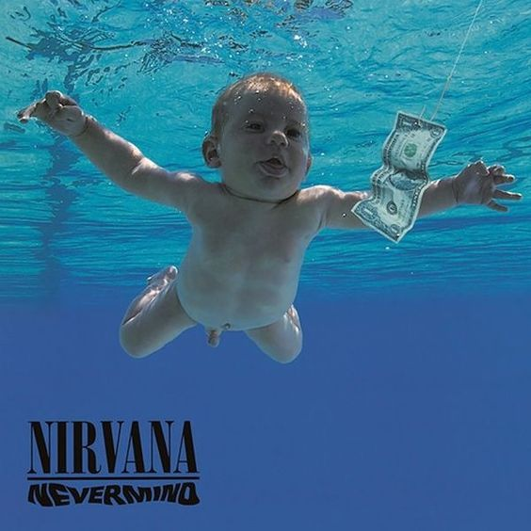
Following this I added texture overlays to mimic an authentic poster. This added grit.
I’m pleased with the final outcome, I have designed a poster that I would actually be happy to put on my wall.

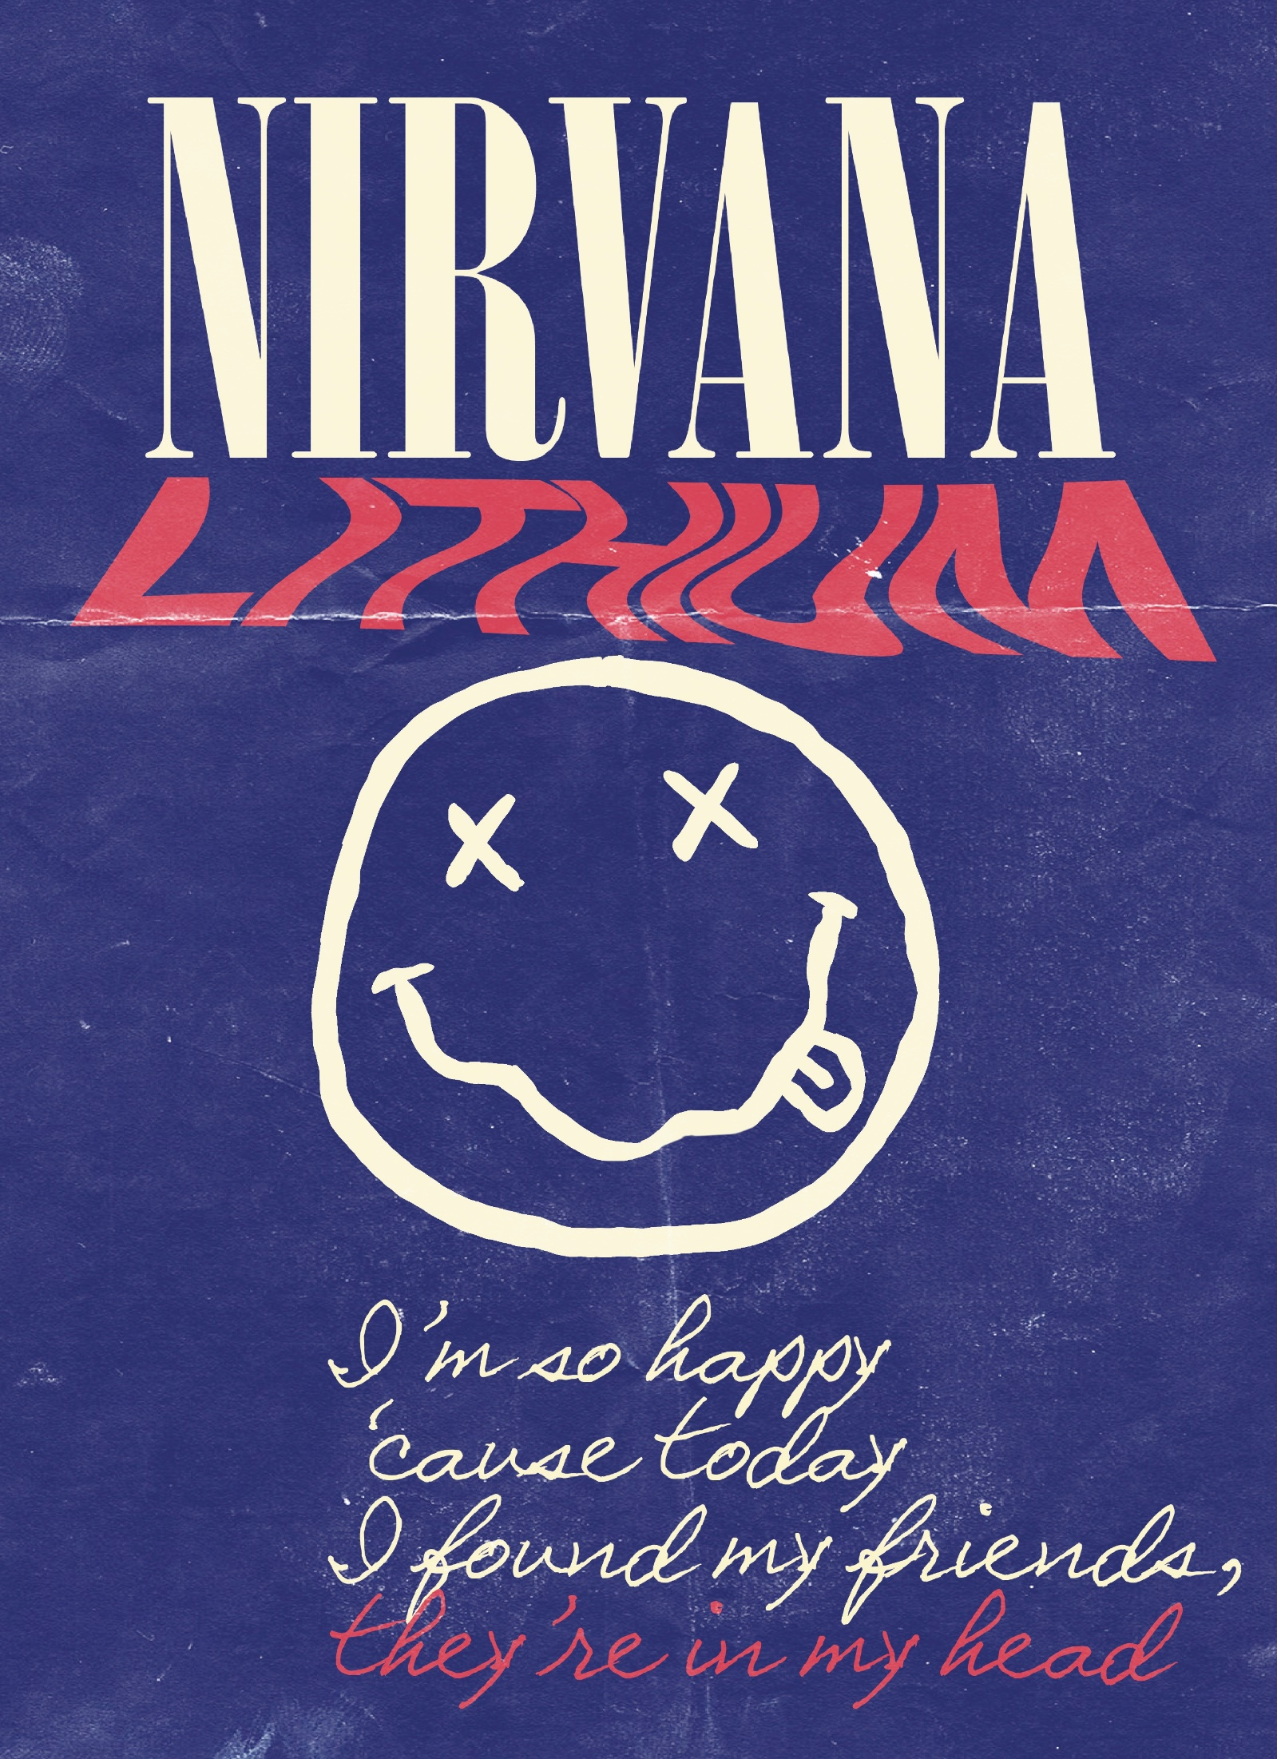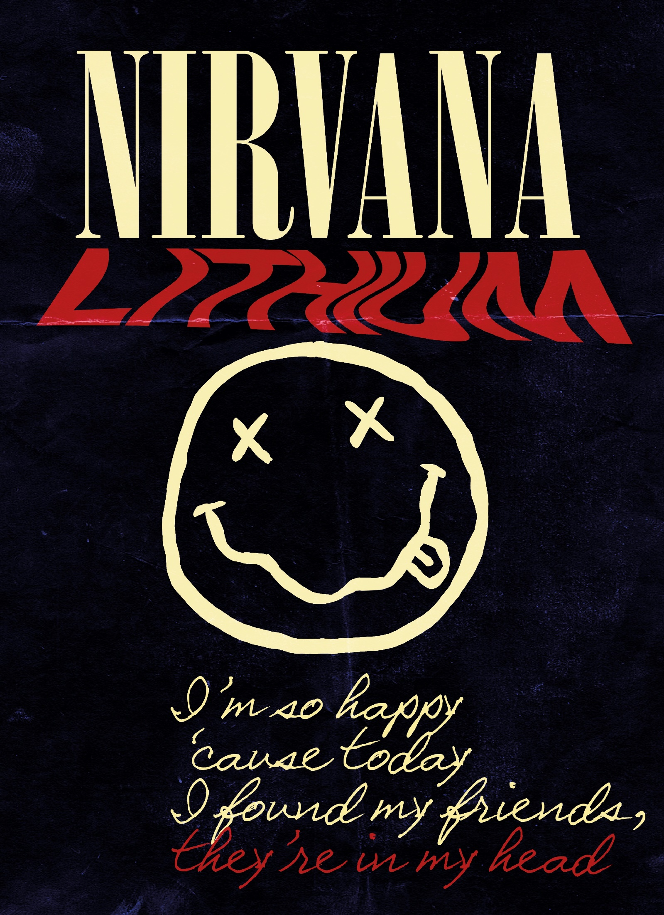
Final version

