AAD011 CASE STUDY TEMPLATE
Student Ava Mooney
Module: Contextual Research and Understanding
Your participation to the module requires that you research the weekly theme to find appropriate information on each topic (theme). Include a relevant artist or designer from the respective topic which may be relevant to your practice.
For each seminar session print out 1 x A4 copy and bring to seminar session. This must also be posted to Blog before the lecture so that it could be discussed in class withing the seminar. You will submit 7 x A4 Case Studies with final presentations in Week 11 and Week 12.
Theme: Gender
Artist / or Designer / or Artefact: Christina Quarles
(please write below a 100-150 word paragraph and attach an image and specify the image content)
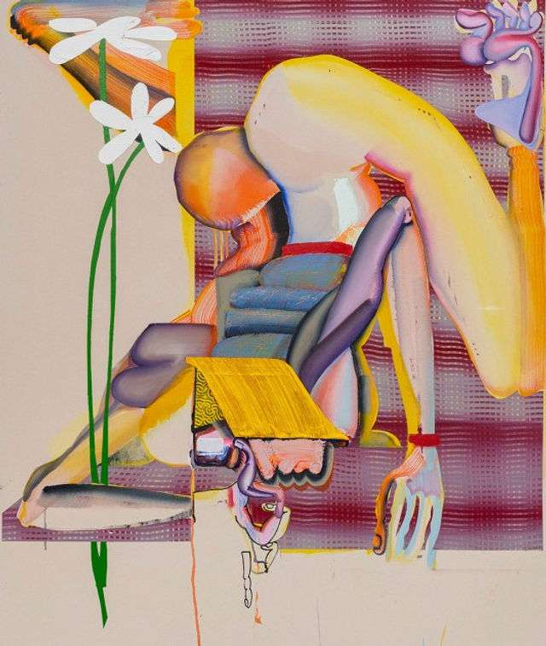
Christina Quarles is a contemporary artist who challenges the orthodox take on gender within her art by exploring the fluidity of gender. As stated by Pophale.N (2020) “Gender fluidity is a spectrum of identities that are not static, neither exclusively male or female that may change over time while rejecting the concept that gender is binary”.
Figure 1 Chrisitina Quarles,2018, Bottoms up
Quarles focuses on the contradictions in one’s own identity and how we all have experienced insecurities about our shape and form. In Quarles work “Bottoms up” you can see how the body depicted can be any gender or even none at all. This is prevalent in a lot of Quarles work as she focuses on the human figure without the attachment of a static gender.
Her work usually poses to initiate introspection as when looking at her work, Pophale(2020) suggests, by just looking at the body language and pose most people will assume a gender. Therefore, her work initiates the question “Why did I think this is a man/woman only by looking at their fingers?” Her portrayal of these figures is demanding attention to gender fluidity and working on “dismantling conventional gender identity” Pophale(2020)

Pophale,N (2020) ”Exploring the fluidity of gender through art” URL: https://www.artfervour.com/exploring-the-fluidity-of-gender-through-art/
https://www.hauserwirth.com/artists/33678-christina-quarles/

