Artist Research

Julien Hübsch
Julien Hübsch is an artist working in Luxembourg and Mainz, taking inspiration from graffiti, vandalism, and constitution sites. Being from the south of Luxembourg Hübsch was surrounded by urban landscapes such as vandalised public spaces and construction sites. Often using materials and found objects found in construction sites such as; tarps, plastic, fabric, brick, concrete, cement, glass, and clay. Using these materials to create works of abstract art.
Hübsch has used the term Post-Vandalism to describe the sculptures and paintings he has created. He states in an interview with Katja Taylor “describe a certain aesthetic of overpainted vandalised walls”.
Hübsch's use of found objects and material makes his works and practice quite sustainable. Using these found tarps, and other materials to create something new and unique, and recycling used materials that would otherwise end up in landfill.
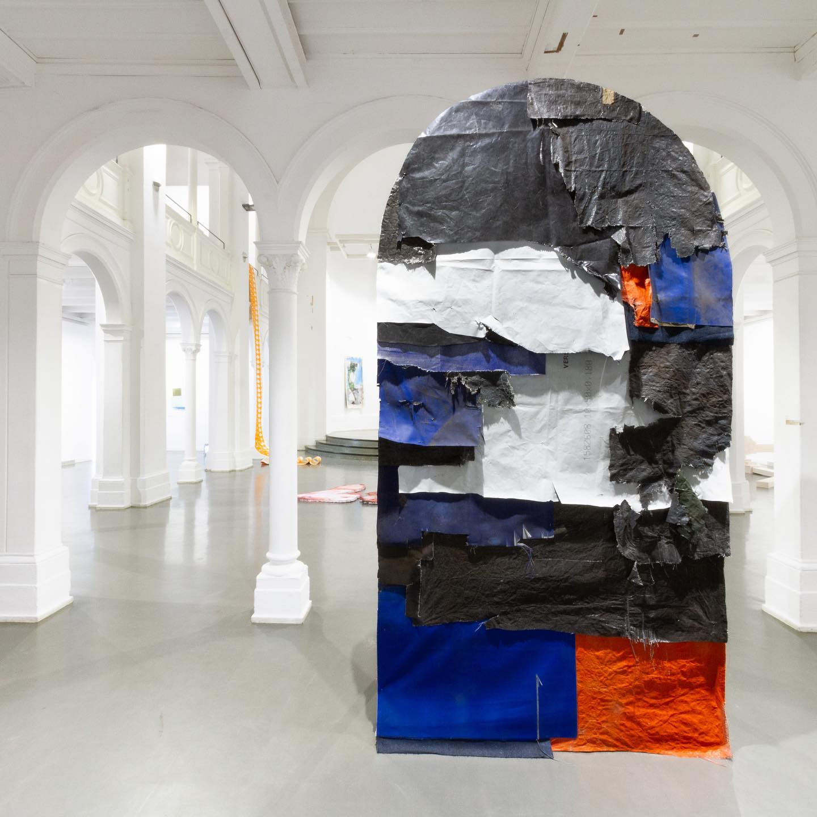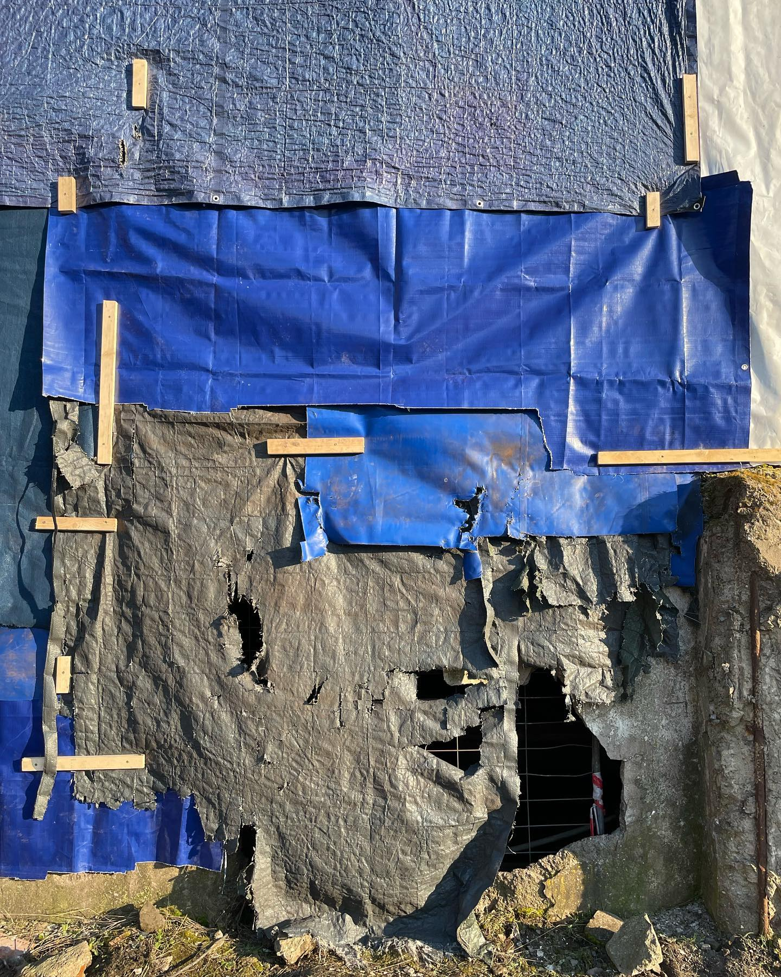
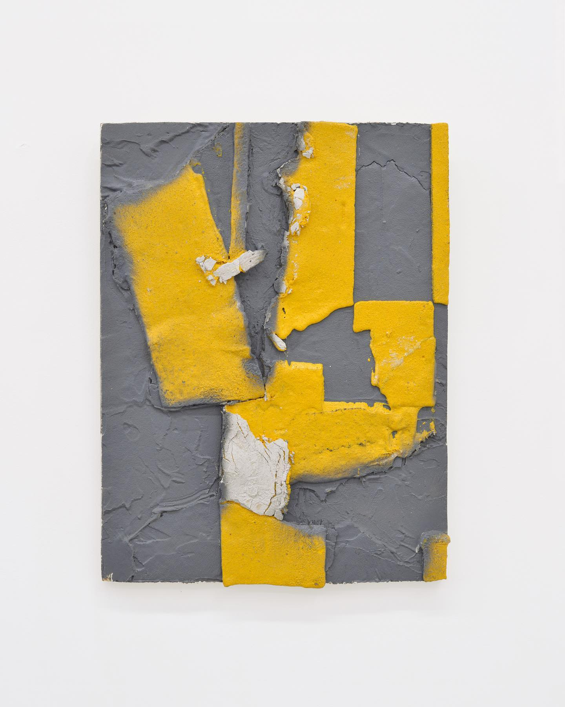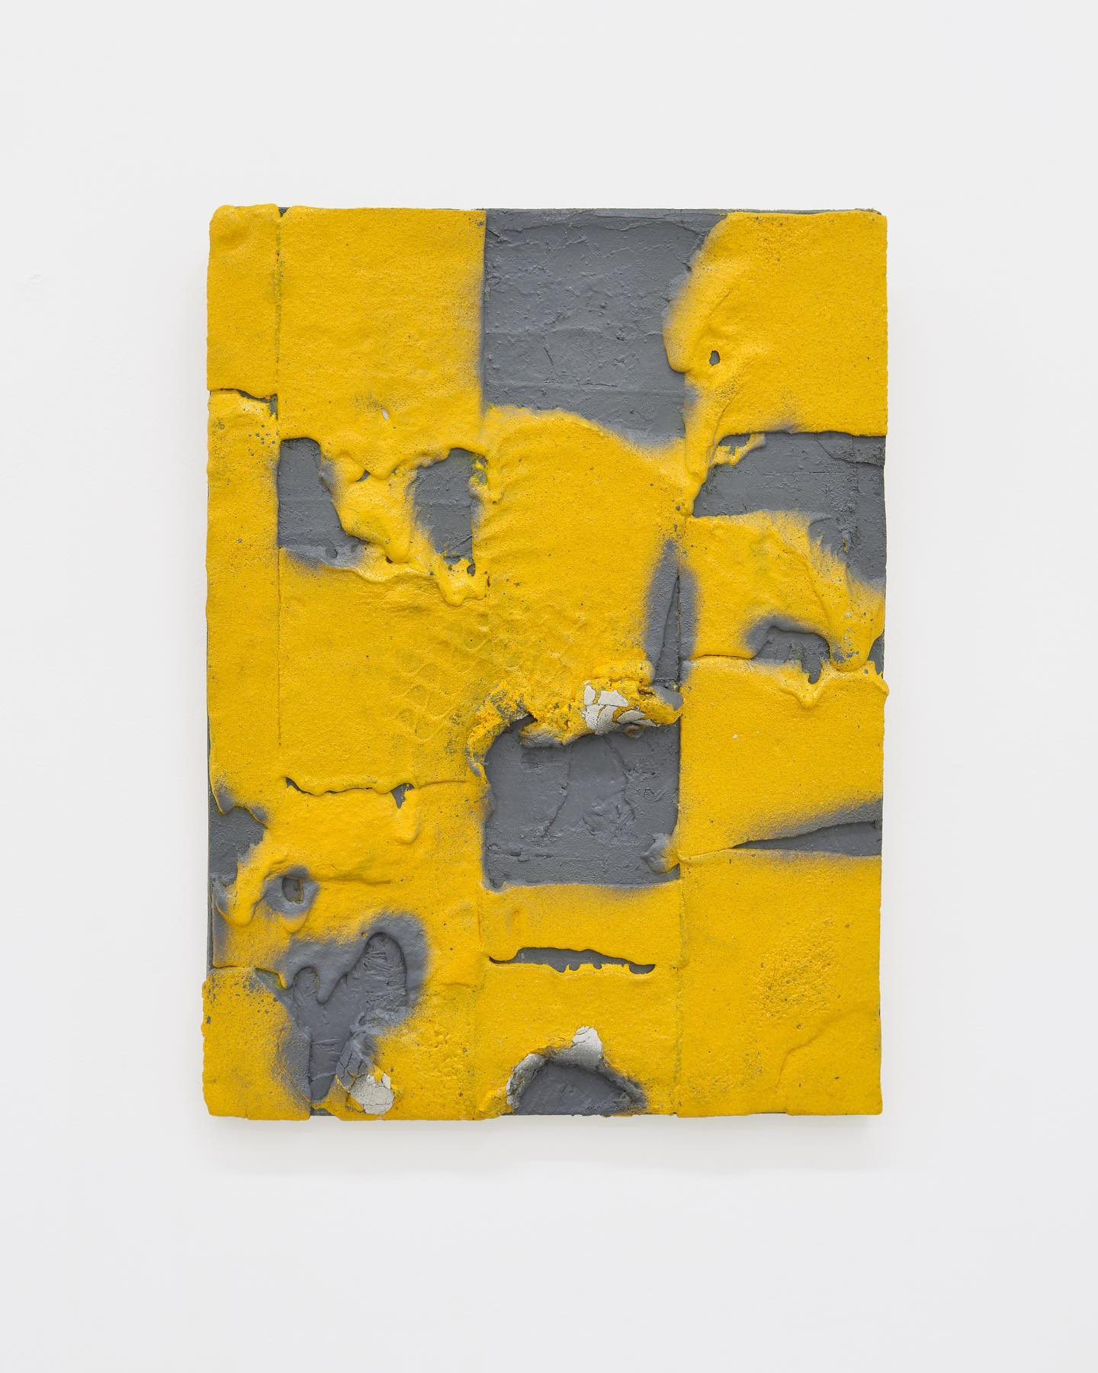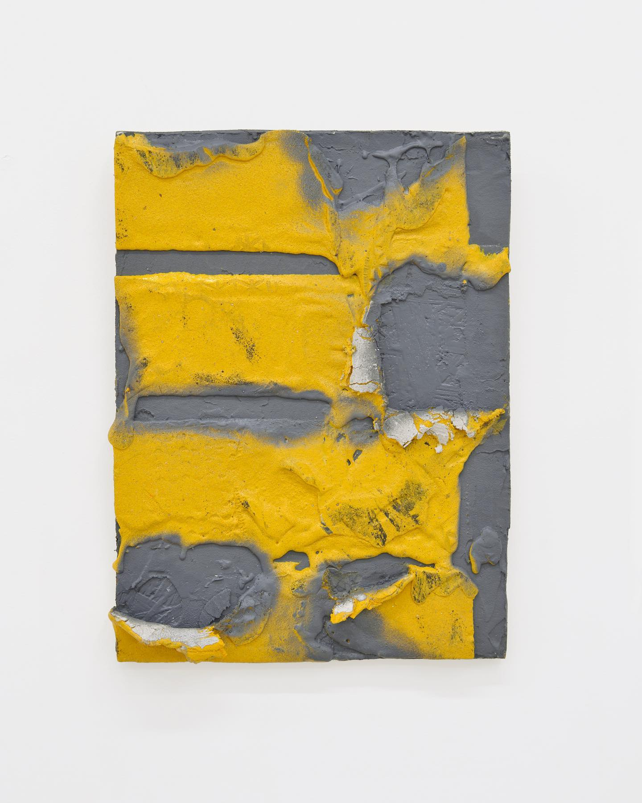
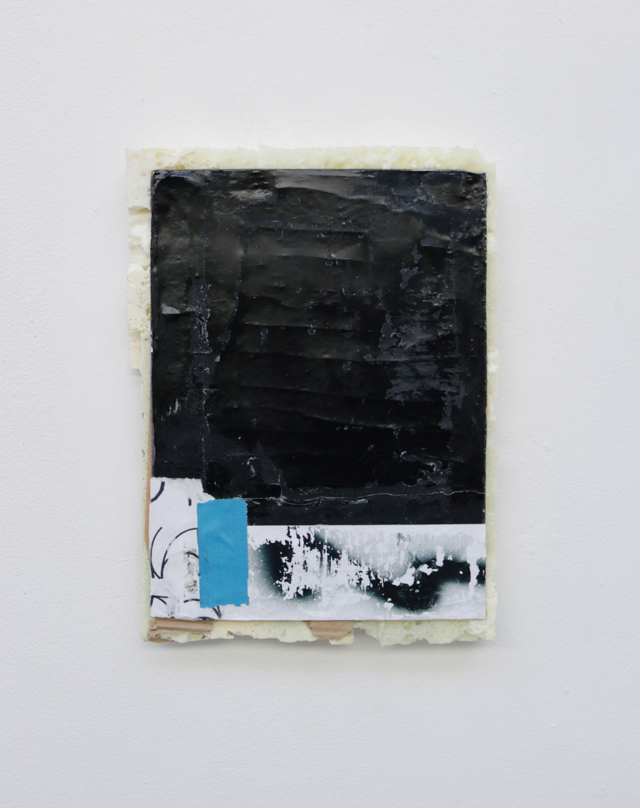
Stephen Burke
Stephen Burke is an Irish artist working in the UK and ireland. He Graduated from the Glasgow School of Art in 2018 with an MA in painting, he has an interest in graffiti and public spaces, often taking inspiration from urban environments.
Burke works on both sculpture and on canvas. Often using found materials within his sculptures such as; anti-climbing fence guards, steel tubes and pipes that have been bent out of shape. Also using spray paint and similar concepts found in urban environments and public spaces, to create works of art meant to blur the lines between fine art and works found in urban environments.
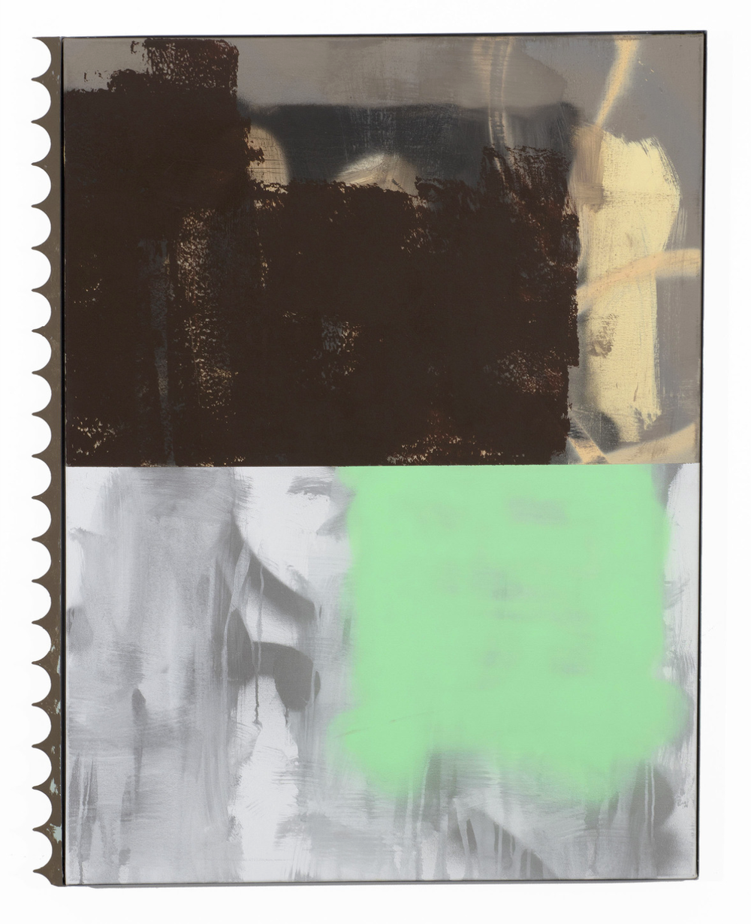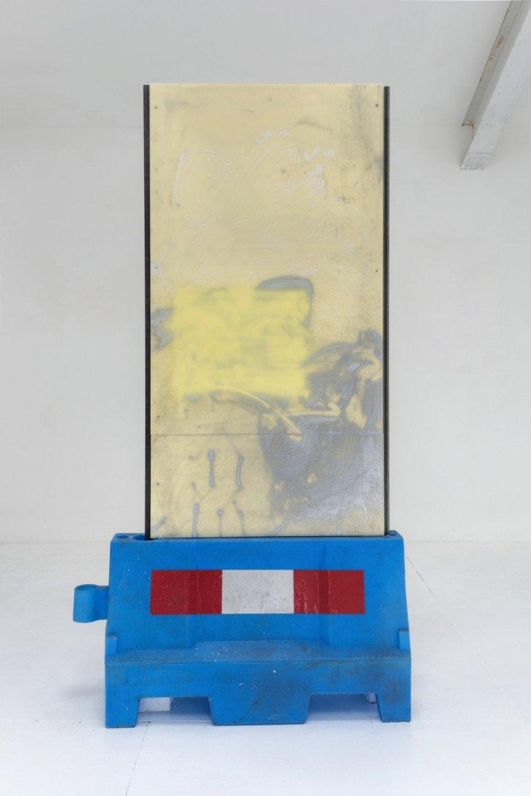
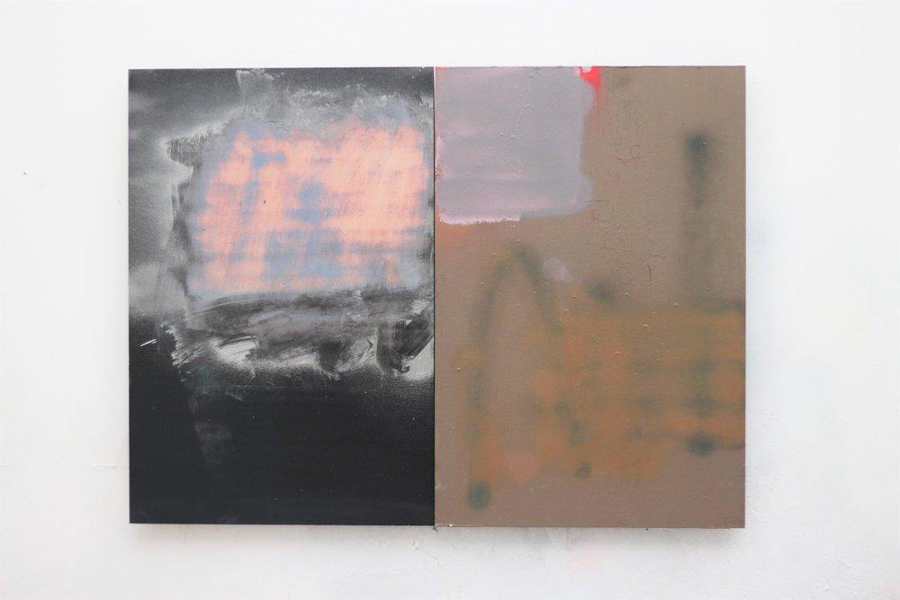
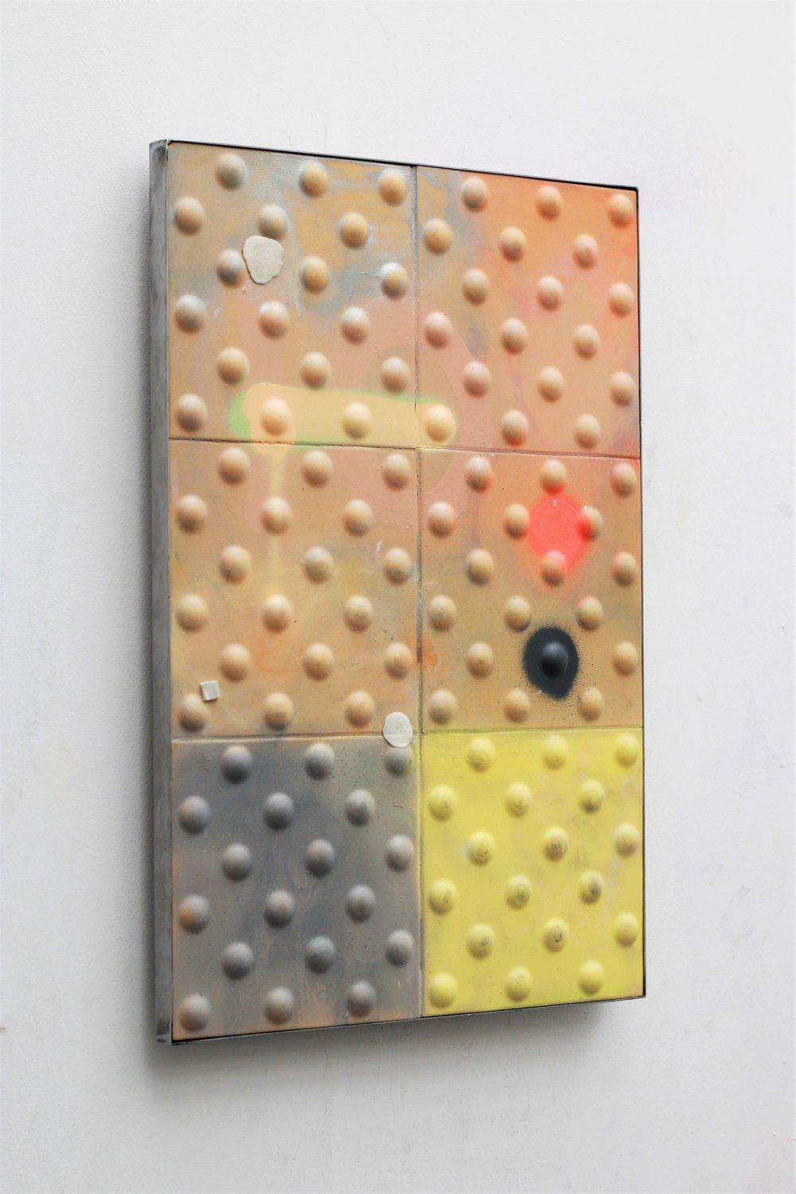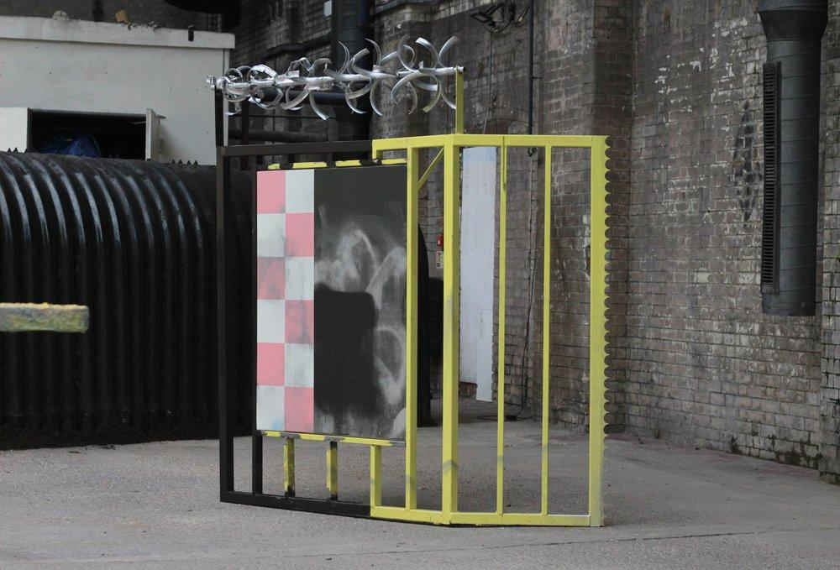

Jean-Michel Basquiat
Jean-Michel Basquiat was an American artist, born the 22 of December 1960 in Brooklyn New York. Basquiat was part of the neo-expressionism movement and gained popularity in the 1980s. Basquiat first began his art career as part of the graffiti dou SAMO. whilst working in the duo Basquiat would begin tagging areas around manhattan, instead of stereotypical graffiti he would paint cryptic messages and poems, they were provocative, edgy and challenging. This style of pushing boundaries and provoking people would become a staple of his work. He would use his background in graffiti to create bright, vibrant, and colourful pieces of work. He would often paint on found objects such as doors, pieces of wood and metal . His work would catch the eye of art curators, who allowed him to use their spare spaces to create his art. After he began to rise in popularity Basquiat would begin to buy better art supplies and more traditional materials to paint on such as canvas. His style and subject matter would remain the same. Using various mark making techniques and incorporating different mediums in his work. Basquiat would layer paint often painting over word, crossing them out and covering up.

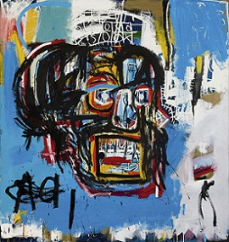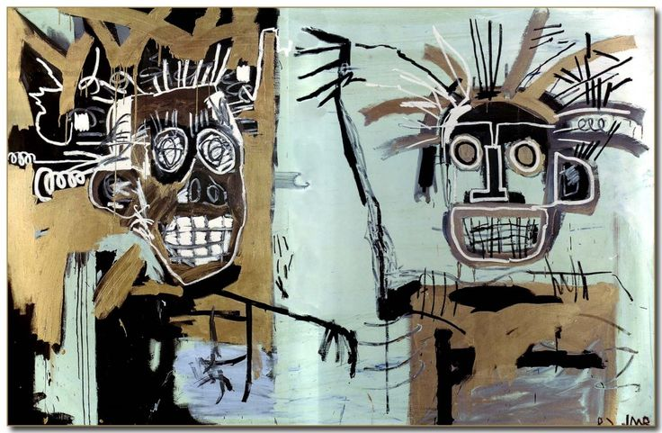
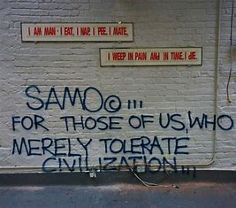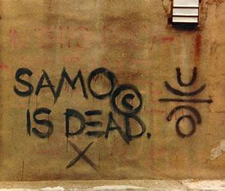

Robert Rauschenberg
Robert Rauschenberg was an American Pop-artist, painter and graphic artist. Born on October 22, 1925. In Port Arthur, Texas. Studying at the Kansas City Art Institute and the Académie Julian in Paris, France. He was known for his mix of paintings and sculpture, and using photography, printmaking, papermaking, silk screening, and performance. He is also known for his Combines. A Combine or combine painting is a style of art that uses elements of both sculpture and painting. Rauschenberg took inspiration from popular culture incorporating things like the moon landing, astronauts, images of American president John. F Kennedy after his assaination, and middle class, blue collar workers. Also taking from places similar to his hometown Port Arthur. .
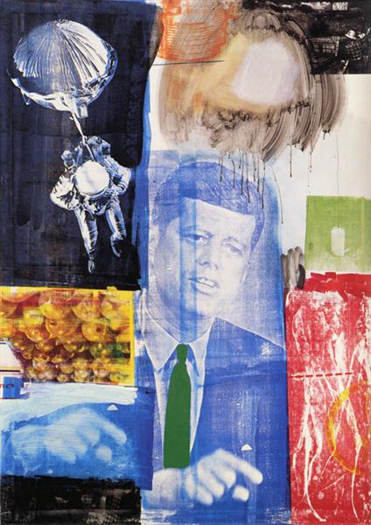
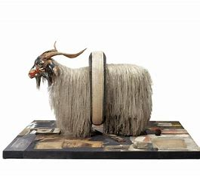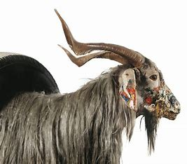

Susan Connolly

