- Alexander McQueen – Fashion Design

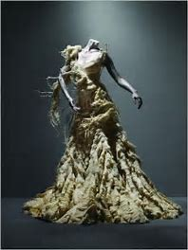

Oyster Dress, Irene Collection, 2003

The oyster dress is one of Alexander McQueen’s best-known pieces and opened the doors to opportunities for other fashion designers in the industry. The dress was made from silky fabric and is a light beige green tone. The Silk Chiffon is layered from the waist down to give the appearance of the dress being formed like a mollusc. The hem of the skirt also emphasises this. The Metropolitan Museum of Art's explains that “unlike Aphrodite, who was born in the foam of the sea and borne to shore on a scallop, McQueen’s beauty is a bruised pearl encased in a deconstructing oyster, the tumbled survivor of the violent action of waves.” In The middle section of the show models are represented wearing much darker and violent gowns. This was to represent the story of survival after facing trauma. The concluding section finally shows models emerge wearing very bold and colourful gowns to give the representation of rebirth. I like the style and meaning of this piece. the creative expression is very evocative even though only one colour and fabric was used. the way the fabric was carefully layered and teared up and the pale seashell colours that were used made the piece stand out as it created a sense of mystery and distress which spiked curiosity about the meaning/backstory behind it.

- Christopher David White – Ceramics

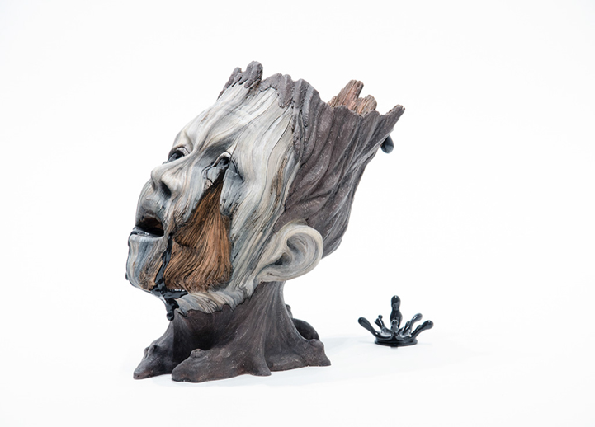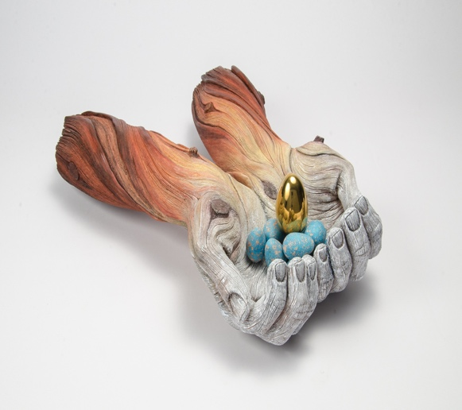
Asphyxia, 2013 Don’t Care How, 2017

Christopher’s artworks are handmade from clay and rendered with acute attention to detail which often gives the appearance of decaying pieces of wood, rusted metal and other objects in stages of deterioration. These works explore the relationship between humanity and nature and how both are in a constant state between growth and decay. I like these two pieces of his as I found them intriguing. The one on the right shows a head that resembles a fragmented tree. The head is mostly dull grey tones with a fragmented section of the face which reveals a brown colour. There could be multiple meanings behind this piece. Due to the black liquid dripping out of the mouth and head along with the lifeless expression I interpret the meaning as a representation of the harmful things that people consume or involve themselves with in today’s world that are breaking us apart or causing us to lose our true selves, leaving the feeling of being helpless or drained of life. I think because the title of the piece is called asphyxia the piece could also be a representation of dying or suffering from illness, whether it be physical illness or mental illness causing the person to be asphyxiated, struggling to breathe, and desperately gasping for air. The piece on the left shows a pair of arms which are holding several eggs. smaller blue eggs on the bottom and a bigger golden egg on top. The colours impact the meaning behind this piece through the end of the arms being a warm brown colouration compared to the hands which are a light grey tone. From my point of view, I see this as a representation of humanity neglecting or destroying nature as the hands are grey showing we are not bringing life or warmth to the eggs even though we have the capability to do so. I like the colour contrast of the blue and warm brown and orange tones this creates an interesting effect. From my perspective the eggs are blue to show feelings of sadness and despair and to show the lack of warmth. there is only one bigger golden egg as it is the only egg that is not being touched by humanity.

- Hanna Hedman - Metal/Jewellery

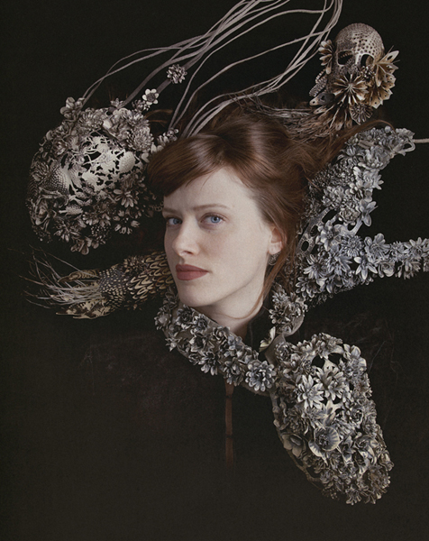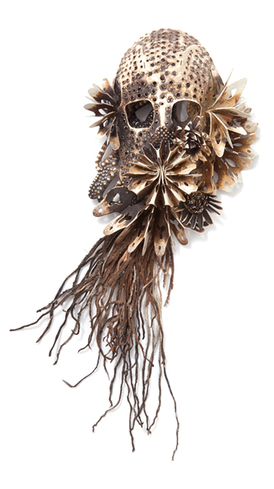

Black Bile, 2013, photos: Sanna Lindberg

Hanna Hedman is a jewellery artist who was born in 1980 in Stockholm Sweden. She works with jewellery mainly to explore the relationship it has directly with the body. She wants her jewellery to be timeless and challenging to categorise to a specific era. The talismanic items and memento mori she has seen in books and museums inspired her work. The meaning of her work is related to the saying that beauty dies when it reaches perfection. The idea is romantic, but can also be frightening, like the feeling of emptiness after seeing something incredibly beautiful. To convey this, she has used conventional symbols such as skulls and flowers to convey beauty and death. Her work often has dark and melancholic themes surrounding them she explains when you first look at her work you see beauty, but upon closer look, a shallow surface can be perceived, also something else that is startling and strange. I like that her work has hidden layers to it, and she tends to hide the scarier and unusual objects which creates a surprise for the viewers making it more intriguing.

Word count - 761

References

David White, Christopher. “Don’t Care How.” Www.christopherdavidwhite.com , 2017, www.christopherdavidwhite.com/index.php/en/portfolios/sculpture/11-portfolio/sculpture/179-dontcare.
Accessed 18 Dec. 2022.

Ebert, Grace. “Hyperrealistic Ceramic Sculptures by Christopher David White Mimic the Splintered Texture of Decaying Wood.” Colossal, 16 Dec. 2021, www.thisiscolossal.com/2021/12/christopher-david-white-sculptures/.
Accessed 18 Dec. 2022.

Forum, Art Jewelry. “Hanna Hedman: Black Bile.” Art Jewelry Forum, 9 Mar. 2013, https://artjewelryforum.org/articles/hanna-hedman-black-bile-2/.
Accessed 19 Dec. 2022.

“Hanna Hedman - Artists - Ornamentum Gallery, Contemporary Jewelry.” Www.ornamentumgallery.com , 2022, www.ornamentumgallery.com/artists/hanna-hedman.
Accessed 19 Dec. 2022.

Kalonaros, Vassiliki. “2003 – Alexander McQueen, Oyster Dress | Fashion History Timeline.” https://Fashionhistory.fitnyc.edu , 7 July 2021, https://fashionhistory.fitnyc.edu/2003-mcqueen-oyster/.
Accessed 17 Dec. 2022.

Menkes, Suzy. “Alexander McQueen in All His Dark Glory.” The New York Times, 2 May 2011, www.nytimes.com/2011/05/03/fashion/03iht-FMET03.html.
Accessed 17 Dec. 2022.

“Stunning Ceramic Sculptures by Christopher David White.” The Awesome Daily - Your Daily Dose of Awesome, 10 Dec. 2016, https://theawesomedaily.com/stunning-ceramic-sculptures-by-christopher-david-white/.
Accessed 18 Dec. 2022.

Super User. “About.” Christopherdavidwhite.com, 2012, www.christopherdavidwhite.com/index.php/en/about.
Accessed 17 Dec. 2022.
‌

