- M.C Escher – Printmaking

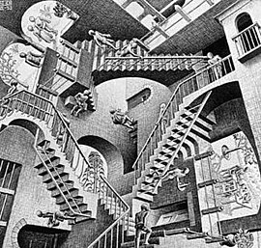

Relativity (1953)

Relativity is a lithograph, firstly printed in 1953 by Dutch artist M.C Escher. The piece presents a picture of a world where the usual laws of gravity do not apply. The piece shows a series of staircases displayed in a labyrinth-like interior. The stairs meet each other through impossible angles. The three main staircases create an impossible shape called a “Penrose Triangle.” The meaning of this piece could reflect Escher’s discomfort with socialising through the lack of interaction as although several people are shown in the piece, they all face different directions, indulging in their own worlds. The facial expressions appear as blank or indifferent as if they are uninterested or aware of the other people’s presence. This could be a representation of our lives, showing how we are consumed with our own habits that we sometimes ignore or forget what is going on around us.

- Henri Rousseau – Painting
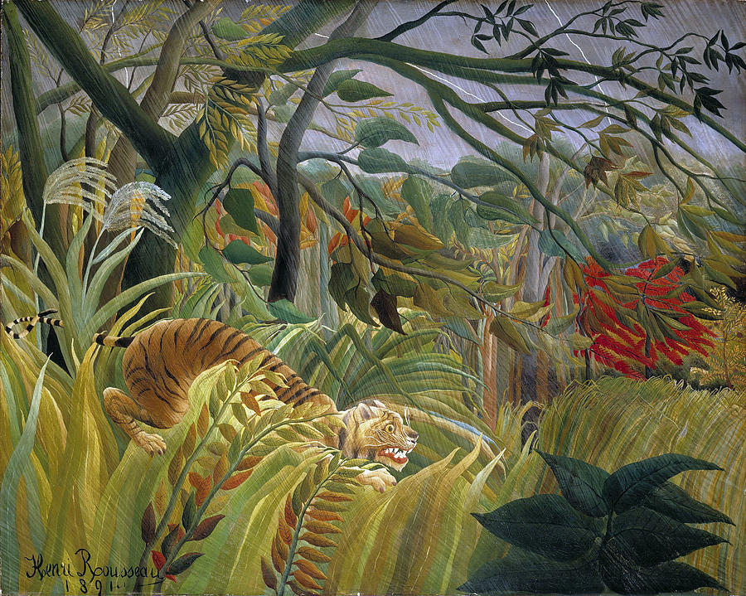

Tiger In a Tropical Storm, (1891)

This painting shows a hungry tiger in a tropical storm, in a position that appears as though it is about to attack its prey. Henri Rousseau never left France during his lifetime, so he had no experience with this environment, so the idea came from his imagination, although he did take inspiration by looking at the plants and flowers in the botanical gardens of Paris, where he visited many times during that time. The painting looks simple at first glance but on further inspection there are a variety of features and techniques that make up the piece. Henri used a unique technique for the rain where he filled the entire composition with very thin strokes of silver paint. This gave the painting more depth and a mystical quality to it. I think because he had no experience with the environment the painting has a more surreal or imaginary appearance, which I think made it more unique and interesting. I like the variety of tones that are in this painting between the dark shadows shown in the nearby trees compared to the light rain strokes with the flashing lightning in the sky. I also like the colour palette that was used as they complement each other well in this painting.

- Lisa Brice – Painting

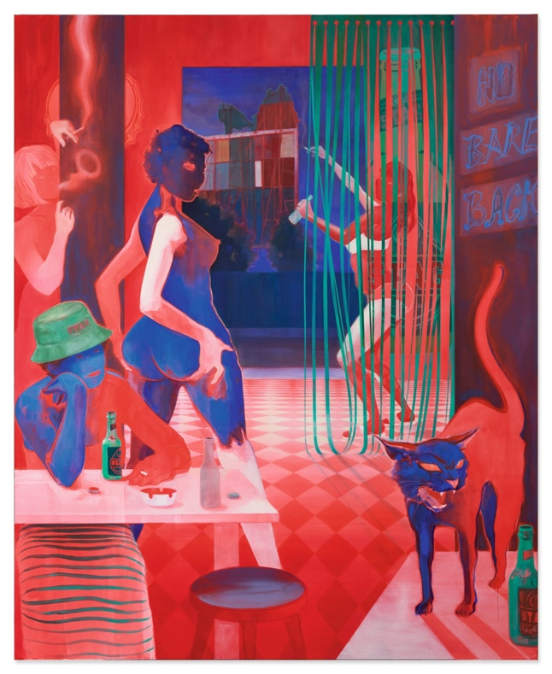
No Bare Back, After Embah, (2017)

Lisa Brice’s paintings often show women either alone or in groups socialising with one another in a puzzling studio setting. She captures the women in a way that shows them in a private world doing everyday activities, she does this to help reverse the usual passive female figures usually painted by men. She investigates ideas of inception and the feminine form. This is seen in the concealment of the figure’s natural skin tones and instead replaced with frequent use of cobalt blue and vermillion. This colour creates a sense of distance from the scene’s intimacy and interrupts any obvious readings of the model's ethnicity. The female figures appear as introspective but not passive as they are indulged by their own desires rather than those of the viewer, whether they are completely unaware or staring directly at the viewers, for example behind the striking red door where one model stays hidden but is in an accusatory stance and is glaring intensely at the viewers. Mirrors and windows are shown in a lot of her painting’s which give them an overwhelming sense of depth and space. Red tones appear light further away but drastically get darker towards the front, which I think creates the illusion of the elongated space in the room, as if they are in a different world, giving the painting a dreamlike quality to it.

- Pipilotti Rist – Installation with video art

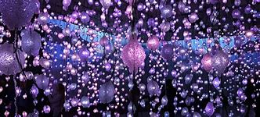
Pixel Forest (2016)

Pixel Forest is a hanging LED installation and media player. Two videos are displayed on the walls “Mercy Garden” and “Worry Will Vanish Horizon” which were made in 2014. This exhibition includes work that goes back from the beginning of her career to now, including videos she made in the 1980’s, exploring the representation of the female body in popular culture including “I’m not the girl who misses much”, to recent video installations that transform architectural spaces into dreamlike environments enhanced by hypnotic musical scores. It is a journey into the various kinds of intimacy with us, with others and with nature. Flowers, myriad plants, and naked bodies are shown underwater, remarkably close amid kaleidoscopic colours. The exhibition also reveals connections between the development of her art and the evolution of contemporary technologies.

Word Count – 737

Reference list

Bradley, A.T. (2022). Tiger in a Tropical Storm by Henri Rousseau - Top 8 Facts. [online] Art Facts. Available at: https://art-facts.com/tiger-in-a-tropical-storm-henri-rousseau/ [Accessed 19 Dec. 2022].

Brooks, K. (2018). M.C. Escher’s ‘Relativity.’ [online] BYU Museum of Art. Available at: https://moa.byu.edu/m-c-eschers-relativity/
[Accessed 5 Dec. 2022].

Channel, L. (2021). Get inside the colourful mind of visual artist Pipilotti Rist | Louisiana Channel. [online] www.youtube.com. Available at: http://www.youtube.com/watch?v=k1vZgXYioTs
[Accessed 19 Dec. 2022].

Contributors to Wikimedia projects (2004). print by M. C. Escher. [online] Wikipedia.org. Available at: https://en.m.wikipedia.org/wiki/Relativity_(M._C._Escher)
[Accessed 5 Dec. 2022].

Cowan, K. (2018). Lisa Brice at Tate Britain explores the art-historical tradition of the female nude. [online] Creative Boom. Available at: https://www.creativeboom.com/news/lisa-brice-at-tate-britain-explores-the-art-historical-tradition-of-the-female-nude/
[Accessed 20 Dec. 2022].

Digicult, R. (2016). Pipilotti Rist: Pixel Forest • Digicult | Digital Art, Design and Culture. [online] Digicult | Digital Art, Design and Culture. Available at: http://digicult.it/it/art/pipilotti-rist-pixel-forest/
[Accessed 19 Dec. 2022].

Fine Art America. (2020). Tiger in a Tropical Storm by Long Shot. [online] Available at: https://fineartamerica.com/featured/tiger-in-a-tropical-storm-long-shot.html
[Accessed 7 Dec. 2022].

Rufus89 (2012). The Artwork of MC Escher. [online] Owlcation. Available at: https://owlcation.com/humanities/The-Artwork-of-MC-Escher
[Accessed 5 Dec. 2022].

Smith, R. (2016). ‘Pipilotti Rist: Pixel Forest,’ Deep in the Wilds of Video. The New York Times. [online] 27 Oct. Available at: https://www.nytimes.com/2016/10/28/arts/design/pipilotti-rist-pixel-forest-deep-in-the-wilds-of-video.html
[Accessed 19 Dec. 2022].

Stephen Friedman Gallery. (2019). Lisa Brice. [online] Available at: https://www.stephenfriedman.com/exhibitions/15-lisa-brice/
[Accessed 19 Dec. 2022].

www.newmuseum.org. (2017). Pipilotti Rist: Pixel Forest. [online] Available at: https://www.newmuseum.org/exhibitions/view/pipilotti-rist-pixel-forest
[Accessed 19 Dec. 2022].

Xu, D. (2021). The Hidden Emotions in M.C. Escher’s Artwork - Illustration History. [online] www.illustrationhistory.org. Available at: https://www.illustrationhistory.org/essays/the-hidden-emotions-in-m.c-eschers-artwork [Accessed 5 Dec. 2022].

