- April Greiman – Graphic Design
April Greiman is a well-known American contemporary graphic designer. According to North Carolina State University (2022) She is recognized for popularizing the “New wave” design movement in the US. Greiman is the head of the Los Angeles based design firm Made in Space. Her groundbreaking concepts and transmedia endeavors have captivated audiences worldwide. She is credited as being one of the first designers to realize the possibilities of using computers as a design tool. Greiman supported the idea of digitization in the 1970’s when other designers were fearful that the development of computer technology might undermine the international style. She saw the technology's potential benefits rather than being repulsed by it. I picked this piece as I thought it looked remarkably interesting and I was intrigued to find out about it. According to North Carolina State University (2022) the piece features a digitized version of her nude body, overlaid with a series of images and text. On the bottom “colourful atmospheric spatial video imagery is mixed with thoughtful commentary and careful references to digital processes, a virtual landscape of text and images.

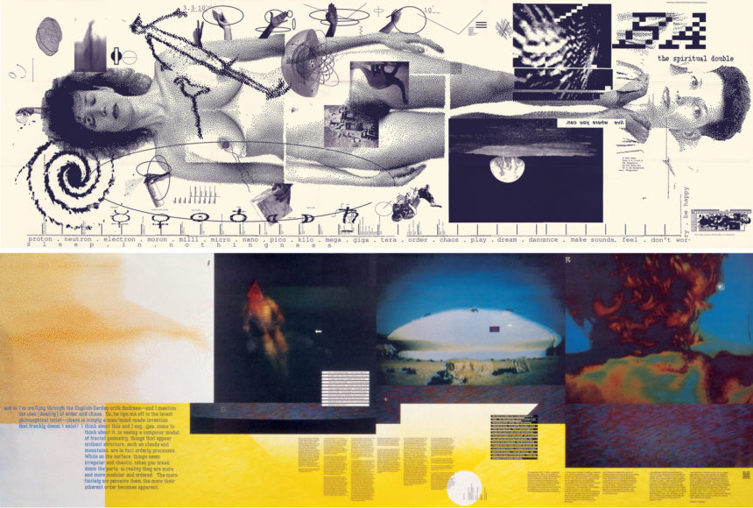
April Greiman, “Does It Make Sense?” Poster, 1986

- Quentin Blake – Illustration
According to Britannica Kids (2022) Quentin Blake is a British children’s book illustrator and author and is best known for illustrating books written by Author Roald Dahl. They both have
worked together on many children’s books including Matilda and the BFG which are the two illustrations down below. There are various distinctive elements in Quentin Blake’s artwork. He utilizes watercolors over ink to add colour to the illustrations, which are often produced in black ink. This works well as it gives the illustrations more depth and emotion to them. His art style is eccentric and peculiar. The line techniques in his drawings appear loose and sometimes messy which I think gives the illustrations a more characteristic look to them. According to Authors Caitlin Stephens and Lara Jarvis from the website Study (2022) Some characters features are very exaggerated to show the characters' personalities or emotions for example with Miss Trunchbull, the villain in Matilda who is drawn as large and intimidating with a big nose, angry expression, strong muscles, and her hair tied up in a tight bun to make her appear as strict and scary.
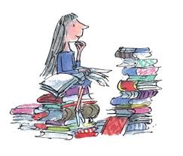
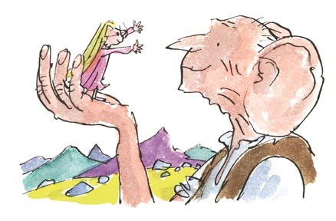
Quentin Blake,
Matilda, 1988,
The BFG and Sophie, 2012

- Bud Luckey – Animation

According to Ranker (2019) Bud Luckey is an animator, cartoonist, singer, musician, designer, composer, artist, and voice actor; however, he is best known for his animation work at Pixar. He was the fifth animator hired at Pixar and created characters for several animated films, such as Toy Story, Toy Story 2, Boundin, A Bug’s Life, Monster’s Inc., Finding Nemo, Cars, and Ratatouille. According to Disney Wiki (2022) His most famous work includes the creation of Woody from Toy Story. The short film “Boundin” According to WikiWand (2022) was additionally written, directed, and narrated by Luckey. The movie tells the tale of a dancing sheep who loses his self-confidence after being sheared. He meets a kind jackalope who teaches him the benefits of “bounding.”
Bud Luckey, “Boundin” short film, Pixar, (2003)

- Shigeru Miyamoto – Game Design
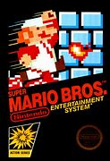
According to Nintendo Wiki (2022) Shigeru Miyamoto is a video game director, producer, artist, designer, and general manager at Nintendo. He is credited in several titles including Donkey Kong, Mario, The Legend of Zelda, Star Fox, Pikman, Wave Race, Exitebite, Stunt Race FX, Pilotwings and Nintendogs which are just a few of the many series he developed. Acoording to CNBC Make It (2021) Shigeru Miyamoto first created the Mario character for the 1981 arcade game” Donkey Kong” where a carpenter must rescue his girlfriend from a giant ape who was Mario’s pet. Mario became a plumber four years later, when it was decided that Mario’s profession should match the green pipes and sewer settings of the Mario Bro’s franchise. According to IGN (2012) Mario was given his name to honour Mario Segali, who ran the original warehouse. The first video game with Mario as the protagonist was Mario Bro’s. Luigi made his debut in this game and played a major role in popularising the game.

Shigeru Miyamoto, Mario Bro’s, Arcade Game, Nintendo, 1983

Word Count – 670

References

https://go.distance.ncsu.edu/gd203/?p=27858
Author - Christine Dill (04/04/2019)
Date accessed (28/10/2022)

https://www.quentinblake.com/gallery/category/illustration
Date accessed (28/10/2022)

https://kids.britannica.com/students/article/Quentin-Blake/600672 (2022)
Date accessed (28/10/2022)

https://study.com/learn/lesson/quentin-blake-illustrations-matilda.html (2022) authors - Caitlin Stephens and Lara Jarvis
Date accessed (28/10/2022)

https://ew.com/movies/2018/02/26/bud-luckey-toy-story-woody-animator-dies/ (2018)

Date accessed (30/10/2022)

https://www.ranker.com/list/notable-animator_s)/reference (2019)
Date accessed (30/10/2022)

https://en.m.wikipedia.org/wiki/Bud_Luckey (2022)
Date accessed (30/10/2022)

https://disney.fandom.com/wiki/Bud_Luckey
Date accessed (30/10/2022)

https://www.hollywoodreporter.com/news/general-news/bud-luckey-dead-oscar-nominated-animator-who-designed-woody-toy-story-was-83-1088229/amp/ (2018) Author – Rhett Bartlett
Date accessed (30/10/2022)
https://www.wikiwand.com/en/Boundin%27
Date accessed (30/10/2022)
https://nintendo.fandom.com/wiki/Shigeru_Miyamoto
Date accessed (01/11/2022)
https://www.cnbc.com/amp/2018/09/13/super-mario-bros-how-shigeru-miyamoto-created-mario-for-nintendo.html (2021)
Date accessed (01/11/2022)
The History of Mario - IGN (2012)
Date accessed (01/11/2022)

