SUSTAINABILITY
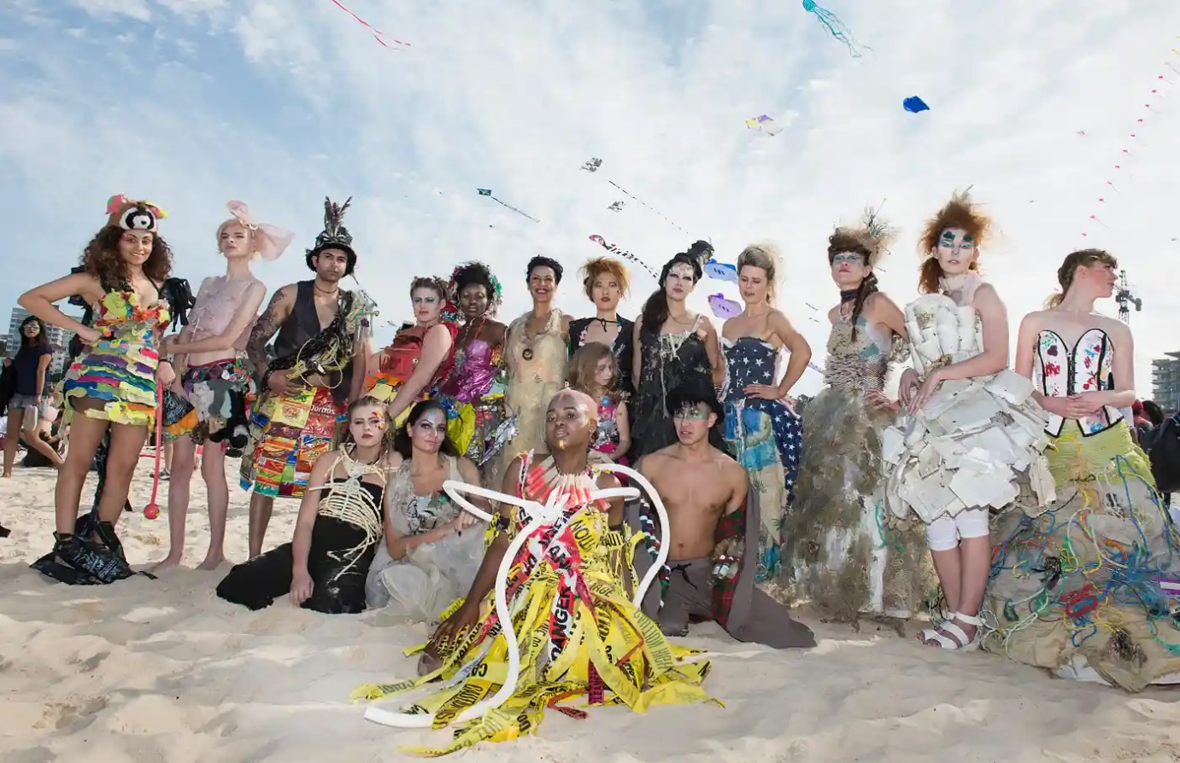
Fig 1. Models wearing the work of Marina DeBris

The Sydney based designer known as Marina Debris is known for her sustainable work within fashion. The artist creates beautifully intricate garments using rubbish and debris washed up on the sands or found within the ocean. Figure one (above) shows her work adorned by models at the ‘Festival of the Winds’ held on Bondi beach. Her work is created with the hope of bringing awareness to how heavily our seas are polluted with waste. She makes incredible uses of these waste products and transforms them into high fashion looks with important messages behind each one. The outfit worn by the model in the centre of the image about is known as ‘Cuidado’. In Spanish thus means be careful – a nod to the use of the masses of caution tape found within Los Angeles beaches.

The Guardian [online]. (2023). Available from: <https://www.theguardian.com/artanddesign/gallery/2016/sep/13/trashion-designer-marina-debris-turns-ocean-rubbish-into-high-end-outfits-in-pictures>. [Accessed 09/05/23].
Eluxe Magazine [online]. (2022). Available from: <https://eluxemagazine.com/culture/articles/eco-friendly-artists/?utm_content=cmp-true>. [Accessed 09/05/23].

