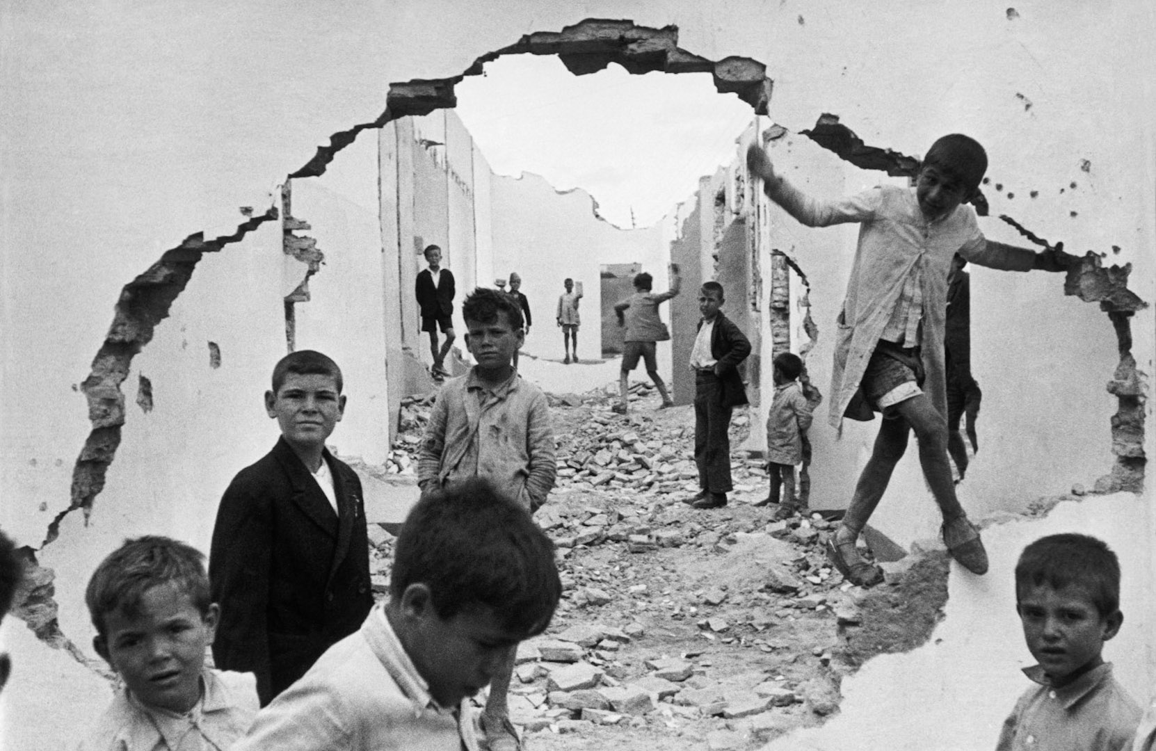
PLACE
Fig 1. Photography by Henri Cartier-Bresson. Taken in Seville, Spain. 1993.

Henri Cartier-Bresson was a French photographer who is most famous for his street photography he took on his travels during the second World War. During his lifetime, he turned his interest towards film making and photography, and ended up being chosen as a photographer for the French Military. Over the years, he spent time documenting France and neighbouring countries through their occupation. His worked showed the effect the war took on not only the people, but the places themselves. We can see this in the above photo, which depicts children playing amongst ruins. His work is moving and highly atmospheric due to the depth of each photo her took.

Another Mag [online]. (2023). Available from: <https://www.anothermag.com/art-photography/gallery/1066/henri-cartier-bresson/0>. [Accessed 09/05/23].
Shot Kit [online]. (2023). Available from: <https://shotkit.com/famous-street-photographers/>. [Accessed 09/05/23].

