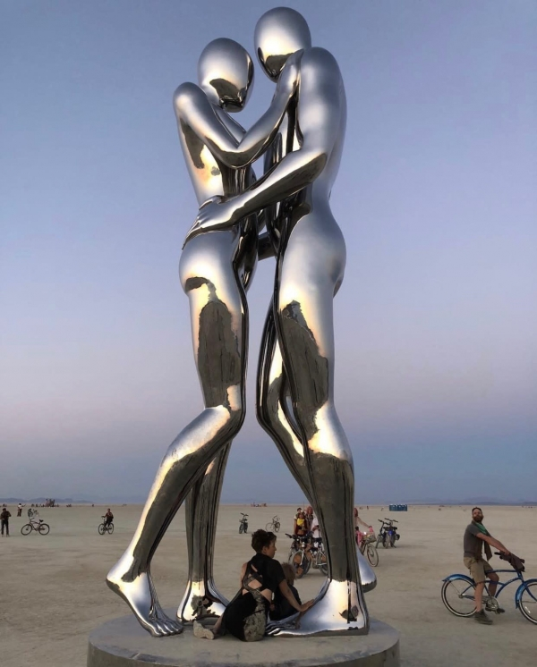
INNOVATION

Fig 1. ‘In Every Lifetime I Will Find You’. Michael Benisty. 2018.

The above work by Michael Benisty is a true reflection of innovation in the art world. With the ever-growing creation digital artwork, Benisty’s steel sculptural work shows the possibilities of how the digital design world and sculptural art can meet. It is a perfect example of creating a piece of physical work that almost pushes the boundaries of what sculptural art looks like in the modern day, with this almost CGI inspired, figure-based piece. The intentional use of a mirror like shine to the metal, combined with the intentional placement of the work on this serene beach, allows for viewers of the piece in person and through photography, to experience how the work interacts with the setting, giving it an ethereal and dreamy feel.
Electric Artefacts [online]. (2021). Available from: <https://www.electricartefacts.art/news/15-innovative-artists-shaking-up-the-digital-art-world>. [Accessed 09/05/23].

