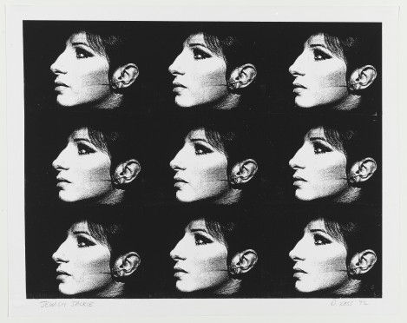
IDENTITY
Fig.1. Debrorah Kass’s work ‘Jewish Jackie’. 1992.

Artist Deborah Kass created the above piece that helped her see reflection of her own identity within the art world. As a born Jewish American, the artist struggled with not seeing people like her reflected in media, film, music etc. Growing up, she found solace in seeing the face of Barbara Streisand. Her features resonated with her and made her feel more seen and appreciated by society due to the love and adoration the actress and singer received. Therefore, the artist created the above print based of the celebrity work of Andy Warhol, replacing the face of Jackie Kennedy – the American First Lady, with the profile of Streisand.

MoMA learning [online]. (2023). Available from: <https://www.moma.org/learn/moma_learning/deborah-kass-jewish-jackie-1992/>. [Accessed 09/05/23].

