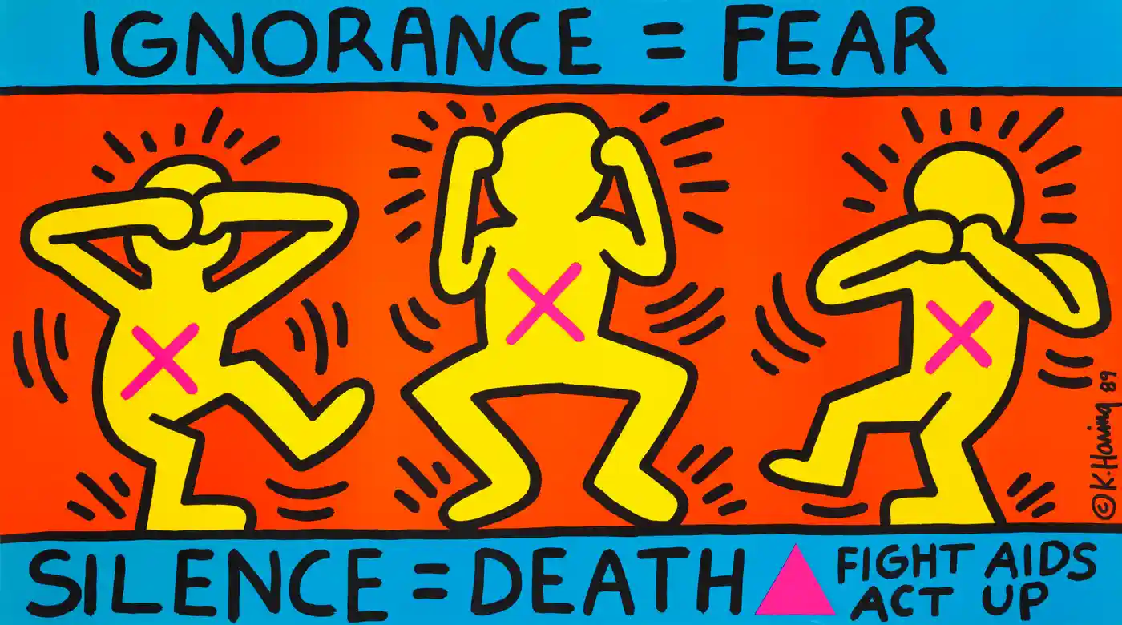
COMMUNICATION
Fig 1. Keith Haring’s ‘Ignorance = Fear, Silence = Death. 1989.

Art is great way to communicate with people. Visual messaging is often a key method in spreading awareness to the public. This technique was used by world famous artist Keith Haring. The street artist gave voices to people, like himself, who dealt with aids and how isolated it could make him feel. His excellent use of bright contrasting colours, paired beautifully with striking text allowed him to be able to easily communicate this message to the masses. He used important symbolism, such as the use of the reclaimed pink triangle – a symbol once used during the Holocaust as an identifier for gay people, but since reappropriated by the LGBTQ+ community.

The Guardian [online]. (2023). Available from: <https://www.theguardian.com/artanddesign/gallery/2017/sep/06/a-brief-history-of-protest-art-from-the-1940s-until-now-whitney-new-york>. [Accessed 09/05/23].
Ruth Millington [online]. (2023). Available from: <https://ruthmillington.co.uk/12-famous-protest-art-examples/>. [Accessed 09/05/23].

