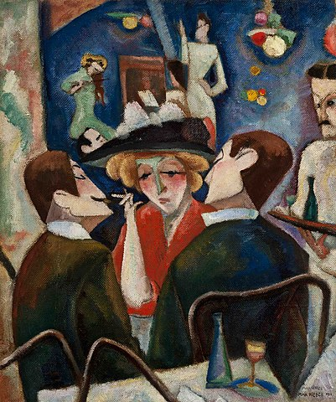
AESTHETICS

Fig 1. ‘Joel’s Café’ by Max Weber. 1910

Across history, many artists become influenced by the art style of the time. For Max Weber, it was Cubism. Cubism can be defined as a, at the time (around 1907), revolutionary way to represent reality. It allowed the artist to paint various subjects and forms in this angular, abstract, and fragmented style – very heavily influenced by the work of Pablo Picasso. The above work is influenced by this aesthetic and depicts a beautiful scene of a typical night within Joel’s Café. The use of this style of painting has allowed what could be a fairly typical painting of a classic scene, to an interesting and eye-catching composition.

Tate [online]. (2023). Available from: <https://www.tate.org.uk/art/art-terms/c/cubism#:~:text=Cubism was a revolutionary new,that appear fragmented and abstracted>. [Accessed 09/05/23].
Study.com [online]. (2023). Available from: <https://study.com/learn/lesson/aesthetic-art-styles-ideas-principles-paintings.html>. [Accessed 09/05/23].

