Worksheet 3 should include relevant artists and / or designers from the respective Workshop Folders and writing about their work.
The research should be completed in a Word document and posted on the Student Blog.
The text should be approximately 350—500 words in total and should include visual and textual references.
The personal contextual research document for each of the three block workshops will be submitted in weeks 6 / 9 / 12 respectively.

Worksheet 3

Student: Emily McIvor

Workshop: DESIGN [2D Digital Design]

- Artist / or Designer / or Artefact 1 (please write below a paragraph and attach an image and specify the caption)
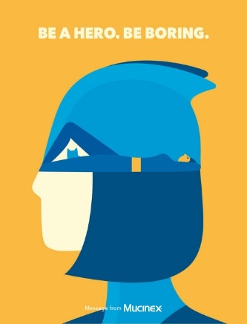
I am fascinated by the work of Noma Bar. His work displays imaginative use of imagery to convey a sense of duality and deeper meaning. In Figure 1 is one of his many works completed as a part of a campaign designed to promote the heroic act of staying at home during peak times of the Covid-19 Pandemic. In this illustration he makes effective use of simple graphics and shapes to hide more complex symbols and graphics within the focal image. Here we can see the main image which portrays a female superhero, which, at a glance is all that can be seen. However, as you look further into his work, you notice the hidden semiotic of a woman laying down with her cat. This amazing use of hidden symbolism alongside his already eye-catching use of bright colours and soft and endearing style choices allow for a visually complex piece of work that is highly effective.
^ Fig. 1 Caption: Noma Bar, BE A HERO. BE BORING Mucinex campaign, 2021
REF: Dutch Uncle [online]. (2022). Available from: <https://www.dutchuncle.co.uk/noma-bar>. [Accessed 01/11/22].

- Artist / or Designer / or Artefact 2 (please write below attach an image and specify the caption)
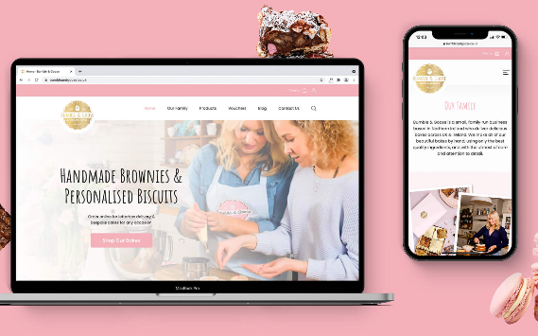
David Henderson designs is a small, Northern Irish design group that works on various projects. I was particularly interested in their interaction design work. The collective makes amazing use of design elements to create cohesive, memorable, and eye-catching interfaces such as the work they completed for this Co. Down based bakery. I am really inspired by how they create easy to navigate designs such as the website created in Figure 2. Their understanding of the needs of the client paired with their extensive skillset in creating both beautiful and workable interfaces is amazing. I really love how different each project they work on is, and how they are able to come together as a team to create memorable pieces of work that allow for users to have an enjoyable and interactive use of their carefully designed work.
Fig. 2 Caption: David Henderson Design, Work for Bumble & Goose, 2021
REF: We are DHD [online]. (2022). Available from: <https://wearedhd.com/work/bumble-and-goose/>. [Accessed 01/11/22].
- Artist / or Designer / or Artefact 3 (please write below and attach an image and specify the caption)
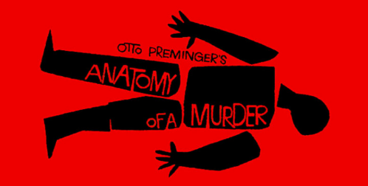
I was very interested in the work of Graphic designer Saul Bass. His piece found in Figure 3 was made as the title screen for a horror movie by the name of ‘Anatomy of a murder’. His clever use of simple shapes and form allows for a simple yet eye-catching visual that quickly conveys exactly the connotations of the film itself – a disassembled body. His clever use of colour also allows for the mood of the film to be conveyed – with red and black being colours often indicating death, destruction, danger, and violence. His use of typography within his work is also something to note as it allows for further information to be displayed while keeping a feeling of ‘wholeness’ to the artwork itself. The type he includes are noticeable but feel one with the overall design which is a hard thing to achieve. His work explores the beauty of simplistic design elements and how classic shapes and colours can easily be used to portray emotion and thinking, without the need for intensively designed and curated design work.
Fig. 3 Caption: Saul Bass, Anatomy of a Murder, 1959
REF: Twisted Production [online]. (2022). Available from: <http://twistedproduction.weebly.com/research-on-saul-bass.html>. [Accessed 01/11/22].

- Artist / or Designer / or Artefact 1 (please write below and attach an image and specify the caption)
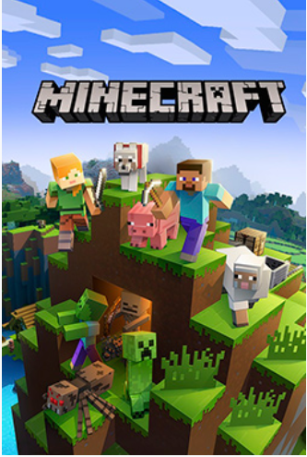
My interest in the work of Markus Persson, designer of the hit-game Minecraft from gaming company Mojang, stems from my love of the sense of individuality of the art style. The designer has made effective use of colour throughout the design of this game that I feel is perfectly suited to its intended audience – young children. I also feel this bright, colorful colour selection pairs perfectly with the signature geometric design that carries throughout every element of the game from character to environment design. The use of such basic shapes and forms combined with the colour palette chosen gives a child-like, inviting feel that I feel is super individual to the game. At the time of release, this design was truly a step into a new way of designing games. I feel the designers truly did an amazing job of creating work that is super unique and memorable, thus allowing the game and art style to be continually tied to the game even years since release.
Fig. 4 Caption: Markus Persson, Minecraft, 2011
REF: Ewen Hosie (2022). A guide to the Top 10 game designers. [online]. The List. Available from: <https://list.co.uk/news/13586/a-guide-to-the-top-ten-game-designers>. [Accessed 01/11/22].

