AAD010 | Contextual Studies  Name: Emily McIvor |  |  |  |  | Analysis 1
Worksheet 1  Assignment  Choose an image from the list (painting, sculpture, textile work, installation work, photograph, advert, graphic design, etc.) and attach the chosen images on this page.  Write one or two or three paragraphs about the work your chosen from the BBL list.  Start writing your own opinion and interpretation of the chosen artefact without researching any sources, just write our own impressions, on what you think the image communicates.  ANALYSIS  What is your first impression? Why it gives this certain impression? What features you observe? What do you think the author’s intention was? What you see when you look longer?  This work …. Seems to … It gives a sense...  My first impression of this work was that it seemed to convey a strong feeling of chaos while also invoking a feeling that the piece itself was created in an organized, and well thought manner. I sensed this feeling from the work due to the chaos the wire wrapping around the figure. It made me feel a sense of the person being surrounded, almost in a whirlwind of fast-moving energy. For me, it made me feel uneasy, as I felt a strong sense of confusion and chaos being conveyed. To juxtapose this, I also felt this piece had been carefully crafted, with each movement of the wire being meticulously planned to perfectly demonstrate this chaotic feeling of the figure.  There were many notable features of this piece of work. Firstly, is the use of line to build areas of light and shade. The artist of this piece has cleverly used the lines of wire to create areas of darkness, such as the figure itself, and extra dark areas such as the intense use of lines around the feet and head. I feel that not only does this help the work to have more dimension but allows for the viewer to further question the meaning behind the use of this. For example, the whirlwind of lines around the central figure are the most condense nearest the body. This makes me question if there is meaning to this, such as the implication of heavier, more chaotic energy nearer the body. The work also includes excellent use of shape, such as the use of continuous circling lines around the figure that conveys a feeling or fluidity and movement of this energy surrounding the person. I also think that the artist uses form to increase interest of their work. I feel that the fact the piece is three dimensional helps to further the feeling of movement and that the figure is more human as they take up three-dimensional space. It allowed me to feel more connection to the piece as I could picture myself as the figure with the mass of swirling lines around me which furthered my understanding of what the artist may be trying to put across.  The longer I looked at the piece the more I discovered. Firstly, I noticed that the line work around the figure was not just circles moving down the figure. There are spots, such as around the head, where the line focuses and changes direction. This furthered my theory that the lines are to represent a type of energy that surround the human body, especially our main energy centers such as our head and connection to the imagined, as well as our feet, and our connection to reality. As time went on, I also noted that the figure was feminine in design with a small frame, and a contrast in dimension from the shoulder and hips to the small waist. This made me think more into what the artist may have wished to convey with this piece of work. Was it possibly a commentary on being a woman in society? I also noticed that the figure was very thin with a large gap between the thighs, small, slender arms, and a thin frame overall. This made me wonder if there was a deeper meaning in relation to this for the artist.  Overall, I really enjoyed taking time to study this piece. I think the artist has done an amazing job of creating work that conveys emotion at first glance, but also leaves the viewer questioning deeper connotations as more details are discovered. |  |  | 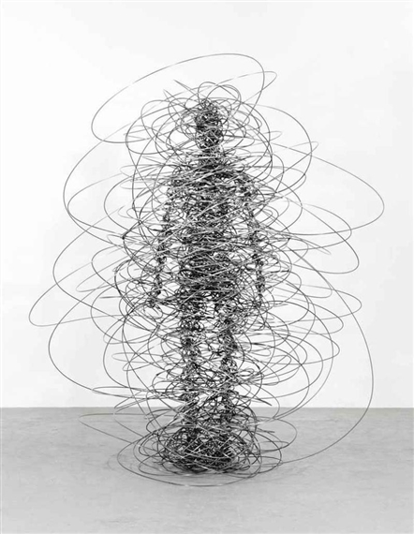  Figure 7 ^

