CONTEXTUAL RESEARCH – FINE ART
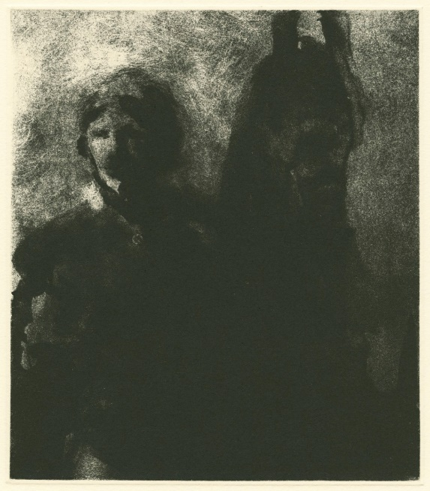
- CHRISTOPHER LE BRUN
I really enjoy the work of Christopher Le Brun. I think this piece is a beautiful example of skilful work and an understanding of print as a medium. This piece does a perfect job at being easily readable as a man and his horse, yet created using a mass of black, shadows, and thick mark-making. His impressive use of ink to create this piece allows for a highly atmospheric piece of art to have been created. I am really drawn into this piece. I feel that perhaps the man depicted is a figure from a historical period due to the hints of fashion you can almost decipher. He may also simply be a man in uniform, maybe depicted a soldier and his horse. I really admire this piece of work and love how much atmosphere and feeling it is able to create simply through viewing.
Fig. 1 - Christopher Le Brun, No. 50, Etching, 2005

Fig.1

- LISA BRICE
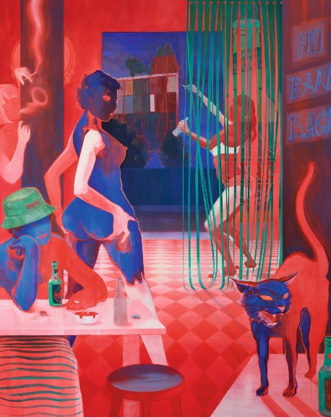
This piece by artist Lisa Brice is truly eye-catching. Brice makes highly effective use of a strict, yet perfectly apt for the piece, colour palette or red, green, and blue. I am really interested in this piece in particular as I feel is provides an interesting commentary on social issues and depicts a very un-favourable scene of what seems to a strip club. I love this piece’s ability to keep me interested due to the variety of emotions and sections to the work. It truly highlights the induvial energies and attitudes of each living body within the piece which brings a sense of realism to any otherwise abstract piece.
Fig 2. – Lisa Brice, No Bare Back, After Embah, 2017

Fig.2

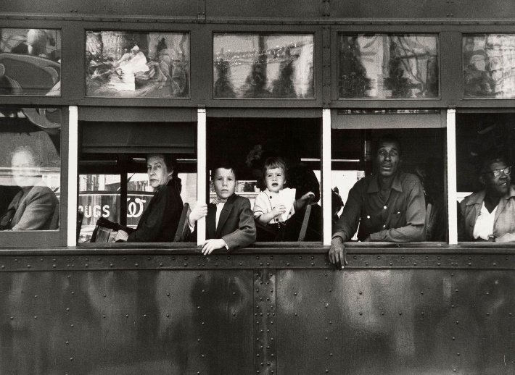
- ROBERT FRANK
Roberts Franks photobook titled “The Americans” is a truly eye-opening, real capture of America in the 1950’s. Figure one is one of my favourites from the series. This piece is simply framed and holds an innocence and feeling of pure and unfiltered emotion. It captures the harsh reality on ongoing segregation of white and balk folk within America during this time. I feel his work is beautifully executed, not harsh or added to, but simple and clean – a perfect depiction of reality at the time.
Fig.3 – Robert Frank – Trolly, New Orleans, 1955. From The Americans

REFERENCES:
- Lens Culture [online]. (2022). Available from: <https://www.lensculture.com/articles/robert-frank-the-americans>. [Accessed 22/11/22].

