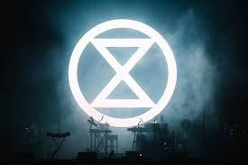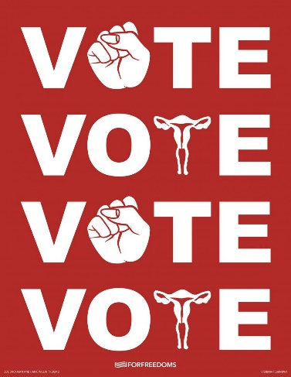***PROTEST AND GRAPHIC DESIGN:***

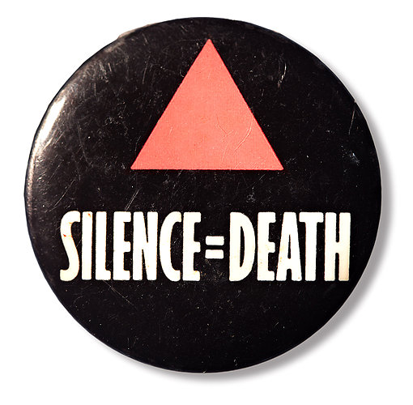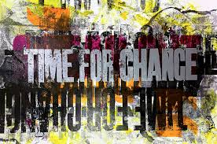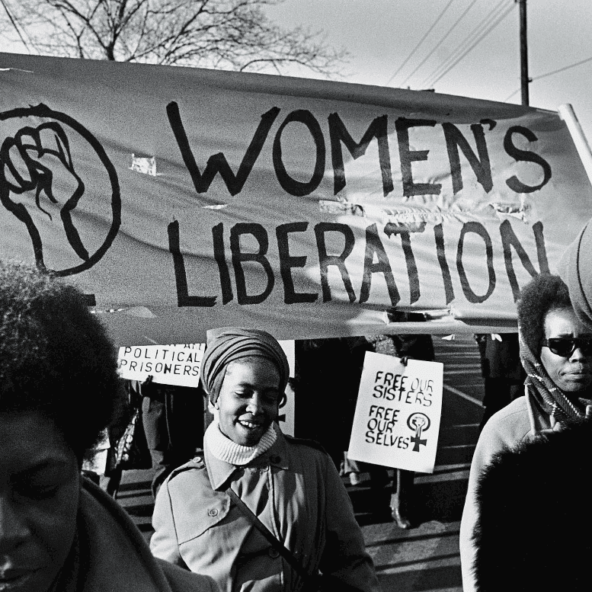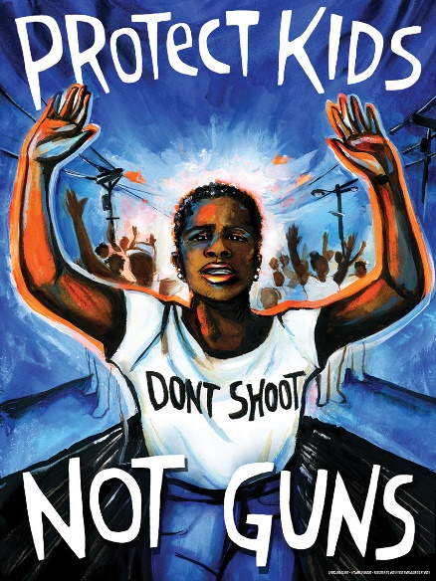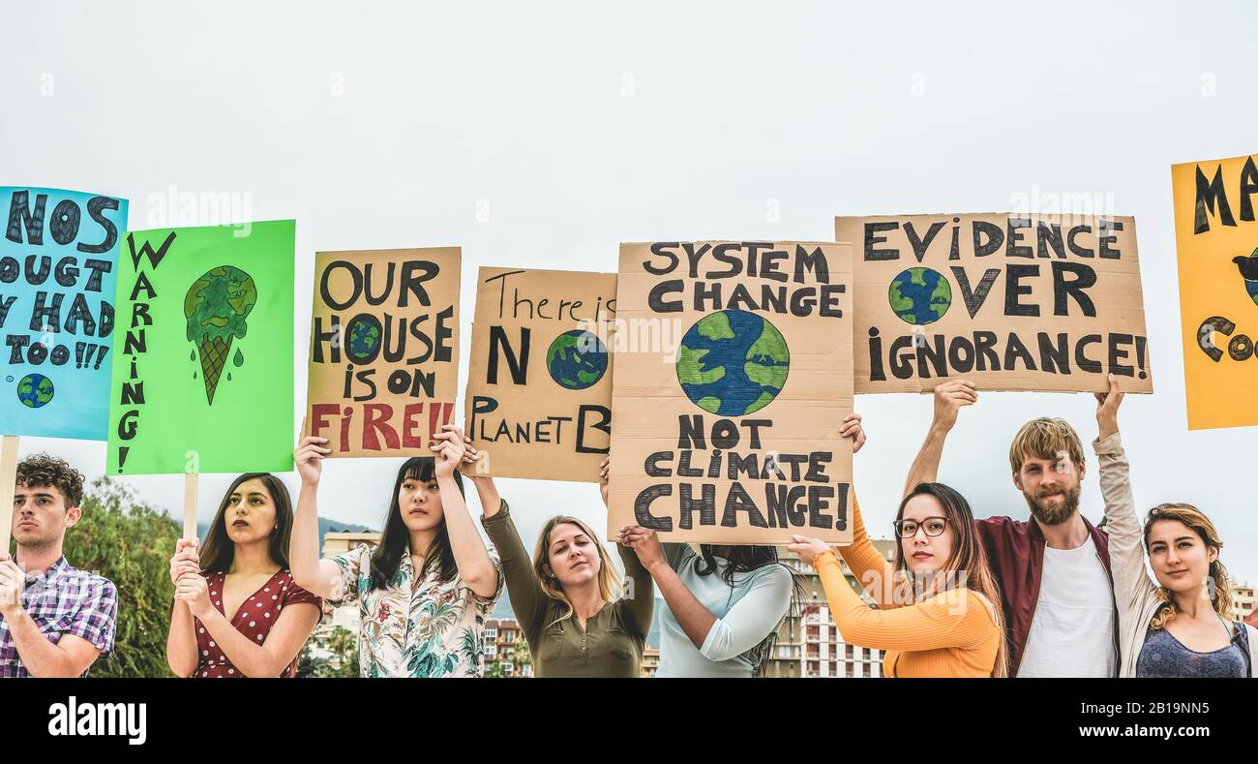

Graphics are vital in communicating messages especially for movements worldwide. Symbolism is created and utilised to create a cohesive visual front that is easily recognised. Graphic design allows for messages to be put across. They allow for ease of visual communication as even when containing text, they are simple and easy to understand. This allows for quick and bold transmission of information and standpoints. Historically, Graphic design has played a part of many movements across the globe, i.e., the recent Black Lives Matter movement as a result of the unfair death and treatment of African American citizen George Floyd in 2020. Graphic design in the modern day is still used for protest. Whether in citizens creating their own graphics for rallies or marches, or designers creating graphics to post on online platforms such as Instagram, all are vital and important in ensuring everyone’s voice is heard.