AAD011 Case Studies
Aoife Conney

Theme: Sustainability

Hiroyuki Nishimura
This artist was born and raised in Osaka (1960). He graduated from Tokyo University of the Arts, then began teaching as a high school and prep school teacher while continuing to work on his art, before establishing his company; Zougei Inc.

As a sculptor, Hiroyuki Nishimura uses timber that is considered to be worthless for other purposes. The wood is usually seen as inappropriate material for furniture or architectural use and therefore, Nishimura utilizes the wood to carve unique and interesting shapes in order to reduce waste.

He has been working with Zouki which is wood from fallen trees, in the Shonan and Izu Peninsula areas of Japan for almost 30 years. Nishimura searches for trees that have fallen due to natural causes such as typhoons, or that will be taken down for construction.

Hiroyuki Nishimura has stated that he finds trees in their natural state to be beautiful and wishes to convey that visual into each of his carvings, working with and against each tree’s particular shape and energy to create extraordinary sculptural pieces of art to express nature’s uniqueness.
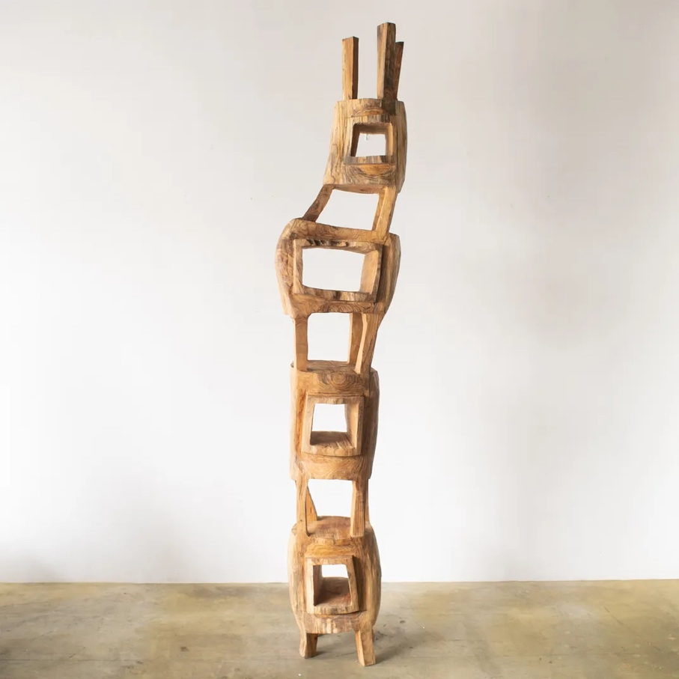

Televisore Tower 2021

References: (Nishimura , Hiroyuki Nishimura: 西村浩幸ウェブサイト)
(Siriyium, From waste to works of art: Our favorite sustainable artists 2022)

Theme: Identity

Frida Kahlo
This artist was born and raised in the México city; Coyoacán (1907).

Frida Kahlo is known for her various portraits and self-portraits, as well as her works inspired by nature and objects that are native to Mexico . In many of her self-portraits, Frida Kahlo paints her appearance as more masculine rather than taking on the typical feminine looks. She accomplishes this by painting odd clothing choices, wild hair and unplucked eyebrows.

Not only does Frida Kahlo portray female defiance in her self-portraits, numerous others of her artworks explore issue that females experience such as abortion, miscarriage, birth, and breastfeeding etc. Frida Kahlo’s artwork was not only political, but also deeply personal, reflecting er own turbulent personal life, her physical ailments and her relationship with the muralist Diego Rivera.

The reason behind many of her self-portraits and why they take up two-thirds of her artwork is because Frida Kahlo was determined to paint her reality, revealing her interest in exploring her own being and identity in depth. Quoting Frida Kahlo, she once said: “I paint self-portraits because I am the person I know best. I paint my own reality. The only thing I know is that I paint because I need to and I paint whatever passes through my head without any consideration.”

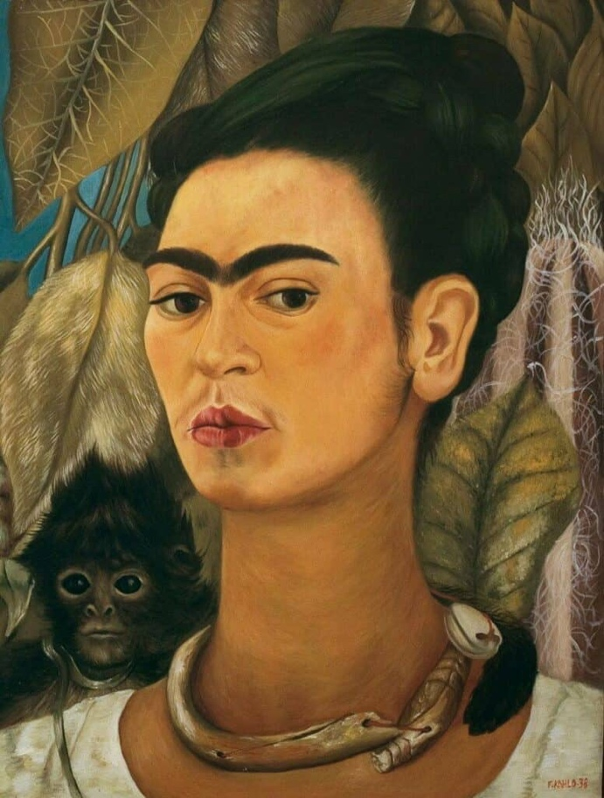

Self-Portrait with Monkey 1938

Reference: (Wolfe, Frida Kahlo - Full Bio & Most iconic paintings & quotes 2023)

Theme: Aesthetic

Kelsey Beckett
The artist was born and raised in Michigan (1993). She graduated from the College for Creative Studies which is a private school in Michigan and now currently resides in Kentucky.

Kelsey Beckett has been working with Spoke Art Gallery since 2013 and has participated in both solo and group projects and exhibitions. She is an illustrator and fine artist, working mainly with acrylic or oil mediums. Beckett’s art is similar to the artwork found within the ‘Pop Surrealism’ category, and often focuses on female portraits and their youthfulness. Due to a lack of cultural diversity seen through Kelsey Beckett’s life growing up, she decided to make her topics on the such, giving each piece a beautiful outlook on the culture it’s based on.

The artist’s use of only one angle helps the audience to keep an eye on the ever changing beauty in a person when a single variable changes. This means it allows the audience to focus on the definite beauty of a shift in the skin tone, shape of the nose, swoop in an eyelid, or texture of the hair.

Adorning her diverse characters are the delicately curated color palettes and dreamy motifs of wind-swept petals. This enhances the beauty within the overall piece.
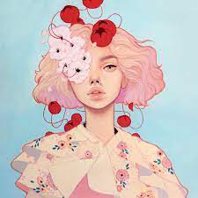

Pink Eye

Reference: (Bruer, Kelsey Beckett)
Theme: Innovation

Bryanna Marie
This artist was born and raised in Tucson AZ.
Her career began in 2007 where she started off as a tattoo artist before taking a challenge to paint on a small 3x3 canvas in 2014. Bryanna Marie still currently works as a tattoo artist, however, continues her interest of painting on small scales and has taking a strong liking to using oils on coins such as nickels and dimes.

Marie first fell in love with the idea of conveying large artistic ideas onto small canvases when she had created a 3x3 canvas for a charity event. Growing up in Arizona, she found inspiration in the plants and wildlife that inhabited the desert.

Bryanna Marie is a self-taught artist and is found a major influence directly from botanical artists such as Pierre-Joseph Redoute and Barbara Deitzsch.

The artist was searching for copper sheets for her miniature paintings and happened to look at her coin jar when she got the idea to paint on the coins. Marie explains that some coins produce different shadows depending on the president’s profile on the coin, for example, on Lincoln’s coin, she prefers to pain landscapes with his face in the background for more interesting details.

Bryanna Marie believes her work highlights the importance of traditional painting styles while proving that tiny things can hold an abundance of wonder and beauty when we stop to notice them. Likes to paint landscapes from her trips around the world on the respective coins from that country, for example a scene from France or the Irish hills on a Euro coin.

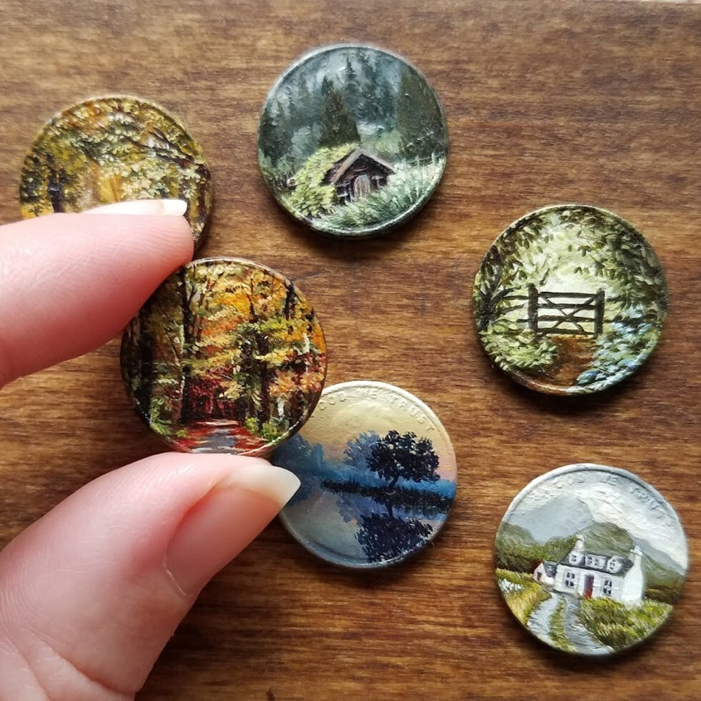

Oil Coins

Reference: (Bryanna Marie 2022)
Theme: Gender

Olivera Parlic
This artist was born and raised in Belgrade (1971). She is a Serbian artist who transforms household objects into richly symbolic pieces of art. Her work brings focus to the role of women in the home and highlights issues of sexuality. This artist’s pieces are visually striking and immensely thought-provoking.

She completed her studies in Sculpture at the Faculty of Fine Arts in Belgrade, 1997 and has been teaching at the Sculpture department of her alma mater as an associated professor since 2005. Balancing her career of teaching, Olivera Parlic has continued to create her works of art, participating in exhibitions of solo and group projects such as the Out project by the Institute of Art in Public Space Styria/Austria.
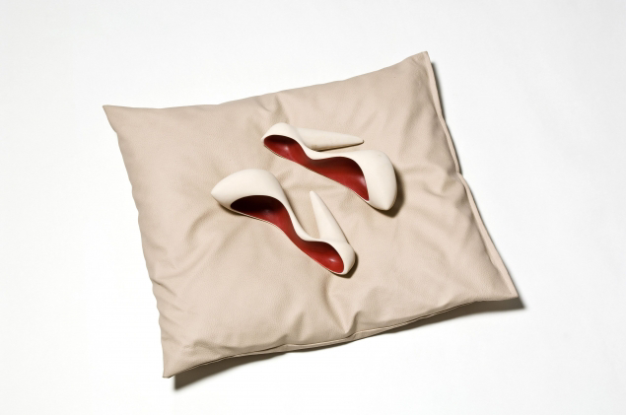

Bloody Shoes

References: (Olivera Parlić Karajanković 2021)
(Millington, Gender in art: 6 artists questioning gender norms 2019)

Theme: Place

Shelia Hicks
Born in Hastings, Nebraska during the Great Depression, Shelia Hicks moved around with her father on the road throughout her childhood life. She has become most known for her innovative and experimental weaving and sculptural textile artwork that incorporates distinctive colors, natural materials and personal narratives. Since 1964, Shelia Hicks has lived and worked in Paris, France

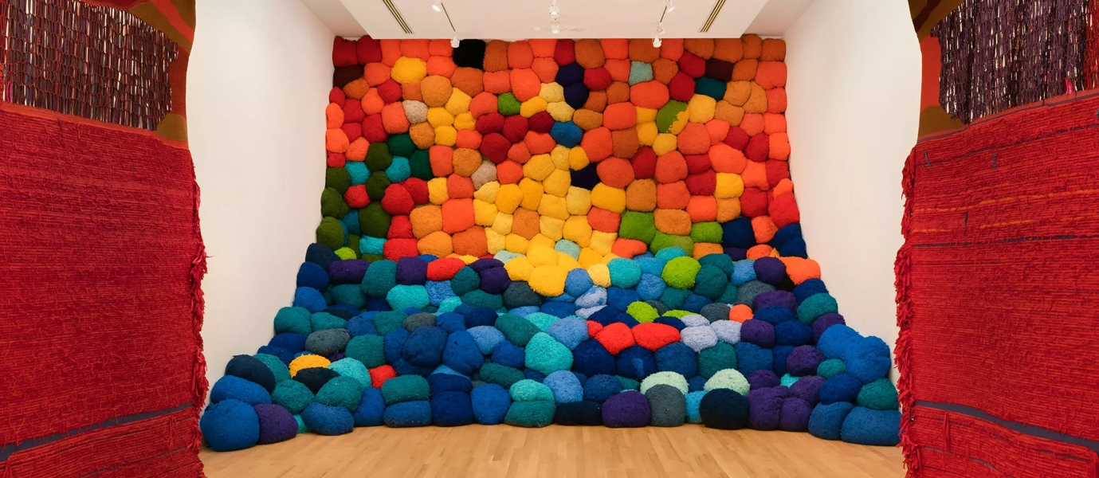
. This artist has created a series of exhibitions to showcase her on growing project of artworks called Off Grid. The artwork ranges from intimate minimes which are small woven exploration that Hicks continually produces on a hand-held frame – to large-scale installations that fill spaces with voluminous forms and vibrant colors. Off Grid reveals multiple of Shelia Hicks’ travels across several continents where she immersed herself in local communities and studied their textile traditions by observing and collaborating with the local artists of the area and together with her own experimentation, this has all lead to inspiring Shelia Hicks to develop her unique artistic language.

Escalade Beyond Chromatic Lands 2016-17

Reference: (Sheila Hicks)

Theme: Communication

Jenny Holzer
This artist was born and raised in Gallipolis, Ohio (1950). She studied a general art course at Duke University in Durham before completing a painting, printmaking and drawing course at the University of Chicago. Jenny Holzer now resides in New York where she continues to create artwork many would claim to be protest to various topics and is considered as a influential artist of communication. She is known mostly as a neo-conceptual artists as well.

Jenny Holzer turns common public objects into subversive artworks that bear powerful words by engraving poetic statements of power, feminism and individual agency onto benches made from streaked Carrara marble that is spotted with granite and royal blue-tinged sodalite. This artist renders her phrases in all-caps and serif lettering which helps turns them into monumental proclamations such as “PROTECT ME FROM/WHAT I WANT”.

Her large-scale installations have included advertising billboards, projections on buildings and other architectural structures, as well as illuminated electronic displays. LED signs have quickly became her most visible medium, however her diverse practice incorporates a wide variety of Merida including street posters, painted signs, stone benches, paintings, photographs, sound and video etc.
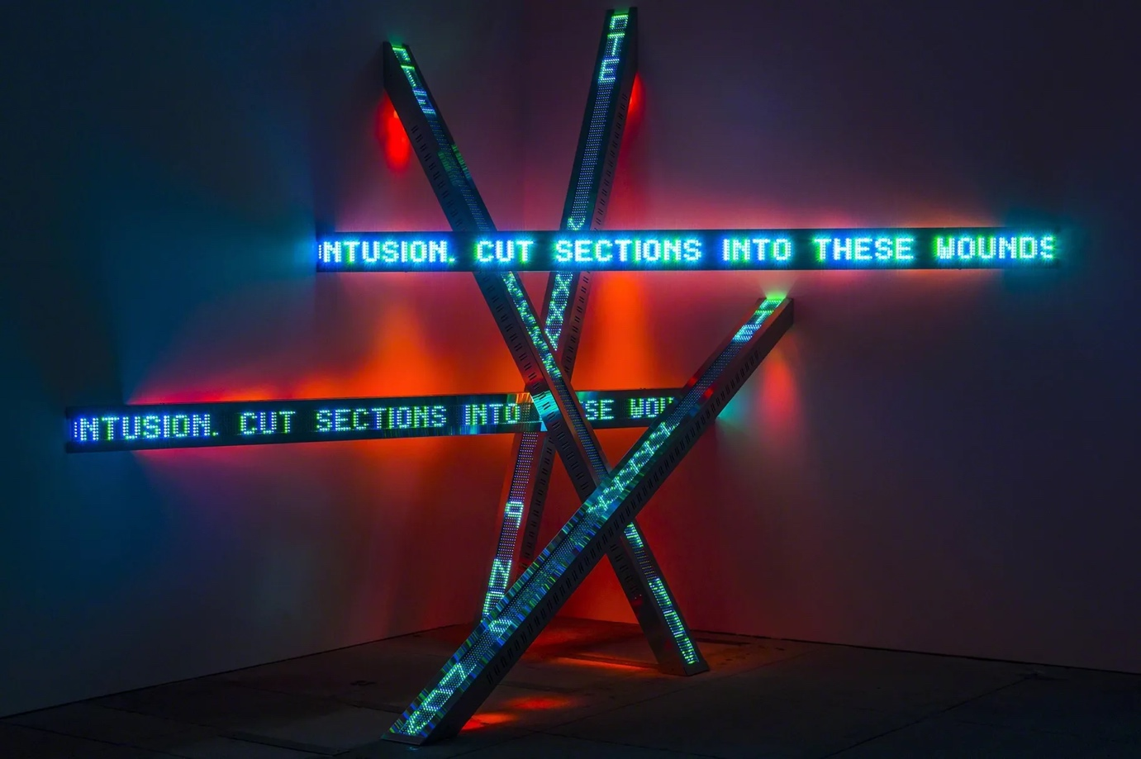

All Fall Text: Truisms 1977-79

References: (Cohen, 13 artists who highlight the power of words 2019)
(Jenny Holzer 2023)

