Fashion Desginer

Definition; Fashion designers sketch original designs of clothing, footwear and accessories. Along with the sketches, they select fabrics and patterns, then give instructions on how to make the products they design.

Yohji Yamamoto is known for his creation of avant-grade spirit like clothing. The oversized silhouettes in black that often feature drapery in various textures is considered as his signature amount the fashion industry.
This fashion designers has developed a large, dedicated global following with two of his main lines; Yohji Yamamoto and Y’s being stocked in high-end department stores worldwide.
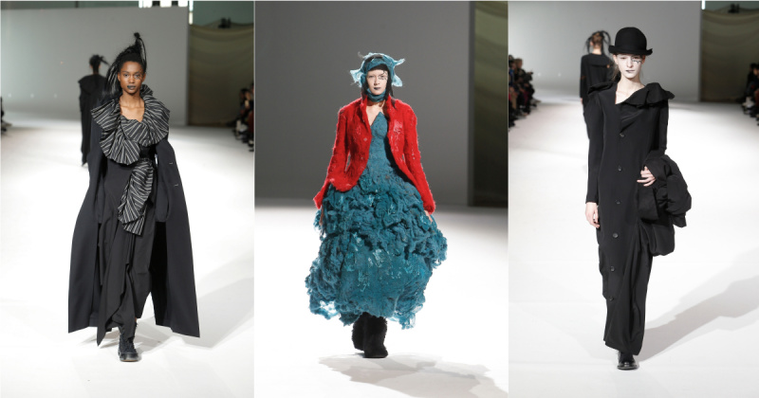

Source: https://www.businessoffashion.com/community/people/yohji-yamamoto

Textile Designer

Definition; Textile designers create fabric designs and patterns that would be used for woven, knitted and printed materials for other designers as customers to purchase for clothes and interior furnishings.

Cath Kidston is known worldwide for her nostalgic flavor prints. Starting out in interior design, Cath Kidston had an eureka moment and began setting out to design fabrics with the theme of ‘English Heritage’. Her company under the same name has grown and became successful over the years, being loved by people of all ages.

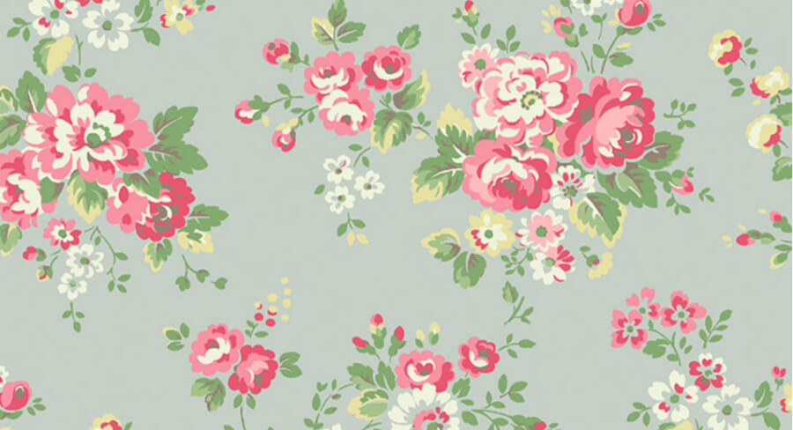

Source: https://www.findcourses.co.uk/inspiration/hobby-fun-leisure-articles/7-textile-designers-who-changed-the-world-17402

Textile Artist

Definition; Textile artists are people who create pieces of artwork using plant, animal or synthetic fibers to construct the topic of their art choice.

Among the community of textile artists, Sheila Hicks’ name is almost synonymous with the catorgy of fiber art. For more than over half a century, Sheila Hicks has removed the seams between art, architecture and design with her bold and groundbreaking artworks that often dominate the public space it is displayed in. In Sheila Hicks’ artwork, textile art has become a mixture between sculpture, painting, architecture and allowed it to be an independent discipline within its own right.

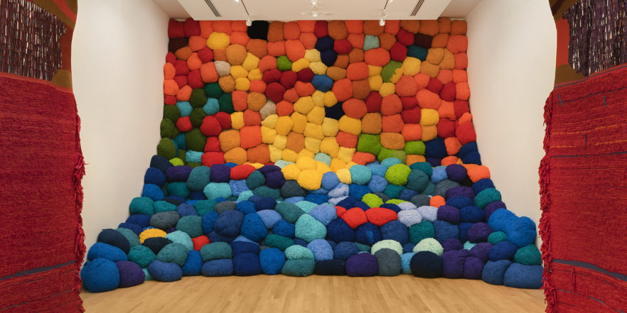

Source: https://www.wallpaper.com/art/contemporary-textile-artists

