2D/Digital Practices

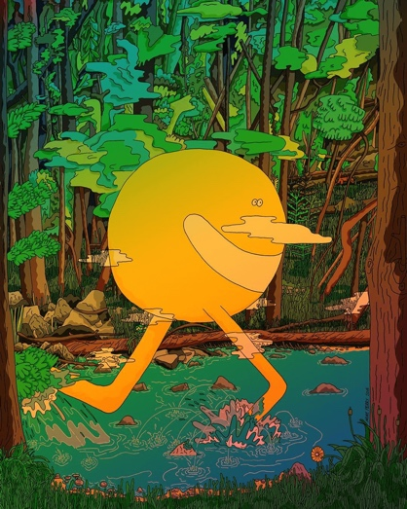
Graphic Design Artist:
Mike Perry

While researching for a graphic designer, I came across this art piece which intrigued me. The artist’s use of color in this piece has created a beautiful scenery with the sun character both blending and standing out in the image. The subtle shifts between the light green – yellow – soft orange in the character are really brought out by the soft light yellow clouds surrounding it. The piece gives an almost whimsical atmosphere in my opinion and I’ve come to really like this piece by Mike Perry.

“Mike seems like a modern surrealist to me. His work feels like a childhood memory of slipping down a giant water slide during summer. Slippery and wet and innocent but not too innocent. His drawings feel like they just fell right out of his brain onto the paper.” – Ana Benaroya artist/illustrator
‘Untitled’ by Mike Perry 2020
Source: https://www.forbes.com/sites/patrickhanlon/2016/04/14/brooklyn-artist-mike-perry-wants-to-blow-your-mind-again/?sh=75bb8e592acd

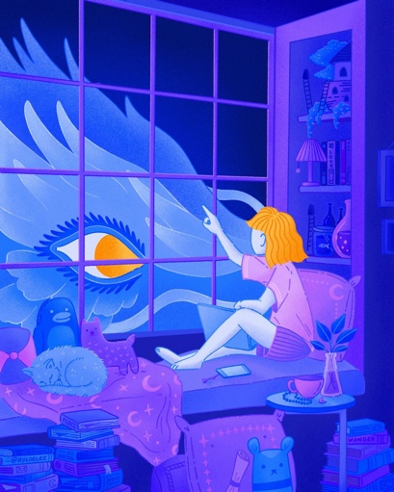
Illustration Artist:
Loe Lee
I became interested in this artist after seeing her artwork, that in my opinion is very whimsical and dream like. The blues and purples used in this piece give it an overall since of calm and peacefulness as the young girl shares a moment with what looks to be a dragon sort of creature. Having an interest in mythology, this piece allows me to see the creature in a beautiful perspective and reminds me of a storybook. The gold in the girl’s hair and the dragon eye also helps to give that impression of a connection being made between the two.

As a new artist, ther doesn’t seem to be many opinions or thoughts on Loe Lee’s artwork yet, however those who have mentioned her briefly and her work have said to be impressed and agrees strongly that each piece Loe Lee produces is whimsical and gives a dream like emotion overall.
“Creatures of Hope” by Loe Lee 2020

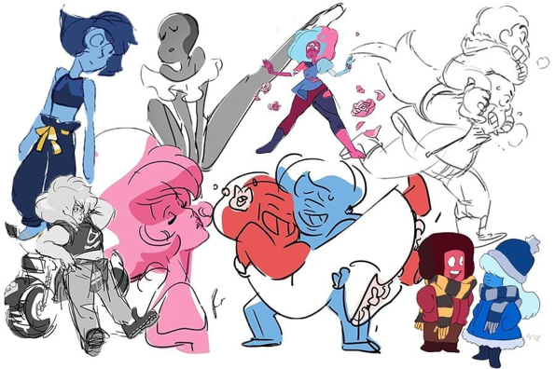
Animation Artist:
Rebecca Sugar
When going to research an artist for the Animation workshop, I knew I had to include Rebecca Sugar as I grew up watching the work they produced. They worked on Adventure Time and Steven Universe, two shows I adored as a kid. This artist inspired my way of sketching for years as I found it to be light and expressive. Each character that Sugar has animated in her career years has an overall impression of being soft and squishy due to the curved and quite lines present in the designs. In my opinion, Sugar creates fun, loving and beautiful characters with just simple lines which allows most of the details to come forth in the colors instead.

Since the shows that Sugar works with are so popular among kids and teens, it’s safe to say that many love her artwork as much as I do, with even some adults favouring her character designs. However, with that being said, not many articles or critics have written their opinions on her style but more on the shows that involved her animations. .

Games Design Artist:
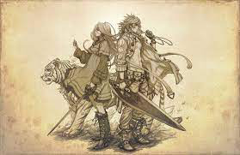
Hironobu Sakaguchi
As I don’t play much games, I found it difficult to find an artist that I really liked, until I came across this artist who I’ve heard about before from friends. I chose Hironobu Sakaguchi because his style is very much close to that of anime and I do actually find the designs of his characters to be amazing.

Similar to Rebecca Sugar, I couldn’t find much criticism or opinions on Hironobu Sakaguchi’s artwork but rather the game itself instead. Considering the game Final Fantasy is a majorly popular game in current time, I am lead to believe many people are happy and satisfied with the artwork produced by Hironobu Sakaguchi.
“Final Fantasy” by Hironobu Sakaguchi

