3D/Creative Practices

Textile Artist:

Itchiku Kubota
While researching different textile artists, I came across the kimono collections created by Itchiku Kubota and my first thought was that each piece was beautifully crafted. After reading some information behind the pieces and studying them, I came to admire the concept of the main collection from this artist; Mount Fuji where Itchiku Kubota has produced sceneries of the famous volcano blanketed in various lighting views which creates beautiful colors mixing together. These kimono pieces gives a calming and enchanting feel which makes the entire collection magical.

“Critics and museum visitors remark on colour, depth and light that seems to radiate from the kimono. Using ‘chirimen’ (silk crepe) as the base fabric and pinching or tying tufts of the material to be dyed, Itchiku Tsujigahana kimono are notably lighter than the more traditional form many people will be familiar with. They are appear to float and the imagery depicted – whether it be the setting sun, a cloud drifting across Fuji or the universe itself – is imbued with movement and its own light.”
Source: https://www.snowmonkeyresorts.com/art-space-japan/itchiku-kubota/

Product Design Artist:
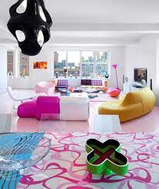
Karim Rashid
The designs created by Karim Rashid are interesting in the way that he has uses colors and patterns. The style of the furniture in the chosen picture gives me the impression of pop art where the colors are jumping out at you. In my opinion, the elements of each piece is quite simple and unusual, however together in the room, they give emotions and expressions that all depend on the person viewing it, meaning that each member of an audience will experience Karim Rashid’s designs in various ways.

“Karim’s designs are timeless and universal. From watches to tableware, his artistic touch has been portrayed in an extraordinarily wide range of designs.”
Source: https://medium.com/@GetScriba/karim-rashid-industrial-designer-innovator-changing-how-we-view-design-ba3a84bbc568

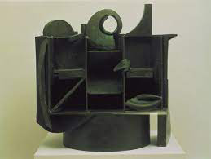
Ceramic Artist:
Anthony Caro
I chose this artist to study for my reference in ceramics because I was intrigued by the designs created in each of his pieces. This green cupboard that Anthony Caro made had solidified my idea of recreating a similar style of levels within the clay structure I produced in the workshop. In my opinion the simple vision of levels gives the overall piece the ability to give various perspectives available for the audience to see the structure in. I be,I’ve that simplicity is a great element to use when little detail is wanted within the piece.

“He is an artist caught between his ambition to be a great modernist, and his technician’s delight in colour and form that makes him put frills everywhere. Except that the frills are perspex, wood and steel. That fussy insistence on play makes the art in this show decorative, lightweight, trivial. There’s just too much ostentatious creativity going on. Some artists have great late periods: Caro didn’t, but he put on a show of having one all the same.”
Source: https://www.theguardian.com/artanddesign/2014/sep/11/anthony-caro-the-last-sculptures-review

Metal/Jewellery Artist:
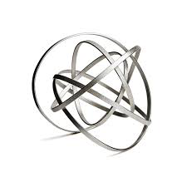
Ute Decker
In terms of jewellery, I wouldn’t normally go for geometric designed pieces, however what caught my attention through Ute Decker’s metal work is that it reminds me of the paper work I created in the Product Design workshop. I find it interesting how Ute Decker has twisted the wires around each other to create many shapes within the one spherical form. This piece that I’ve chosen gives me the impression of a cosmic star of some sort, perhaps the way that it would maybe be animated. As simple as the piece may appear, it has slowly become one of my favorites to find.

“Her sculptural pieces posses the physicality of being made by her own hand, yet her ideological beliefs are imbued in the fact that the materials she uses are wholly ethical and traceable.” – Mazzi Odu
Source: https://magnusoculus.com/ute-decker-jewellery-artist-and-activist/

