AAD011 CASE STUDY TEMPLATE

Student Name, Surname: Tija, Petruseviciute

Module: Contextual Research and Understanding

Your participation to the module requires that you research the weekly theme to find appropriate information on each topic (theme). Include a relevant artist or designer from the respective topic which may be relevant to your practice.
For each seminar, session print out 1 x A4 copy and bring to the seminar session. This must also be posted to Blog before the lecture so that it could be discussed in class within the seminar. You will submit 7 x A4 Case Studies with final presentations in Week 11 and Week 12.

Theme: Place
Markus ‘star’ Harwood-jones
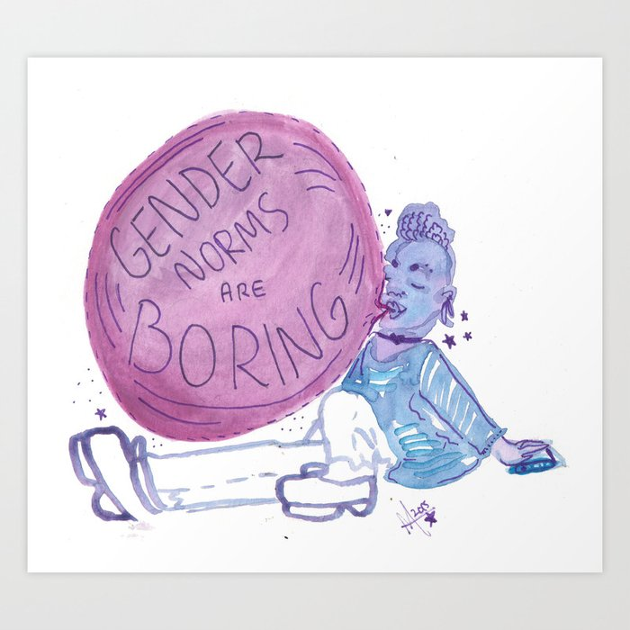
Markus ‘star’ Harwood-jones
Harwood is an author, artist and academic who is based in Toronto USA. He is very vocal about gender and sexuality, so I thought he would be an amazing artist. He is very in tune with gender and also studied gender science at queen’s university. I love the way his artworks bend gender norms and add more fluidity to the meaning of gender. He allows us to look past the typical norms like blue for a boy or pink for a girl and allows us to express gender through what we feel inside.

