Molly McVeigh Beckett
AAD012 Contextual Research – Contemporary artist associated with my work
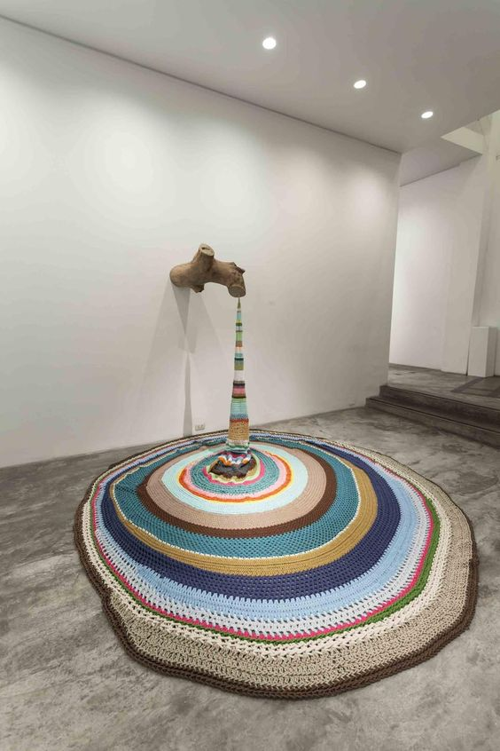
Figure 1: Ana Teresa Barboza, Corte Del Tronco, Installation made of wood and embroidery, 2013
Ana Teresa Barboza is a contemporary textile artist and designer born in Lima, Peru 1980. She creates art pieces and installations that reflect nature with handcrafted elements. Barboza began her embroidery journey in 2004 after graduating. She continued to refine and develop her ideas using embroidery and knitting to bring handcrafted design and nature together. Barboza uses different thread and wool techniques to create structure and form within her work, the installation in Figure 1 – Corte del Tronc meaning trunk cut in English, which shows a segment of tree trunk acting like a tap with wool knit in such a way that we are led to believe it is liquid pouring from a tap and puddling on the ground.
I choose Ana Teresa Barboza as her art installation – Installation made of wood and embroidery 2013, shown in figure one as it is similar to my idea for the AAD012 Fashion Textile assessment and final show piece. Even though Barboza uses embroidery within her installation, the wool looks as though it has been crocheted. I am focusing on and developing different wool knit and crochet techniques to incorporate into my theme - textured textiles. I am experimenting with different wool colours and textures to create different elements for my final piece. I have experimented with different stitches such as a chain stich, granny circles, granny squares, increasing and decreasing patterns to consider for my final piece. Ana Teresa Barboza also incorporates knitting within her artworks and for experimentation I have also made a few knitted samples that I can use within my final piece.
As an experimental piece, I created a spherical fabric collage using strips of fabrics placed on an inflated balloon, using PVA glue to hold the pieces in place I created a fabric mâché bowl. I thought about how I might use this piece once dried considering using it as a vessel for flowers or fruit then having the idea of using it as an installation piece along with a tapestry incorporating it as a hanging installation (air balloon). Inspired by how I might use the piece I considered creating an installation using crochet and knitting using the fabric mache piece as a point from which flowers might flow. I thought about how elements might cascade from a vase/jug (crocheted or knitted with chains and panels) with crocheted flowers as though the vase had toppled over with flowers, water and petals spilling out. On further consideration, I thought of using a water tap and sink showing water and nature overflowing from the sink. As this idea has developed, I have decided to use a simple brass tap with various woollen techniques and fabric in shades of blue and white to create a piece that brings nature and the handmade together similar to Ana Teresa Barbozas concept.
I am keen to create an impactful and interesting installation and want to consider the elements I am creating to give the piece some meaning. I like the idea of using mixed media to create a natural resource such as water, something we often take for granted. I want to evoke the thought that if we were to turn on the tap and only get wool - a dry and absorbent material that it would represent how we must try to conserve resources such as water. By incorporating flowers, I aim to represent nature and the environment and how important water is for growth.
Overall, I feel that Ana Teresa Barboza’s art installation is similar to my final idea. I like how she has used various coloured ring of wool to create the rippling effect water has when it drips onto another body of water, Barboza has created movement within her piece that I am also keen to incorporate within my piece. I like how her wool begins from a finer funnel shape then puddles out onto the floor. I have taken some first-hand images of water pouring from an outdoor tap to help me create texture, movement and form within my piece. I find it interesting that whilst Barboza has not used natural colours the element in her work still evokes the feeling of water.
In the next few years, I can see my work improve and I would like to continue developing more techniques and skills within crochet as I have really enjoyed being able to create my own patterns and learning from YouTube tutorials. I also feel that going into Fashion Textiles in September, I will be able to develop my own style and allow myself to blossom in a course that I will love and enjoy as I love being hands on and trying to figure out problems within my work. Since doing a large-scale piece in the first few weeks of AAD012, I have stepped out of my comfort zone more, feeling free to experiment and play with different mediums. I have been able to adapt part of each of my samples and pieces together and experiment in larger scales. Previous feedback highlighted my need to let go and free up my work, having always working safely in a tight and considered way. Foundation has allowed me to push myself out of my comfort zone and be messy and productive, realising that my work and ideas don’t have to be perfect and even if I dislike something I have created, I acknowledge that this is also part of the development of ideas and of developing an understanding of my style and practice within my artwork.

References:
Sam, Ana Teresa Barboza – Handcraft and Nature, N/D. Available on: Ana Teresa Barboza – Handcraft and nature - TextileArtist.org [Accessed on: 28th April 2023]
Figure 1: Figure 1: Ana Teresa Barboza, Corte Del Tronco, Installation made of wood and embroidery, 2013. Available on: (20) Pinterest [Accessed on: 28th April 2023]

