Worksheet 3
Sarah Mcdonald
2D Digital Design

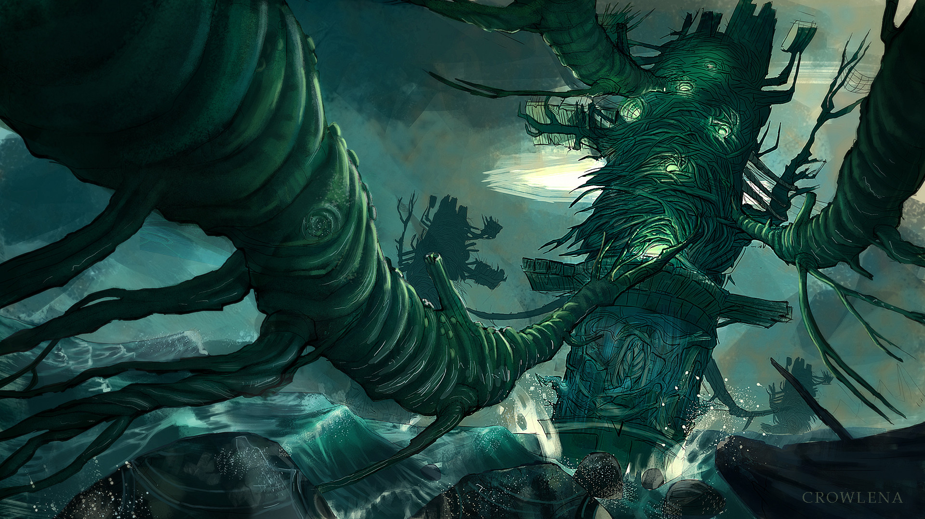
Animation

The creator of this work is Natasha Crowley. The title of this piece is Beak Tower and it was published in 2018.
https://www.artstation.com/artwork/9JgWR

This artwork is chilling and haunting. It drew me in instantly. The design is powerful and has a lot of movement to it as a still image, it feels like you are being swept away into the world it exists in. The deep greens and blues create a dark and cold otherworldly environment and the deepest of shades, paired with the crashing waves, adds a life threatening edge to the art.

Designer
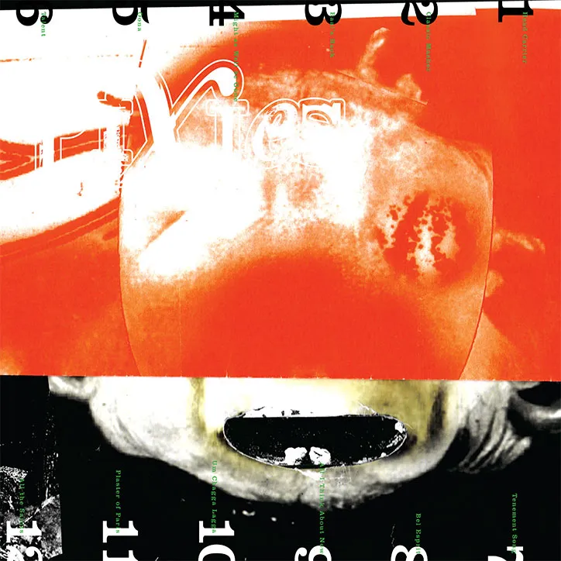

The artist of this piece is Vaughan Oliver. He is an art director and designer who has been working closely with the band Pixies for the last 30 years. This artwork was created to be the Pixies’ Head Carrier album front cover which was released on the 30th of September, 2016.
https://www.itsnicethat.com/news/vaughan-oliver-pixies-head-carrier-album-artwork-290916

I am enticed by Vaughans’ work as his method of creating results in bone chilling designs. His work is not complicated but yet draws the viewer in by capturing a sinister energy. Vaughan has captured the feeling of Pixies lyrics in this album and transformed them into art. At first glance, my immediate reaction to this cover is that it’s scary. This is due to the contrasting colours and the unusual figure featured. When taking my time to understand the cover, I gather the impression of confusion, fear, frenzie, pain and anger all tangled into one. It is a very complex piece and yet it is not over the top. I believe that its abstract appearance intentionally allows the viewer to interpret their own understanding.

Animation
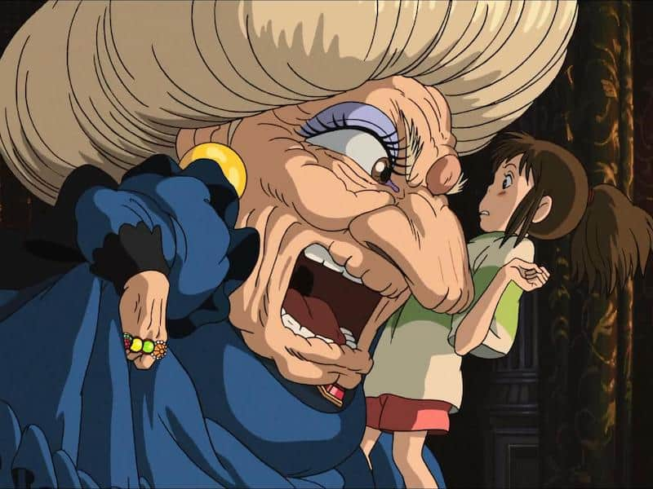
Spirited away, (movie).
The director and designer for this movie is Hayao Miyazaki.
Hayao Miyazaki is my all time favourite animation designer and director. I have thoroughly enjoyed every one of his Studio Ghibli movies due to the storylines but also the design of characters.
From this one shot taken from the movie Spirited Away, it is clear what the characteristics of the characters are. His detailing is powerful as just by looking at a still from the movie, the viewer can gather an idea of what the dynamics between the characters will be. Many of his character designs are over exaggerated for comical relief which is why I enjoy his movies as much as I do.

