Contextual studies

Christina Troufa,
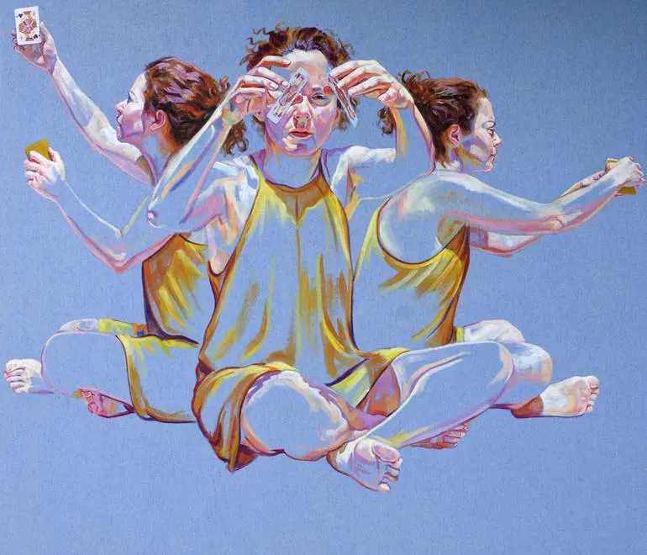

Cristina Troufa is a Portuguese fine artist born and based in Porto, Portugal. Troufa wants to consolidate the idea of a self-portrait and/or self-representation but for other hand wants to reflect on a spiritual, emotional, and psychological inner self-portrait, that may be done conceptually. She uses her own image in autobiographical paintings that explore her life and spiritual beliefs. As a form of self-knowledge and self-questioning, her work explores an inner world in a symbolic way, which remains inaccessible to the voyeur that can only guess what each painting represents.

Lindsay Alder
Lindsay is an award winning photographer / director and world renowned photographic educator. Based in New York she has traveled the world shooting for iconic beauty brands and high end editorial publications. Lindsay is known for her signature clean, bold, and graphic style. Driven by her passion to be a visual problem solver and her love for creative collaboration, she utilizes her best-in-class crew and production resources to push boundaries and lift her commissioned and personal work. In 2020, Lindsay became the first woman to win the Rangefinder Icon of the

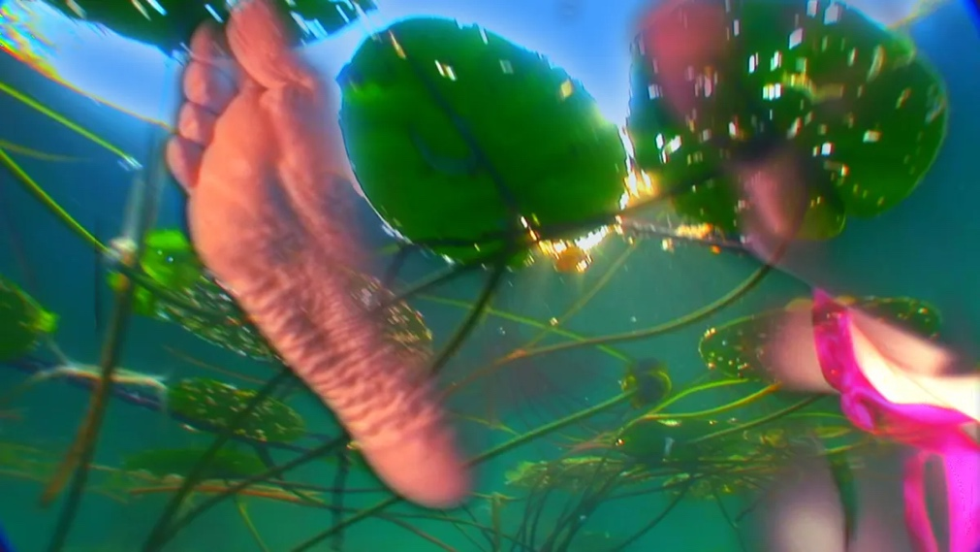
Pipilotti Rist

Rist is a Swiss visual artist best known for creating experimental video art and installation art. Her work is often described as surreal, intimate, abstract art, having a preoccupation with the female body. Her artwork is often categorized as feminist art.
Rist's work is known for its multi-sensory qualities, with overlapping projected imagery that is highly saturated with color, paired with sound components that are part of a larger environment with spaces for viewers to rest or lounge. Rist's work often transforms the architecture or environment of a white cube gallery into a more tactile, auditory and visual experience.

