Worksheet

Alex Coffey

- Kelly Spencer
Kelly’s creative style is characterised by bright fresh colour palettes and curvaceous forms, meticulously hand crafted lettering, and illustrative elements of flora and fauna. Her work often serves as a platform to promote the conservation of our natural environment. Kelly’s portfolio includes murals/street art, illustration (editorial, promotional, books), sign painting, apparel graphics, festival & gig branding, installation, identity design and more.

- Katsuya Eguchi
Eguchi is a game designer, producer and deputy general manager at Nintendo Entertainment planning and development, most known for being a creator and a spokesperson of the AnImal Crossing series. He began work at Nintendo in 1986 and spent some time doing promotional artwork before starting as a designer on 3. He first served as director for Star Fox in 1993. Other games he has directed include Super Mario World, Star Fox 2, Wave Race 64, and Yoshi's Story.

- Leslie David
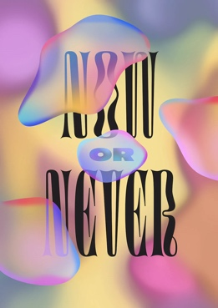

Leslie David Studio is a creative agency founded in 2010 by Art Director Leslie David. The studio focuses on creating visual and conceptual solutions across branding, print and digital designs, photographic direction and illustration. Leslie oversees a team of 4 and has hands-on involvement in all projects. Through mixed media creativity and exploration of new mediums, the studio works to create holistic visual solutions across disciplines in order to propose a unique creative vision to clients in the Beauty, Fashion, Art, Lifestyle and Music industries.

This poster was designed for 'Protection', a Riposte Magazine group exhibition in support of Amnesty International and the fight for human rights

- Rebecca Mock
Rebecca Mock is a Brooklyn-based digital illustrator and animator who counts traditional illustration and comics as her inspirations, yet uses them to create elegantly engaging digital art. Rebecca is most famous for her impactful environments and truly enthralling animated gif illustrations, her work is always in high demand.

- Kevin Systrom

nstagram is a photo and video sharing social networking service owned by American company Meta Platforms. The app allows users to upload media that can be edited with filters and organized by hashtags and geographical tagging. Posts can be shared publicly or with preapproved followers.

