Theme: Aesthetics
Student Name: John O’Boyle
Student number: B00874473
Module code: AAD011
Title: Case Study Template / Contextual Research and Understanding

Georges Braque
Georges Braque (1882-05-13, 1963-08-31)(Aged 81) is an Italian artist that focused on the art style of cubism, as well as being one of the founders of it alongside Pablo Picasso, whilst being a prominent cubist artist. Braque also liked to touch up on the likes of Impressionism in art and developed a liking to very bold colours, this was nice as it paired well when it was going with his use of cubism and diverse use of shapes.
I believe that his art style is outstanding as he was able to make these distorted cubist images that can show the hidden chaos found everywhere in the world. I believe that his choice of using cubism and painting various sceneries with it creates a magnificent aesthetic as when we look through places we are not familiar with such like a forest (Figure one). It almost looks like a winding labyrinth and we would then get lost within it, what is fantastic about Georges Braque's art and his art style, is how he can and has taken that sense of confusion that we would get when looking into and through a typical forest and has painted it so clearly using this style.
Similarly to figure one he has also shown he is capable of showing the roughness and chaos of a location, in figure two we can see a ship in a dock, what I love about Figure two is how he can almost tell a story through the chaos of his cubist art style, we can see this through the many brush strokes he made whilst painting the sky and waters. I believe the fact he uses so many is to simulate the chaotic waves and winds, his use of colour adds to this as the clouds have been depicted looking very grey and stormy Practically showing us a storm.
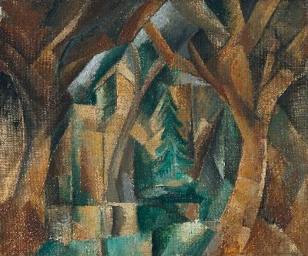
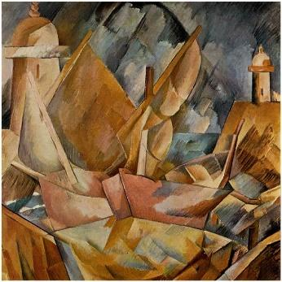
Figure one

Figure two

Figure one - Georges Braque, The Parc at Carrières-Saint-Denis, 1909
Figure two - Georges Braque, Harbor in Normandy, 1909
References
Georges Braque, museo thyssen. Available on https://www.museothyssen.org/en/collection/artists/braque-georges/parc-carrieres-saint-denis [Accessed on 20th February 2022]
Georges Braque, Georges Braque, 2009. Available on https://www.georgesbraque.org/ [Accessed on 20th February 2022]

