- Raphaël Dallaporta
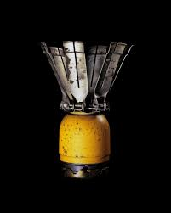
Raphaël Dallaporta makes the viewer ask questions on topics from science to Morales to even who they are as an individual. His main ideas stem from wanting to link his audience with these topics and create a bridge that opens the subject to so many more people. This is why, I enjoy his work-though often horrifying in reality, the pieces are photographed and shown to be glorified and full of beauty. This is often done by combining photography, video, metal sculptures and prints of various kinds. Raphaël Dallaporta is to me amazing at matching the perfect medium to the idea he is conveying through art. These pieces are for the most part, close up/zoomed in while shown in a large display. This allows every detail to be observed. A personal favourite of mine is “Antipersonnel” (Figure 1). The photography from this seems to make, what we know is a hellish device-a landmine which caused trauma and travesty for so many people, into something that resembles an advertisement and something to be wanted/cheered for. For me, it looks like a piece of kitchen hardware that would be wanted by every household.
Figure 1- “Antipersonnel” (2004), Raphael Dallaporta

- Hiroshi Sugimoto
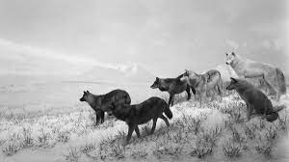
Hiroshi Sugimoto’s work leaves both a curious but daunting taste in my mouth-just making me want to ponder and explore his ideas more, specifically his pieces around nature and lack thereof. His most well-known revolves around these pieces with inspiration coming from a focus on habitat displays and “the distinction between real and the fictive.” For four decades Hiroshi photographed scenes made at the Natural History Museum of America, comparing what he thinks nature should be and the reality. This technique is so unique due to the number of layers that are put into each photograph from taxidermy by the museum’s artists to Hiroshi’s skills as a photographer to make it seem so real. This topic is especially interesting in today’s climate with nature and wildlife seeming to be disappearing more and more-these photographs show a version of what could’ve or can be for our world.
Figure 2- “Wapiti” (1980), Hiroshi Sugimoto

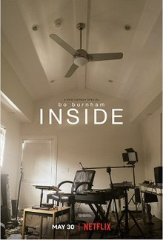
- Bo Burnham
Bo Burnham is a personal favourite of my own due to the messages he conveys and compositions he uses. His most recent and well known work was a Netflix special called “Inside.” This special followed Bo throughout his experience of 2020 COVID lockdown-a year where he planned to return to comedy and music but was faced with something much different. He focuses on mental health and his own (often relatable) struggles with such due to the isolation and everyday pressures. His videography is accompanied by songs and music composed by himself-as well as lighting that adds to each piece. The entire series was managed by this single man, making it so much more vulnerable and personal. Each shot/scene is shown in an everyday room with a focus on lighting to illuminate Bo as the main subject. Part of why I love this special is because of how limited it is on expensive or big props-allowing Bo’s skills as a film maker to excel.
Figure 3- “Inside” (2021), Bo Burnham

References:‌
Coppelman, A. (n.d.). Eerie Yet Gorgeous Scenes Make Taxidermy Spring to Life. [online] Wired. Available at: https://www.wired.com/2015/01/hiroshi-sugimoto-dioramas/ [Accessed 14 Nov. 2022].
‌
Raphael, D. (n.d.). Raphaël Dallaporta. [online] pp.40–41. Available at: https://www.raphaeldallaporta.com/dallaporta-en.pdf [Accessed 14 Nov. 2022].
‌
www.netflix.com. (n.d.). Bo Burnham: Inside | Netflix Official Site. [online] Available at: https://www.netflix.com/gb/title/81289483.

www.youtube.com. (n.d.). Hiroshi Sugimoto: Four Decades of Photographing Dioramas. [online] Available at: https://www.youtube.com/watch?v=q9GiyPbLYPg [Accessed 19 Mar. 2021].

