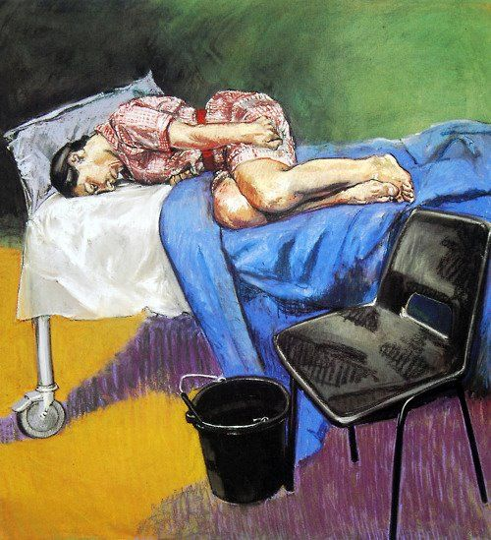
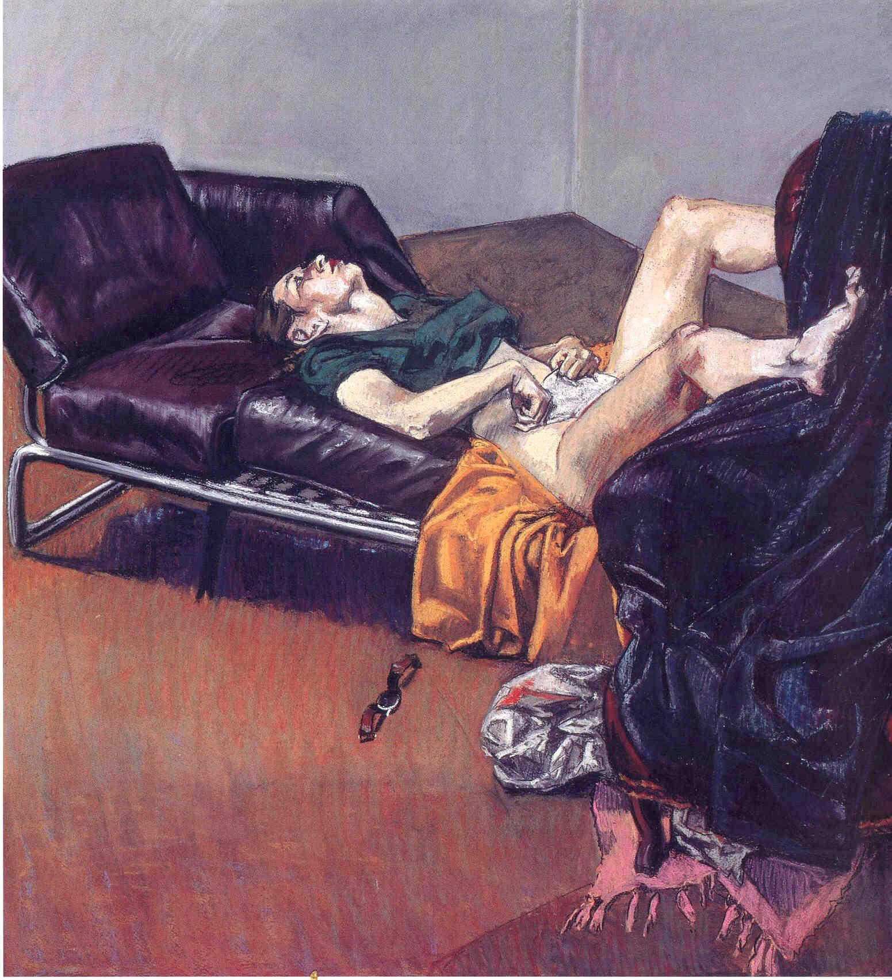

Paula Rego- 1998- Abortion

In 1998, a referendum to leagalise abortion in Portugal failed. In response to this, Portuguese artist, Paula Rego, created the Abortion Series (1988), a selection of paintings which draws attention to the dangers of making abortion illegal. The effect of the series was so powerful that it has been credited with helping sway public opinion to form a second referendum in 2007. With these powerful paintings, they are credited to have helped the legalisation of abortion in various countries along with Spain.
Created using pastels, Rego has successfully used her bright and vibrant colour tones to draw an eye to her work, helping her protest be heard.

"I tried to do full frontal but I didn't want to show blood, gore or anything to sicken, because people wouldn't look at it then. And what you want to do is make people look, make pretty colours and make it agreeable, and in that way make people look at life." - Rego
“It highlights the fear and pain and danger of an illegal abortion, which is what desperate women have always resorted to,” she said. “It’s very wrong to criminalise women on top of everything else. Making abortions illegal is forcing women to the backstreet solution.

