Initial Ideas
During our fine art 6-week workshop I decided to elaborate further on my fascination with the limitations of our physical world and wanted to go down the route of exploring further the ideas of dimensions in art. I generally struggle with the initial excitement of starting a project and wanted to dive right into research in order to inform myself with the contemporary art of today and take inspiration for my art series. As I was generally interested in conceptual and performative pieces, I took inspiration from various movie directors who specialised in sci-fi, extreme digital filters, liminal spaces and a plethora of quirky film effects.
Research and Informing
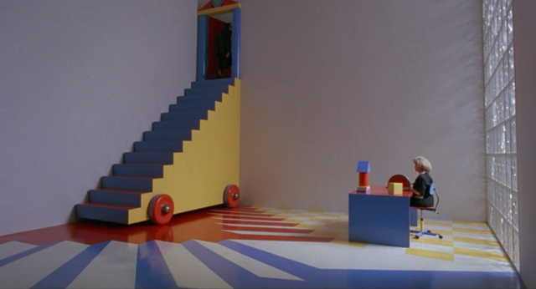
Toys 1992 - Barry Levinson
I loved the idea of the enlarged toys and the almost unsettling liminal scenes in the movie, and it led me to the idea of portraying the dimensions as an almost play-like structure. Like how us as three-dimensional beings can manipulate and ‘play with’ two dimensional objects (or beings), us too may be manipulated and played with by beings in incomprehensible dimensions. I began to incorporate this idea in my work as I started making a few sketches inspired by the hills and large sets of this movie. This began my initial planning stage.

Phase IV 1974 – Saul Bass
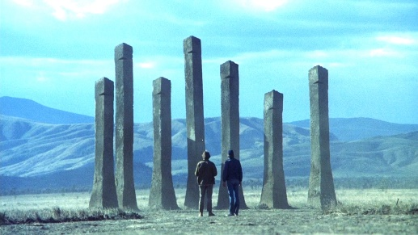
I got more inspiration for liminal space through the movie Phase IV directed by Saul Bass, I loved the outlandishly large landscapes contrasting the small people in the scenes, almost perfectly encapsulating the sublime and it is almost humanising the unsettling feeling you get from watching the scenes. I loved Bass’s ability to evoke emotion through even his imagery, and I wanted to integrate this into my own work.

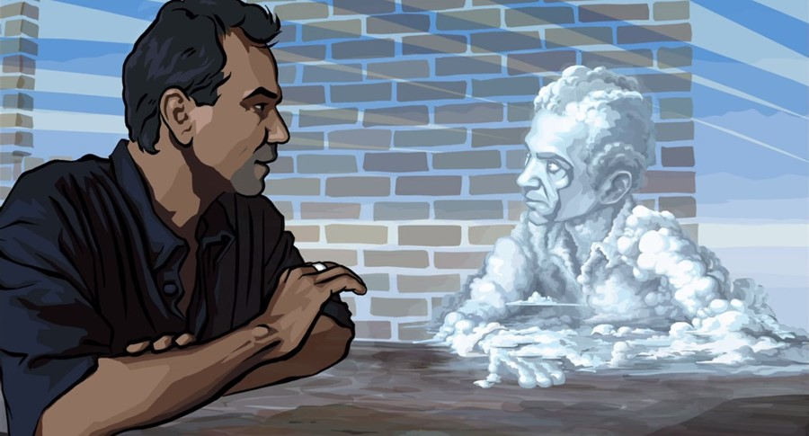
Waking Life 2001 – Richard Linklater
After Watching Richard Linklater’s Waking Life movie, I knew I wanted my art to go down the route of a dreamy-type theme… On account of many of my personal beliefs of which I will not bore you, I believe that dreams themselves take place in a dimension other than the third, so I wanted to begin a series of dream-like scenes that almost seem to blend the fourth dimension and the concept that we are almost the pawns or ‘toys’ of the fourth dimension. Linklater’s method of filming real life actors and then going through and painting over the scenes to create an even more dreamy environment really caught my eye as I was watching the movie. I knew that my sketches and drawings were good steppingstones, but as I felt as though if I wanted to convey everything that I wanted to, I would have to choose a method that allows for easier communication, so I began to look into creating my own videos.

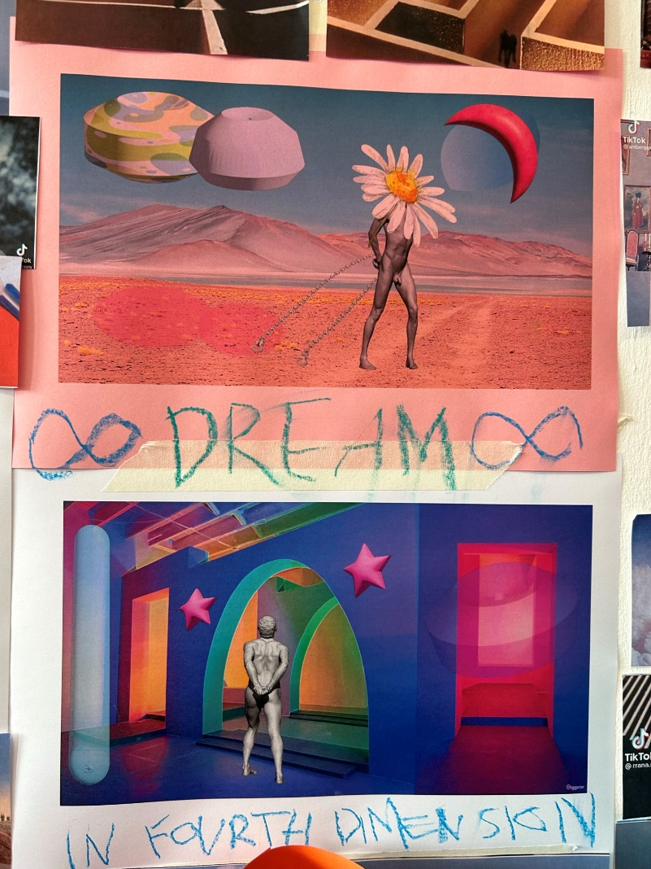
Beginning
I began building 3d scenes along side drawing my own 2d scenes in order to create a foundation on which to create my videos. I also tried my hand in creating digital scenes using Adobe Illustrator. I began collecting footage and after much trail and error trying to figure out how to use various video editing platforms, I began to create short dream like videos inspired by the directors I had researched.

3D Sets
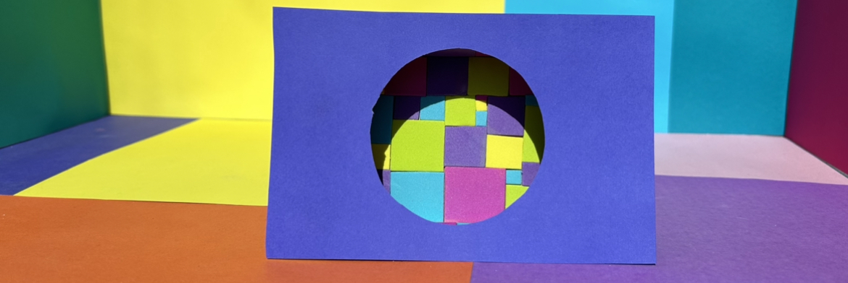

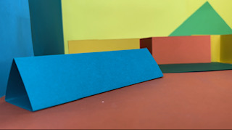

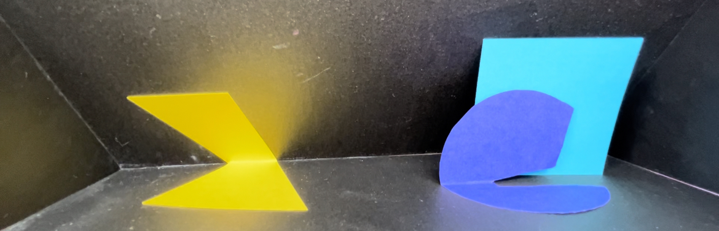

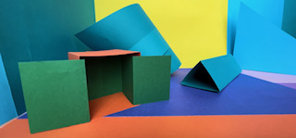
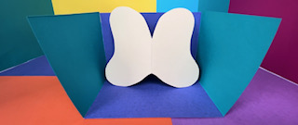
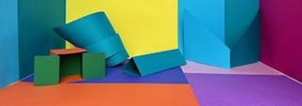

Final Piece
It was then time to start thinking about my final piece and how I would display my work. I considered projecting into my 3d and 2d pieces, but I wanted to create a more immersive experience for the audience. I thought to create a large 3d cube structure made up of slat 2d shapes. I had fun creating physical scenes so I decided to include a scene inside the box. I wanted to create a more personal experience, so I decided to put a ‘peep hole’ in the front for a more 1-1 experience. I wanted to convey my personal journey into learning more about the universe and in turn it has helped me discover so much about myself. I am hoping that this piece will encapsulate the almost spiritual frustration I feel in my endeavours. I have a lot to say about this piece and plenty of explanation as to why I did everything how I did, however I would prefer to leave this piece up for the personal interpretation of the viewer.

