AAD011 - Aesthetics

In his novel The Picture of Dorian Gray, Oscar Wilde flagrantly claimed, ‘All art is quite useless’, feeding into his belief that art does not need to express anything but itself. This quotation almost perfectly juxtaposes the Aesthetics movement of the late 19th century with its rebellion against ‘useless’ art from the Industrial Age, escaping the mass production of similar-looking art and extracting all deeper meaning for the sake of focusing on the beauty of art alone, 'Art for Art's sake'.
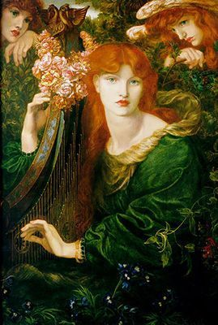
Dante Gabriel Rossetti was an English creative mind who participated in painting, illustration, literature etc, during the Aesthetics movement. His painting La Ghirlandata (The Garlanded Lady) is the embodiment of his transition into a more aesthetically pleasing genre of art. In this piece, he ditches sharp features and linework to portray a delicate scene which could be described as balanced and harmonious. His bright and playful colour palette compliments the overall tone of the painting creating a scene to be admired, perfectly encapsulating the essence of the Aesthetics movement as Rossetti almost inspires a new standard of beauty in the art world through the allusion of the beautiful woman depicted. Her unconventional beauty for the time of the Victorian age was a bold statement to allude the fact that art does not have to be traditional to still be beautiful.
"La Ghirlandata" by Dante Gabriel Rossetti (1828-1882)

References:
Wilde, O. (2008). The Picture of Dorian Gray. Harlow: Pearson Education.
‌ Victoria and Albert Museum. (n.d.). V&A · An introduction to the Aesthetic Movement. [online] Available at: https://www.vam.ac.uk/articles/an-introduction-to-the-aesthetic-movement#:~:text=The%20Aesthetic%20Movement%20in%20Britain.
Souter, A. (2016). The Aesthetic Movement Overview. [online] The Art Story. Available at: https://www.theartstory.org/movement/aesthetic-art/.
‌
‌

