ANN VAN HOEY
Ann Van Hoey is a Belgian ceramic artist, best known for her uniquely delicate clay technique. Hoey’s work demonstrates great skill through precise mathematical and scientific precision as evidently, each thin slab of clay seems to be skilfully and intentionally placed displaying an almost technical impeccability. Her love of geometry and her travels to different parts of the world have informed her skill as in Japan she discovered the art of origami, inspiring her to develop her own unique clay style which would be internationally appreciated.
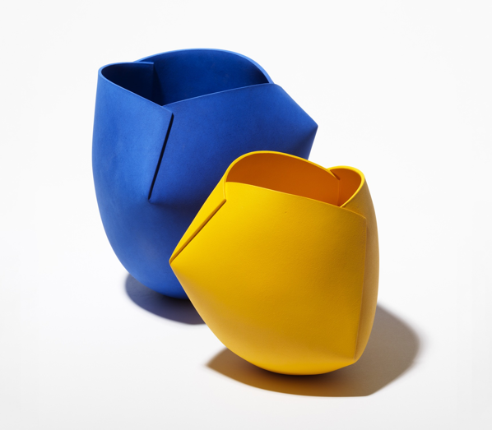
During Hoey’s creative process she utilises the simplest of tools such as a rolling pin, moulds, knives and scalpels which almost accentuate the simplicity of her works final outcome, juxtaposing her precise and detailed process. It is interesting to note that Hoey has expressed that at the beginning of her career, her process was very calculated, being a self proclaimed perfectionist. However as time went on she found herself becoming more organic in her work, abandoning a strict regime for an almost natural ritualistic approach. Hoey designs her sleek clay bowls inspired by the style of Japanese paper origami, cutting her clay slabs into carefully thought out puzzle pieces to be reassembled and erased of seams, to be finally held together with a thin bead of glue-like slip.
Ann Van Hoey. Blue Object n° 21-19, 2020, stoneware and engobe, h. 22,5 x 21 x 21 cm. Orange-yellow Object n° 21-20, 2020, stoneware and engobe, h.18 x19 x 19 cm (catalogue p. 4). Photo Dries Van der Brande

Hoey is best known for her ‘Eathenwear Ferrari’ series in which the simplicity of her designs become accentuated by the bright layers of automotive Ferrari paint she uses to completely block out her clay bowls and create an even more sleek and exciting to look at final product, using bright primary colours, brightly lacquered, some of her work could be described as reminiscent of childhood and emphasising the playful approach to clay which Hoey engages in. For other pieces however, Hoey sticks to more natural and warmer colours, which may not be as exciting to look at but rather inviting. Ditching the shiny lacquered finishes she was known for, these more natural coloured clay pieces are finished in matte engobes, a process Hoey discovered whilst she was travelling in Taiwan.
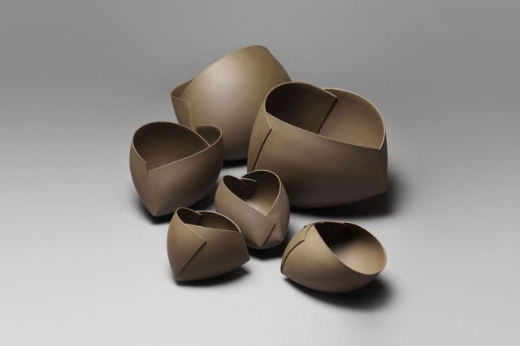

Titre : Object, dimension : H20x26x24cm, medium : Earhtenware, technique : Slab building and press molding, date : 2015

